SPIRIT 2.0 Lesson:
Infrared Remote Controller
==========================Lesson Header ==========================
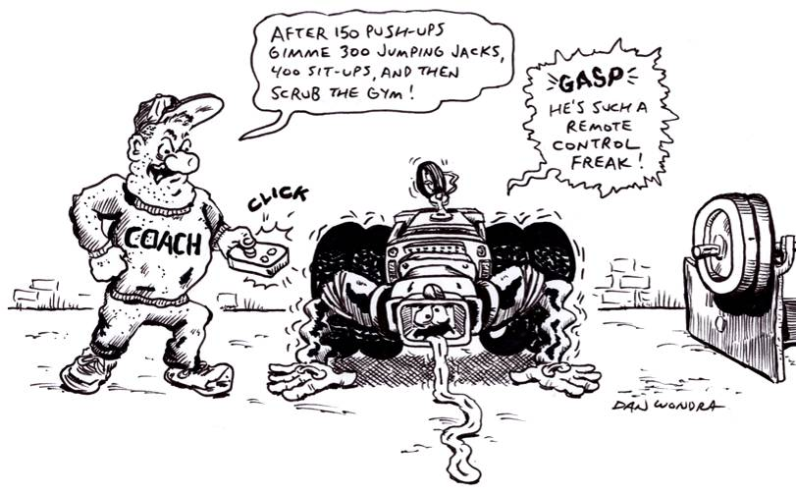
Lesson Title: Infrared Remote Controllers
Draft Date: 12/29/09
1st Author: David Porter
Instructional Component Used: Infrared
Grade Level: 6-8 Middle School

Content (what is taught):
- Infrared (IR) vs. radio frequency (RF) remote controllers
- Advantages and disadvantages of IR and RF controllers
- The nature of infrared
Context (how it is taught):
- Inquiry into how two different types of robots are controlled—tasks to accomplish are part of the inquiry.
Activity Description:
In this lesson, students are given two robots: a CEENBoT with a remote controller (or other RF-controlled robot) and an Isobot (or other IR-controlled robot). Students are to discover as much as they can about each controller by using the robots. Characteristics to explore include range of control, directionality of the controller, and interference (do objects between the controller and robot block the signal?). Once this is completed, students will be provided a video camera, which is sensitive to infrared light. Students will discover which controller emits IR pulses. Other remote controllers will also be provided in order to discover which are/aren’t IR (such as garage door openers, television and other electronics controllers, remote controlled toys, and car key-fob door openers/alarms) and how to discern whether a device is IR or RF controlled (without a video camera). Finally, students will research IR and RF controllers.
Standards:

Science - SF5, SA2 Technology - TF1

Materials List:
CEENBoT with remote controller (or other RF-controlled robot)
Isobot (or other IR-controlled robot)
Video camera sensitive to infrared light
Student data sheet divided into categories of range, directionality, interference, and other.
Other remote controls (such as car key fobs, garage door openers, television, and VCR).
Grade level appropriate information about both IR and RF controllers.
Asking Questions (Infrared Remote Controllers)

Summary:
Students discover two types of remote controllers (infrared and radio frequency) and some of their characteristics.

Outline:
- Students are informed that the two robots are operated by different types of controllers.
- Students will operate the robots while investigating the controllers according to at least the three criteria provided.

Activity:
The students will operate the two types of robots while completing the student data sheet: a CEENBoT (or another radio frequency (RF) controlled classroom robot) and an Isobot (or another infrared (IR) controlled classroom robot).

Questions | Answers
Does one controller have a longer range than the other? Measure the distance from which they can be reliably operated. | The RF controller should have 2-3 times the range of the IR controller.
Does one controller have to be pointed more directly at the robot in order to reliably operate it? Measure the range of degrees in which each controller operates. | The RF controller should work without regard to directionality. The IR controller will only work within a certain range of degrees.
Will one controller work through objects better than the other? That is, what are the effects of interference by people or even walls? | The RF controller will be much less effected by objects than the IR controller.
RF or IR
Waves
Worksheet: S050-IR-Remotes-A-DataWrksht
Exploring Concepts (Infrared Remote Controllers)

Summary:
Students will investigate different types of remote controllers, recognize that many devices are remotely controlled with these two different types of devices, and make connections between background knowledge and their new understandings.

Outline:
- Infrared (IR) controllers use light, which people can’t detect without assistance. Radio frequency (RF) controllers use radio waves.
- Comparison of these characteristics and their corresponding remote controllers with light and radio.

Activity:
Start by having a discussion about the two types of controllers. Students observe the two types of controllers while operating to see if any differences are noted. Introduction of the idea that one type uses light (IR) and one uses radio waves (RF). Students again observe the two controllers in action, this time in a darkened room in order to try and see which uses light. Again, no difference will be noted. Students will then be provided with a video recorder, which is able to detect infrared light. They will record the remote controllers while in operation. The video will then be played back so that other students can see the light emitted by the IR controllers.

Students will likely be interested in exploring the concept of infrared and the ability of the video camera to record in nearly total darkness using infrared light. The teacher may wish to permit/encourage the use of the video camera to create short “movies” demonstrating the invisible (to the human eye) presence of infrared light.

A teacher-led discussion will follow as to the pros/cons of each type of controller. It seems as if RF has no disadvantages. Students will then conduct research to find why RF controllers are not universally used (IR has lower cost and uses less power, RF uses limited band of radio waves). The students will write short (one page) reports, with citations, explaining the reasons for different types of controllers in different applications. The teacher may wish to expand the range of the reports to include topics such as the nature of infrared light (where it fits into the electromagnetic spectrum) and whether other animals can see into the infrared range.

Resources:
If readily available, night vision goggles would make a good connection.
Any additional instructional resources on the nature of infrared light.

Instructing Concepts (Infrared Remote Controllers)

Infrared Light waves

Putting “Infrared Light waves” in Recognizable terms: Infrared Light waves are a form of light that is outside of the visible spectrum of human beings. These waves are longer in wavelength than visible light. There are three different classifications of infrared light waves, far, mid and near. The near infrared is closest to visible light and has the shortest wavelength of the IR spectrum. The far infrared is closest to microwaves and has the longest wavelength of the IR spectrum.

Putting “Infrared Light waves” in Conceptual terms: Infrared Light waves fit into part of the light spectrum that we cannot see but since it is close to the visible spectrum it still behaves similar to visible light. It cannot pass through matter and can be reflected and focused. This is different from the extremes of the electromagnetic spectrum, which easily pass through most matter. The IR spectrum is best known as the spectrum of light that provides heat although not all parts of the IR spectrum are thermal in nature. The more you deviate from the visible spectrum into the IR spectrum the more heat is present (longer wavelengths provide more heat). IR is present in all light and is radiated from matter, which can be seen in the form of thermal energy.

Putting “Infrared Light waves” in Mathematical terms: Infrared Light waves have wavelengths (from longest to shortest) between about 1 mm and 750 nm (nanometer, one billionth of a millimeter) where as visible light waves range (from longest to shortest) from deep red, roughly 700 nm, to violet, roughly 400 nm.

Putting “Infrared Light waves” in Process terms: Thus, the Infrared Light Waves affecting an object cannot be seen but still have the ability to change the object. The longer the wavelength in the IR spectrum the more heat is absorbed by the matter.

Putting “Infrared Light waves” in Applicable terms: Infrared Light Waves can be “seen” using special equipment that measures the heat radiating from matter. One of the most common uses of IR waves is from the near part of the IR spectrum. This portion of the spectrum does not emit heat but can send signals that can be used to control electronic devices as in a TV and TV remote control. The waves are sent in rapid predetermined patterns that are absorbed by a receiver that decodes the pattern thus tells the device what to do.
Organizing Learning (Infrared Remote Controllers)

Summary:
Students will reflect on their inquiry into the characteristics of two different types of remote controllers (infrared and radio frequency). They will then analyze this knowledge in order to evaluate other types of remote controllers.

Outline:
- Students will use their data found previously in order to present their findings to the class.
- Students will use their findings in order to make predictions about how other remote controllers operate.

Activity:
Students will reflect upon the inquiry into differences between remote controllers and then present what they learned. Presumably this will include the facts that the RF-controlled robot can be operated from a further distance, with less of a need for the controller to be pointed at the robot, and with little interference effect. Other student-discovered findings may be presented as well. The teacher will appropriately question these results-returning to the inquiry if necessary in order to confirm/refute the student “findings.”

The teacher will explain the two types of controllers they used were IR and RF: one which operates in a fashion similar to light and the other which is similar to radio. The students will use their own background knowledge to correctly identify which is which. The teacher should not explain the IR and RF initials until after the students have made this identification.

Three other remote controllers will then be presented: a key fob-style car door opening remote controller, a television remote controller, and a garage door opener. Students will conduct an inquiry using the first two items and predict what types of controllers they are: IR or RF (the key fob is an RF and the television is an IR). The students will then work in small groups to consider what they know about garage door remote controls and make a prediction about the type of controller they must be (RF, since a door separates the controller from the unit and they work from relatively long distances). Students may complete this investigation at home.
Understanding Learning (Infrared Remote Controllers)

Summary:
Students will create a formative assessment as they conduct an inquiry into the characteristics of two different types of remote control operated robots. A summative assessment will be conducted via an authentic assessment experience.
Outline:
- Formative assessment of infrared wave using remote controls.
- Summative assessment of infrared wave using remote controls.
Activity:
Having completed the inquiry into the types of remote controls used by a CEENBoT and Isobot (or other RF and IR controlled classroom robots), the students will use their data sheets in order to organize the information and assess their learning.

The summative assessment will be an authentic inquiry using two different types of remote controllers. Each student will be presented with a description of three remote controls. The students will identify each controller as radio-frequency (RF) or infrared (IR) based.

Formative Assessment
As students are engaged in the lesson ask these or similar questions:
1) Do students understand how an IR controller works?
2) Do students understand the limits of IR when applying it in remotes?
3) Can students cite the pro/cons of IR versus RF or other controller types?
Summative Assessment
Students can answer the follow writing prompt:
Explain how infrared light wave are used to control electronic equipment. Be sure to explain why it is effective and what its limits are.

Students can perform an authentic exploration of different types of controllers to determine which is IR and which is not. Students should be able to differentiate an IR controller from another type and know it’s strengths and weaknesses.

Worksheet: S050-IR_Remotes_U-AssessmentWrksht.doc
Worksheet Answers:
1. RF because it operates from a distance and isn’t disturbed by obstacles. This is all consistent with its operation using radio waves.
2. IR because it operates in close proximity, obstacles prevent its operation, and the directionality of the controller is important. This is all consistent with its infrared operation using a type of light beam.
3. IR because it operates in close proximity, obstacles prevent its operation, and the directionality of the controller is important. This is all consistent with its infrared operation using a type of light beam.
4. RF because it operates from a distance, isn’t disturbed by obstacles, and directionality isn’t important to its operation. This is all consistent with its operation using radio waves. It might be noted that Bluetooth is a higher wavelength wave than typical RF controllers. It is in the microwave band.

