SPIRIT 2.0 Lesson:
Plate Tectonics
==========================Lesson Header ==========================
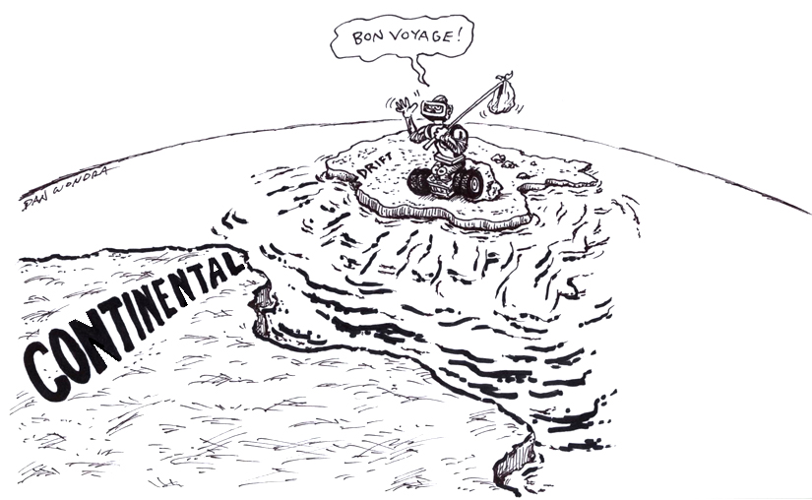
Lesson Title: Plate Tectonics
Draft Date: December 2009
1st Author (Writer): Lisa Tingelhoff
Instructional Component Used: Plate Tectonics
Grade Level: Middle Level

Content (what is taught):
- Theory of plate tectonics
- Types of plate boundaries
- Causes of volcanoes, earthquakes and geological formations such as mountains

Context (how it is taught):
- Plate tectonics and continental drift are modeled
- Plate boundaries are simulated
- Collection and organization of earthquake data to formulate a conclusion
Activity Description:
In this lesson, students will investigate the theory of plate tectonics and continental drift. Students will use robots to simulate the theory of plate tectonics and continental drift. Students will discover what causes earthquakes, volcanoes and geological formations such as mountains. Students will model different plate boundaries. Students will gather real-world data exploring the location of earthquakes to formulate a conclusion about fault lines.

Standards:

Science - SD1, SD2, SF3 Technology - TA3, TA4, TD3, TE

Engineering - ED3 Math - ME3

Materials List:
CEENBoTs or other motorized vehicles
Continental plate templates
Candy bars (Snickers or Milky Way)
Internet connection and computer
Asking Questions (Plate Tectonics)

Summary:
Students discover that Earth’s surface is a composition of many lithospheric plates.

Outline:
- Demonstrate plate tectonics using motorized vehicles or CEENBoTs.
- Demonstrate Pangaea and continental drift to current location using motorized vehicles or CEENBoTs.

Activity:
7 CEENBoTs (or motorized vehicles) will each have one of the major lithospheric plates: North American, South American, Pacific, Eurasian, African, Indo-Australian and Antarctic, attached to the top. The templates of the continents are in the attached .pdf file. The largest Eurasia is 8.5” x 11”. India is the smallest. You may want to print them off and go to a copier and increase the size so that the robots are covered more efficiently. Students can place the robots with the plates in their current location and then try to fit the puzzle together like Pangaea would have looked like. (The solution is attached). Then students can move the plates from Pangaea to their current locations.

Questions | Answers
Have the continents always been in their current location? | No, the Theory of Plate Tectonics provides evidence that the plates have all separated over time and moved to their current location.
Are the continents stationary? | No, the plates are still moving.
What causes lithospheric plates to move? | It is quite complex but stems from the creation of convection currents deep inside the mantle.

Resources: Several resources can be found online by typing in ‘plate tectonics’ at www.google.com

Worksheets: S051-Plate_Tectonics-A-Tectonic_Plate_Puzzle.pdf
S051-Plate_Tectonics-A-Tectonic_Plate_Puzzle_Soln.pdf

Exploring Concepts (Plate Tectonics)

Summary:
Students will simulate various plate boundaries using candy bars and robots.

Outline:
- Teacher will guide students through a candy bar exploration of plate boundaries.
- Students will use two CEENBoTs (or motorized vehicles) to simulate plate boundaries.

Activity:
In this lesson, students will investigate three types of plate boundaries: divergent, convergent and transform. The lesson will begin with the teacher guiding students through a hands-on demonstration of plate boundaries using a candy bar such as a Snickers or Milky Way. Students will begin by using a fingernail to make a few breaks in the crust or top of the candy bar. To illustrate divergent boundaries, students will gently pull on the edges of the candy bar. They will notice that the plates move apart to reveal the caramel/nuts or asthenosphere. To illustrate transform boundaries, students will push the plates back together, then slide one half of the candy bar forward and the other backwards. To illustrate convergent boundaries, students will then push on both ends of the candy bar to squeeze it together. They should notice the plates colliding and possible see one slide over the top of another.

Once students have completed the candy bar simulation, guide them to use robot movements to simulate the same types of boundaries. Each of the robots could have “crust” mounted to the top and this would demonstrate how each of the portions of crust interact at the boundary.

Worksheet: S051-Plate_Tectonics-E-Plate_Boundary_Organizer.doc

Plate Tectonics

Introduction:
Plate tectonics is the motion of the outer part of the earth called the lithosphere. The lithosphere is comprised of the earth’s crust and upper part of the mantel. Currently, it is thought that there are 8 major plates and many minor plates that are moving across the surface of the earth. The cause of their movement is believed to be from radioactive material deep below the earth’s surface decays releasing heat, which produces convection currents. This movement forces plates to interact in three different types of boundaries: 1) convergent, 2) divergent, and 3) transform.

1) Convergent boundaries are where plates compress or collide with one another. The formations created by this action depends on the types of plates involved. If an oceanic plate collides with a continental plate, the denser plate (typically oceanic) will be sub ducted (go below) the other plate. Mountains tend to be formed although they generally are not that large (i.e. Cascade Mountain Range). Also, an oceanic plate can collide with another oceanic plate. Again one plate (the denser) will be sub ducted below the other. In this instance there can be two formations: deep-ocean trenches located near the second formation of volcanic islands chains (i.e. Aleutian Islands). Finally, a continental plate can collide with another continental. In this instance, some subduction may occur, but widely more folding and faulting action of the rock layers is present due to increased compression as the density of the crust is less than the lower mantel forcing the layers into large mountains (i.e. Himalayan Mountain Range).

2) Divergent boundaries are where tension occurs or plates are moving away from each other. If the boundary is between two oceanic plates, then mid-oceanic ridges occur (i.e. Mid-Atlantic Ridge) from the rising of magma weakening the crust and moving the plates apart. If the boundary is between continental plates it can produce an ocean basin (i.e. Red Sea) or fault zone (i.e. New Madrid Fault).

3) Transform boundaries is where plates slide past one another or shearing occurs. This can cause some vertical and horizontal movement between the plates forming a special type of fault zone. Transform boundaries (faults) can be found in the oceans but the best known are on land (i.e. San Andreas Fault). These types of boundaries are well known for producing earthquakes, although any boundary can produce an earthquake.

Earthquakes are caused by two plates (either major or minor) moving along a fault (breaks in the earth’s crust along a boundary). As the plates move along a fault, they gradually build up stress on one another. When the stress becomes too great, the plates can slip rapidly against each other, causing lots of energy to be released changing the shape of the landscape. The changes of the landscape depends on the type of fault: 1) dip slip faults where the major movement is vertical, 2) strike slip faults where the major movement is horizontal, and 3) oblique faults where the major movements are both horizontal and vertical.

The Richter Scale can measure the energy of earthquakes. It is a logarithmic scale that assigns a number of magnitude for an earthquake. Since the scale is a base 10 logarithm the difference between a 4.1 and 5.1 magnitude earthquake is a factor of 10. This means that an 8 magnitude quake is 100,000 times more powerful than a 3 magnitude quake (Note: to get 100,000 take 10 x 10 x 10 x 10 x 10…5 times).
Organizing Learning (Plate Tectonics)

Summary:
Students will collect data on earthquakes that have occurred in the last seven days via an online resource. Students will construct a map using latitude and longitude to orient the map. Students will use a robot to plot data points and connect them on the map.

Outline:
- Students will work in groups of three to collect data of 30 earthquakes that have occurred in the last seven days.
- Students will then use a robot to plot data points and connect them on the map.

Activity:
For this activity, students will visit an online earthquake map. They will collect data points of latitude and longitude for thirty recent earthquakes and record it on a data table. Students should be encouraged to select a variety of locations from the map. Once groups have collected their information, they will move over to a large class map. They will use the CEENBoT (equipped with a pencil) to plot each earthquake location and connect each location in between. The groups should move in a succinct pattern from north to south or south to north.

Resources:
http://earthquake.usgs.gov/eqcenter/recenteqsww/

Worksheet: S051-Plate_Tectonics-O-Earthquake_Location_Organizer.doc

Understanding Learning (Plate Tectonics)

Summary:
Students will complete a chart summarizing plate tectonics. Students will complete short answer essay questions.

Outline:
- Formative assessment questions asked during the learning activity about plate tectonics and its meaning and impact.
- Summative assessment essay questions and chart summary about plate tectonics.

Activity:

Formative Assessment
As students are engaged in the lesson ask yourself or your students these or similar questions:
- (Can students answer) What does the theory of plate tectonics say?
- (Can students answer) What impact does the movement of plates have on Earth’s surface?
- Can you use two robots to simulate the three types of plate boundaries?

Summative Assessment
- Students will complete the following chart summary and essay questions about plate tectonics.
 | convergent | divergent | transform
description of robot simulation
type of movement
geological event at the boundary
specific example

- Students will answer the following essay questions about plate tectonics:
- At the Mid-Atlantic Ridge, the North American and Europe plates are moving further and further apart. What is causing this and what type of boundary would you expect to see here?
- Numerous volcanoes happen near Japan and at the edge of the Pacific Plate. What do you expect causes this and what type of boundary would you expect to see here?
- California is located near the San Andreas Fault. Many earthquakes occur here. What do you expect causes this and what type of boundary would you expect to see here?

