SPIRIT 2.0 Lesson:
Plane Mirrors
==========================Lesson Header ==========================
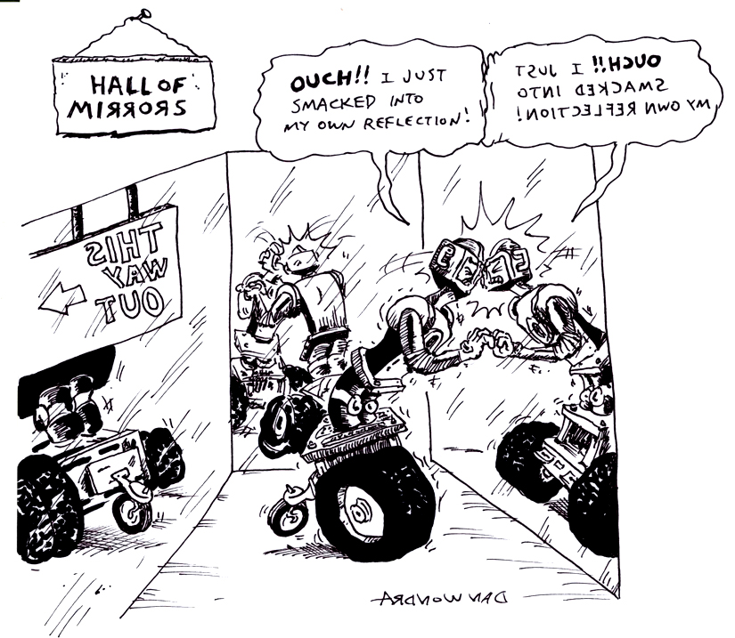
Lesson Title: Plane Mirrors
Draft Date: 1/10/10
1st Author (Writer): David Porter
Instructional Component: Plane Mirrors
Grade Level: 6-8 Middle School

Content (what is taught):
- Plane mirrors reflect images accurately, although reversed.
- A plane mirror creates a virtual image.
- A ray of light reflects off of a plane mirror at the same angle at which it strikes it.

Context (how it is taught):
- Students learn content through control of a classroom robot while using plane mirrors.

Activity Description:
A maze will be created for the classroom robot to navigate. Students will be timed as they first control the robot through the maze while looking at it directly. They will then repeat the timed trial while looking at the reflection of the robot and maze, rather than directly at them. The ensuing classroom discussion will highlight the first content item, above. The concept of a virtual image will be discussed and discovered. Students will then learn that infrared (IR) controlled robots use light beams invisible to human eyes as the controlling mechanism. Students will find that the light in IR controllers is emitted generally in a straight line and must strike its device in order to operate. Finally, for the third content item, above, students will attempt to reflect the IR controller’s light off of plane mirrors towards the classroom robot in order to operate it.

Standards:

Science - SA1 SB1 Technology - TA1

Engineering - EA1 Math - MC3 MC4

Materials List:
Any type of controllable classroom robot
Classroom robot with infrared-operated remote control (such as an Isobot or Lego Mindstorm)
Large mirror (25 cm square or larger) Plastic mirrors preferred. 12” square mirror tiles will work as long as they are firmly attached to unbreakable backing for safety.
Hand mirrors (approximately 6 cm square or smaller)
Small, well-focused flashlights
Metersticks.
Video camera capable of recording infrared light (optional)
Asking Questions (Plane Mirrors)

Summary: Students will experience two properties of plane mirrors: accuracy and reversal of the image. The concept of the mirror’s virtual image will be discussed and explored.

Outline:
- A classroom robot will be operated both directly and through its reflection.
- The accuracy and reversal of a plane mirror’s reflected image will be discussed.
- Students will discover the concept of the virtual image seeming to appear behind the mirror.

Activity 1:
A maze will be created for the classroom robot to navigate. The maze will ideally be created by the students and done in such a way as to be challenging. Perhaps the students will wish to add penalty factors for crossing the maze’s lines or bumping into its walls (depending upon how the maze is created). Students will be timed as they operate the robot through the maze. The time trial process will then be repeated, however, this time a barrier will be erected (any type of screen will do) in order to prevent the students from seeing the robot/maze directly. A mirror will be placed behind the robot/maze (taped to a wall) so that the students will be able to control the robot while looking at its reflection. The times will be recorded. (This would be a fine experiment with which to practice the use of mean, median, and mode.) Once all time trials are complete a classroom discussion will highlight the following:

Questions | Answers
What usually happens as a skill is practiced? What would you expect to happen as students practiced driving the robot through the maze? | People become more proficient. Students should be able to get through the maze more quickly.
Which of the time trials was generally (always) slower? | The second time trial was slower.
Was the reflection of the robot and maze difficult to see? Blurry or distorted? | No, the image was easy to see.
What can explain the slower times during the second time trial? | The mirror made everything appear backwards.

Activity 2:
The teacher will then introduce the concept of the plane mirror’s virtual image, that is, an image which can be seen, but not touched. The teacher will state that a plane mirror’s virtual image appears to be behind the mirror. Students will be challenged to find evidence, using the classroom robot and the large mirror, to support/refute this statement. Students will be provided the meter sticks, robot, mirror, and these guide questions:

Questions | Answers
If you place the robot against the mirror, how large does each appear to be? | The sizes are nearly identical.
As the robot is moved away from the mirror, towards the viewer, how large does each appear to be? | The virtual image will be smaller—relative to the actual image just as if it were as far behind the mirror as it is in front of it.
Exploring Concepts (Plane Mirrors)

Summary: Students will learn that light is reflected from plane mirrors at the same angle at which it strikes.

Outline:
- Students will learn that some remote controls use infrared (IR) light and that this light behaves in the same manner as other light-traveling in a straight line.
- Students will use plane mirrors to reflect IR light from the emitter/controller to the classroom robot.

Activity:
As one student uses an IR controller to operate a robot, other students are told to carefully watch the controller. If available, students are given an IR-capable video camera and told to record the controller in operation. This will permit students to recognize that beams of light are used in this type of controller. Students will then be asked about characteristics of light—one of which is it traveling in a straight line. As this understanding is reached, students are aided in the consequent recognition of why IR controllers must be pointed towards the device. Like most light, unlike a LASER, IR is somewhat diffuse, so it doesn’t have to be precisely aimed at the device. This understanding will be promoted by the students’ use of flashlights and mirrors, aiming the light sources at various angles and noting the angle of the reflected light (an object for the light to strike will need to be in place). Students will then be challenged to operate the IR-controlled classroom robot by bouncing the IR controller’s light off of one, and then two mirrors. The flashlights may be used by the students to help place the mirrors.

WARNING: Laser pointers could be considered as an effective resource in this activity. However, many warnings exist against their use by children. Teachers may choose to use red laser pointers (green ones have greater potential to cause eye damage) with close personal supervision—certainly not distributed for use by small groups under general supervision. However, our recommendation would be to avoid their use altogether due to the possibility of harm. This is not an obstacle to learning since flashlights are even more readily available and are acceptable for the activity. Small penlight flashlights could be attached to the classroom robots near the IR receiver as an assist to aiming.
Instructing Concepts Plane Mirrors

Plane Mirrors

Putting “Plane Mirrors” in Recognizable terms: When we observe an image in a plane mirror, it is a ‘mirror image’ that is, it is reversed from the object.

Putting “Plane Mirrors” in Conceptual terms: When you look in a plane mirror, you see the ‘virtual image’ behind the mirror. A virtual image cannot be touched or captured by a camera.

Putting “Plane Mirrors” in Mathematical terms: When a ray of light strikes a plane mirror, it is reflected off at the same angle with which it strikes. The angles are measured from the normal or from the perpendicular to the mirror. The virtual image is located the same distance from the mirror as the object. The incident angle = the reflected angle. i angle = r angle

normal line
i
r

Putting “Plane Mirrors” in Process terms: Even though the light rays seem to pass through the mirror, we know that they do not. They seem to come directly from the object to the eye of the observer, but we know this is not possible. This is why you can’t project a virtual image.

Putting “Plane Mirrors” in Applicable terms: Plane mirrors are abundantly plentiful. They serve several functions in our everyday living; applying cosmetics, decorative displays, some optical instruments, reversed lettering on the front of an ambulance.
Organizing Learning (Plane Mirrors)

Summary: Students will measure angles created by reflections from mirrors.

Outline:
- Definitions of incident and reflected angles as well as review of the use of protractors and the need for measuring from a perpendicular line from the mirror.
- Students will measure incident and reflected angles.
- Students will then make predictions as to the location of a reflected beam of light given the incident angle.

Activity:
The students will be taught the concepts of incident and reflected angles, how to measure degrees with a protractor, and the need for measuring from the perpendicular. Students will then work with a partner to set up a lab for measuring the angles of beams of light reflected from plane mirrors. Each set-up will consist of a mirror placed perpendicular to the floor or table (temporarily attached to a wall or perpendicular surface), a piece of paper below the mirror, a perpendicular line drawn on the paper from the center of the mirror, a protractor, and flashlight. Students will then shine the flashlight towards the center of the mirror/perpendicular line endpoint. Students will place an object, at the same distance from the mirror as the flashlight, so that the beam from the flashlight shines upon it. Students will then draw lines on the paper from the location of the flashlight to the center of the mirror/perpendicular line endpoint and from the object to the center of the mirror/perpendicular line endpoint. The students will measure the angles of these lines from the mirror. The students will record the data and then repeat this several times until they are able to confidently make a conclusion regarding the relationship between the incident and reflected angles.

Students will then test their conclusion by successfully predicting where a beam of light will reflect. Students will mark a location for the flashlight and where they predict the object should be placed for the beam of light to be reflected upon.

Although students should be able to determine that the incident and reflected angles are identical, there is possible variability in the experiment due to the diffuse nature of flashlight beams as well as experimental error in set-up of the perpendicular line and aiming of the light.

Worksheet: S052-Plane_mirrors-O-DataSheet.doc

Understanding Learning (Plane Mirrors)

Summary: Students will demonstrate their understanding of reflection from plane mirrors through formative questions and answers and a summative assessment called “Light Billiards.”

Outline:
- Formative assessment questions regarding student understanding of plane mirrors.
- Summative assessment of student understanding of characteristics of plane mirrors.

Activity:
As students are engaged in lesson inquiries and follow-up discussions, questions will be asked in order to inform the teacher of each student’s level of understanding regarding the characteristics of plane mirrors. The summative assessment will be each student’s creation of a “light billiards” game table, see directions below.

Formative Assessment
As students are engaged in the lesson ask these or similar questions:
- Do students understand how an image is changed when it is reflected in a plane mirror?
- Do students know what is unchanged when an image is reflected in a plan mirror?
- Do students know what a virtual image is and where it is located in relationship to the plane mirror?
- Can students verbalize what angle light is reflected after it strikes a plane mirror?

Summative Assessment
Students can answer the following writing prompt:
1) Using what you learned in the lesson describe what happens to a beam of light when it is reflected by a plane mirror.
2) You are in a room shaped like the one below and want to impress your friends with your ability to turn on the TV when you cannot see it. Describe how you would do this using mirrors if the TV has an infrared remote. You must state the position of the mirror for two different solutions for turning on the TV and state why each will work.
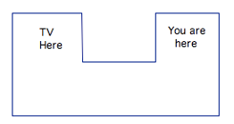
Another assessment option is for students to play “light billiards”. In this assessment students will sink 6 different balls on a billiards table with mirrors serving as bumpers. On each ball there will be a unique asymmetric symbol that will be reflected in the mirror. Students will also have to describe what the symbol looks like after the “shot” is made. Further directions and an example are in the worksheet.

Worksheet: S052-Plane_mirrors-U-Assessment_Activity.doc

