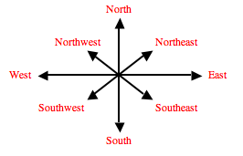
Questions for Cartography Research

What is cartography?

What are different types of maps that cartographers make?

What type of education do cartographers need and how much money do they make?

What is similar on the maps you have found/seen?

What is different about maps you have found/seen?

What does the scale of map represent?

How does the scale relate to the real world?

