SPIRIT 2.0 Lesson:
Cartography
==========================Lesson Header ==========================
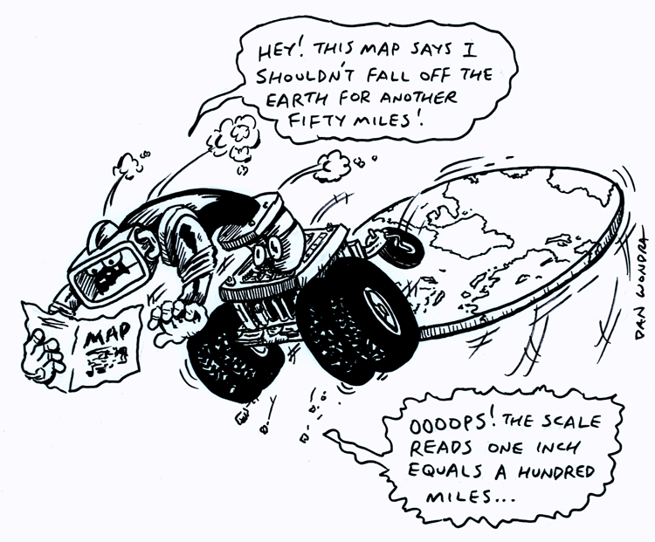
Lesson Title: Cartography
Draft Date: January 17, 2010
1st Author (Writer): Sara Bowen
2nd Author (Editor/Resource Finder):
Science Topic: Cartography
Grade Level: Elementary School

Content (what is taught):
- Cartography is the science of map making
- When making maps, cartographers must use many different mathematics topics simultaneously.
- The scale on a map is the relationship between the distance on the map and the actual distance on the earth as a relative fraction (RF) or ratio.
- Coordinate systems on a map are how you are able to find a specific location.
- The map is a proportional representation of the real world.

Context (how it is taught):
- Students will learn about the basic Math concepts needed to become a cartographer.
- Students will explore how to find a location on a map.
- Students will explore directions and the changing of direction.
- Students will understand the map is a representation of the real world.

Activity Description:
Students will learn about cartography and what the job entails, what schooling you need to become a cartographer and the income of a cartographer. Students will learn about the different aspects of a map and how a cartographer does his job. Students will explore the basic concepts of a map by using a human like robot or CEENBoT to understand how to read a map and how to move around on a map.

Standards:

Math – MD1, MC4 Science – SA1, SA2

Technology – TA1, TA2, TA3, TB1, TB4 Engineering – ED1, ED2, ED3, ED4

Materials List:
- Human like robot or CEENBoT | - Large floor maps
- A globe | - Similarities & differences worksheet
Asking Questions Cartography

Summary: Discuss, define and understand cartography and the parts of a map.

Outline:
- Students will research cartography and learn about the skills that are needed.
- Students will look at maps and see what they have in common and differences.
- Students will learn what a map scale means.

Activity:
Students will be taught about cartography, what a cartographer does, and the different parts of a map. The teacher should find some websites about cartography for students to look at and research the answers to the questions below. Next maps need to be given to the students to see what they have in common and what is different. Particular attention needs to be focused on the scale and what it means and how it works. Students can use the attached worksheet to answer the questions.

Questions | Answers
What is cartography? | The science of mapmaking
What types of maps do cartographers design? | Physical, such as roads or landmasses. Or abstract, such as political boundaries
What kind of salary do cartographers make? | Answers vary.
What type of education do cartographers need? | Answers vary, but math and drawing skills are essential.
What types of things do cartographers put on most maps? | Directions and/or compass rose, a cartouche (the title of the map), cartographers name, publication company, a legend that explains the symbols, and a scale that shows explanation of measurements
What is the scale on the map? | The scale of a map is something like 1”=150 mi.
How does the scale relate to the real world? | The scale shows that the map is an exact replication of the real world drawn smaller. (Although some maps scale up the real world) For instance, if the scale is 1”=50 mi. Then 1” on the map will actually be 50 miles in the world.

Worksheet: S053-Cartography-A-Wrksht.doc

Exploring Concepts Cartography

Summary: Students will experiment and discuss a compass rose and the difficult task of changing direction using a CEENBoT or human like robot.

Outline:
- Students will use the robot to learn the directions of the compass rose and changing directions.

Activity:
Students will get into groups of four. One student will sit on each side of map and be in charge of one direction. For example, the student on the top of the map is to understand that direction is north. Students will use the robot to experiment with and learn the directions of a map. The students will move the robot around the map and discuss the direction it is going and the new direction it goes when it turns. The student that the robot is moving toward is in charge of making sure everyone knows that the robot is going north, east, etc. When the cardinal directions are mastered, students will move on to understanding northeast, northwest, southeast & southwest. This time the two students that are involved with that direction are in charge with assisting everyone to understand that direction and how they got it. Students will change spots and learn their new direction until all directions are understood.
North
West
East
South
Northwest
Southeast
Northeast
Southwest

Instructing Concepts Cartography

Mathematics of Cartography
Cartography is the science of map making. A map is a scale drawing containing a set of points, lines, and areas that define their positions relative to a coordinate system. When making maps cartographers must use many different mathematics topics simultaneously. Some of these topics include: 1) Geometry (points, lines, areas, coordinates, etc.), 2) Scale (scale drawings), 3) Coordinate systems, and 4) Ratio and proportion. This instructional component will briefly highlight how these mathematical topics are applied in cartography.

Geometry
Maps are applied coordinate geometry. You can represent points, lines, curves, and areas that are in the real world on paper using a dilation (shrink). It is critical that the map be similar to the thing it is representing for it to be an accurate representation.
Scale
The scale on a map is the relationship between the distance on the map and the actual distance on the earth as a relative fraction (RF) or ratio. It will look something like 1:25000. This means that one unit of measurement on the map will equal 25000 of the same units in the real world. It doesn’t really matter what the unit is as long as you realize that it has to be the same for the map and in the world.
There are large scale and small-scale maps. Large/small scale refers to the size of the relative fraction of the scale. Large-scale maps have a scale of 1:24000 and larger fractions (smaller 2nd denominator). Small-scale maps have a scale of 1:250000 and smaller (larger 2nd denominator). A good way to think about scale is if the fraction is closer to 1 then the map is more detailed.
Coordinate Systems
Coordinate systems on a map are how you are able to find a specific location. Map coordinate systems are not all that different from the Cartesian coordinate system. In fact on flat maps the Cartesian coordinate system is widely used. On the earth, locations are stated by using latitude and longitude in terms of an angle measure expressed in degrees, minutes, and seconds. Latitudes or parallels run east to west and begin with 0 degrees at the equator and increase to 90 degrees at the poles. The angles of latitude increase to the north and south on opposite sides of the equator. Longitudes or meridians run north to south and begin at the prime meridian with the angles of longitude increasing to 180 degrees east or west (half way around the globe). On the earth one degree of latitude is approximately 70 miles. One minute of latitude is a little bigger than a mile and a second is approximately 100 feet. Since latitudes are parallel a degree is always constant. The length of a degree of longitude varies from about 70 miles at the equator to zero miles at the poles because meridians are not parallel, but all intersect at the poles.
Ratio and Proportions
The map is a proportional representation of the real world. The scale on the map will be in the form or a ratio that is the scale factor between the world and the map representation. Every distance will correlate to that scale factor. This means that given the scale factor (ratio), you can measure a distance on the map and set up a proportion to find the actual distance in the world.
Organizing Learning Cartography

Summary: Students will label the directions in their classroom and then draw a map of it. Next students will be given instruction to move their robot in the classroom orally by direction. For instance: move north, turn to the east, turn SW, etc.

Outline:
- Students will stay in their group of four and identify the directions of the classroom.
- Students will measure the room and location of objects, set a scale (the teacher might help with this) and draw a map of the room.
- The teacher will instruct students to move the robot around the room using directions N, S, E, W, SE, etc.

Activity:
Students will need to identify the directions of the classroom. A compass can be used to accomplish this or the teacher can point out west, for instance, and students can then identify the other directions. Next measurements of the room are to be made including a couple of “landmarks” (a desk, the fish bowl, etc) and a scale map with legend will be drawn. The teacher may have to help with what an appropriate scale should be with younger students. Finally, the teacher or a student should place the robot somewhere in the room and direct a classmate to move the robot by giving directional commands.

East
North
West
South
Teacher’s Desk
Whiteboard

Understanding Learning Cartography

Summary: Students will use what they have learned about cartography to draw maps for other students to use.

Outline:
- Formative assessment of cartography.
- Summative assessment of cartography.

Activity:
Formative Assessment
As students are engaged in the lesson ask these or similar questions:
- Are students able to determine the eight directions and correctly identify them?
- Do students understand what a cartographer does and what they put on maps?
- Explain how to find what direction something is on a map from all angles.
- Do students understand the scale on a map and how it related to the real world?

Summative Assessment
Students can answer one of these writing prompts
- Find 3 cities you would like to visit, what direction are they from Omaha and how did you know that?
- How would you describe to someone who had no idea what a cartographer does the way that they make your life easier?

Option #1: Present the students with a circuit board or other part from a robot, computer, etc. Students are to measure the object and make a scale map of the locations of the parts soldered to the circuit board. This map should include a legend, scale and anything else that is deemed important.

Option #2: Students can go on a “treasure” hunt. Students should be divided up into groups and taken to a large area near the school (it could be the playground, a commons area, the library, etc.) that has landmarks, obstacles, so that a direct path from one location to another is not really possible. When the students are in the location, they will become the cartographer. First students will identify the cardinal directions, determine a starting point/ending point and a path to get from start to finish for the “treasure” hunt (different groups should use different starting points/ending points). After these things are determined, students will measure the area, figure out a scale and draw a treasure map. In addition to the map a set of directions will be given. For instance drive the robot 5 feet north. Turn to the E and continue for 10 feet. Next turn SW and continue for 8 feet. The scaled map with landmarks and set of directions will be exchanged between groups and each group will see if they can find the “treasure”. Grades can be given on the maps, set of directions, group collaboration, if a group could follow the directions they were given, and if the directions the group gave were able to be followed.

