SPIRIT 2.0 Lesson:
Energy and Energy Conversions
==========================Lesson Header ==========================
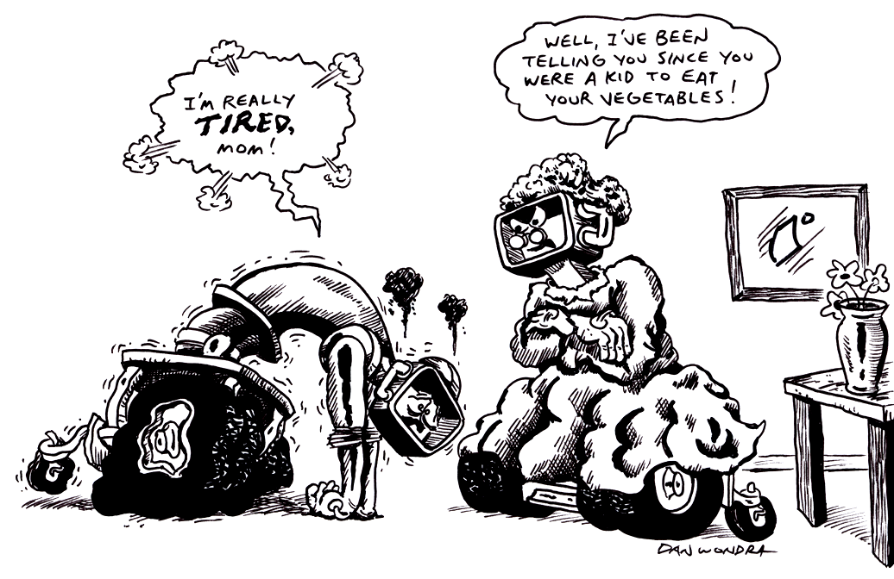
Lesson Title: Energy and Energy Conversions
Draft Date: January 2010
1st Author (Writer): Lisa Tingelhoff
Instructional Component Used: Energy Types and Energy Conversions
Grade Level: Middle Level

Content (what is taught):
- Energy is the ability to do work.
- There are many types of energy.
- Energy is converted from one form to another.

Context (how it is taught):
- Students will analyze every day situations and determine the types of energies involved in the situation.
- Students will manipulate energy types to show how energy is converted from one form to another.
Activity Description:
During this activity, students will learn different forms of energy. Students will analyze every day situations and determine what types of energy are involved in the situation. Students will then show energy conversions that happen in the situation. Students will use the CEENBoT as a manipulative to order energy conversions. Finally, students will analyze the CEENBoT and discuss the types of energy conversion that are present.

Standards:

Science Technology
SB3 TA3
SE2

Materials List:
Energy Conversions-A-Organizer, match, wind up toy, ball, turn off the lights, bag of popcorn, microwave, Types of Energy Cards, Energy Conversions Flow Chart, Energy Types and Conversion Assessment, CEENBoTs or other motorized vehicles
Asking Questions (Energy and Energy Conversions)

Summary:
A variety of events will be demonstrated to students. Students will be asked to analyze how energy is involved in each of the events. The discussion should lead to definition of energy, various types of energy and the idea of energy conversion.

Outline:
- A variety of events will be demonstrated to students. Students will analyze involvement of energy in each event.
- Students will be asked to define energy.
- Students will begin to identify energy conversions.

Activity:
The teacher will strike a match, wind up a toy, roll a ball, turn off the lights, and pop a bag of popcorn in the microwave. During these events, teacher will ask students to identify how energy is involved in each of these events. Students may be asked to record their answers on a graphic organizer or may be asked to share in a whole class discussion. After the demonstrations, students will be asked to define energy. They will also begin to describe energy conversions in simple situations. Students could end this lesson by viewing BrainPop: Energy and Forms of Energy.

Questions | Answers
Striking a match: How is energy involved? | It takes mechanical energy to strike the match.  The match burns because of stored chemical energy.  The match releases thermal energy as it burns.
Winding up a toy: How is energy involved? | It takes mechanical energy to wind the toy.  The toy moving uses kinetic energy.
Rolling a ball: How is energy involved? | It takes mechanical energy to roll the ball.  The ball rolling has kinetic energy.
Turning off the lights: How is energy involved? | The lights on uses electrical energy.  Flipping the switch requires mechanical energy.  The light on provides light energy.
Driving the CEENBoT: How is energy involved? | Mechanical energy is used to use the controller.  Chemical energy is converted to electrical energy with the battery.  The moving CEENBoT has kinetic energy.

Resources: BrainPop Video (http://www.brainpop.com): Energy and Forms of Energy

Attachment: S054_Energy_Transfer.doc-A-Organizer.doc

Exploring Concepts (Energy and Energy Conversions)

Summary:
Students will explore various types of energy and create cards to represent each form. The cards will be colored coded and labeled to visually represent different types of energy. The cards will be used to quickly map energy transfer in a variety of scenarios. CEENBoTs or other motorized vehicles could be used to conduct races in identifying and ordering energy conversions.

Outline:
- Students will learn different types of energy.
- Students will give examples of different types of energy.
- Students will model energy conversions using color-coded cards.
- Students will model energy conversions using CEENBoTs.

Activity:
During this activity, students will construct energy cards to represent different forms of energy. The cards will resemble Monopoly cards and will list the type of energy and examples for each form. The types of energy will be represented by a different color forms making it easy for teacher to observe student comprehension. Students will then have robot races to identify and order energy conversions.

Attachment: Types of Energy Cards: S054_Energy_Transfer-E-Energy_Cards.doc

Instructing Concepts (Energy and Energy Conversions)

Energy and Energy Transfer

Definition of Energy
Energy is defined as the capacity to do work that causes physical change within a closed system. In a closed system, energy cannot be created or destroyed only transformed into a different type.

Types
Some scientists state that there are only two types of energy potential and kinetic. Potential energy is stored energy. Kinetic energy is energy resulting from motion. Other scientists state that there many different types of energy like: mechanical, electrical, thermal, nuclear, wind, chemical, water, geothermal, wave, light, and sound. Each of these could fit into potential (stored) or kinetic (motion) categories.

Transfer/Conversion
Energy can be converted or transferred from one form to another. The Law of Conservation of Energy from physics says that the total energy in a close system is constant over time. A result of this law is that energy cannot be created or destroyed. It can only be changed from one state to another. Examples where this change in state occurs are:

- Hydroelectric dams: Dammed water (potential), moves through turbines and turns them (kinetic) which causes a generator to create electricity (electrical).
- Electric lamp: Electricity (electrical) makes a light bulb light up (heat and light)
- Microphone: Sound energy converted into electricity.
- Fossil Fuel power plant: Fossil fuels (potential) are burned (thermal) to heat water which in turn moves turbines (kinetic) to create electricity (electrical).
- Friction: Kinetic energy is turned into thermal energy.
- Solar cells: Light energy is turned into electricity (electrical)
This list is far from exhaustive, but should point out the many different ways that energy can be transformed.
Organizing Learning (Energy and Energy Conversions)

Summary:
Students will be given a scenario and a list of types of energy. They will complete a graphic organizer that helps them organize the energy conversions that take place in each scenario.

Outline:
- Students will be presented with several scenarios and a list of types of energy.
- Students will analyze each scenario and break it down in terms of energy conversion.
- Students will use a graphic organizer to demonstrate the flow of energy in each scenario.

Activity:
Students will be provided a variety of scenarios, a graphic organizer and a list of types of energy. Students will analyze the scenario, breaking it down in to energy conversions that take place. Using the list of types of energy they were provided, they will cut and glue a series of energy types that documents the energy conversion of each scenario on their graphic organizer. Students should be encouraged to give scenarios to allow for diversity in situations and extended practice.

Attachment: Energy Conversions Flow Chart:
S054_Energy_Transfer-O-Conversion_Flow_Chart.doc

Understanding Learning (Energy and Energy Conversions)

Summary:
In this activity, students will be given several scenarios for which to analyze energy conversions. They will respond to the given scenario with written responses.

Outline:
- Students will demonstrate understanding of energy conversions by verbally responding to questioning by the teacher throughout the lesson.
- Students will demonstrate understanding of energy conversions by constructing written responses to two essay questions.

Activity:
During this activity, students will complete two essay questions pertaining to energy conversions.

Formative Assessment
As students are engaged in the lesson ask these or similar questions:
- What type of energy is used (here)?
- What conversion do you note (here)?

Summative Assessment
Students can answer the following writing prompt:
1) Cite a situation where energy changes type at least 3 times. In doing so be sure to define what each different type of energy is present and how it is different than the previous type.
2) Describe the energy conversion process when: you turn the key on your car to start it, a corn plant receives sunlight and is then turned into cornflakes, or something relating to the students background.

Students can complete the attached Energy Types and Conversion Assessment. See attached file: S054_Energy_Transfer-U-Assessment.doc

Attachment: Energy Types and Conversion Assessment:
S054_Energy_Transfer-U-Assessment.doc

