Project SHINE / SPIRIT2.0 Lesson:
This Teacher was mentored by:


www.loup.com

In partnership with Project SHINE grant funded through the

National Science Foundation

“Who Turned on the Lights?”
==========================Lesson Header ==========================
Lesson Title: “Who Turned on the Lights?”
Draft Date: June 11, 2010
1st Author (Writer): Jeff Erixon
Instructional Component Used: Energy
Grade Level: 7th grade

Content (what is taught):
- Power
- Energy Transfer
- Energy Types
- Energy Production
- Data Analysis

Context (how it is taught):
- Review step-by-step process of energy moving from one object to another object
- Review energy types
- Energy is produced by converting mechanical (water) energy to electrical energy
Activity Description:
In this lesson, students will build a water-powered generator and then modify the design to test how mechanical energy input affects the electrical power output.

Standards:

Science: SB2, SB3 Technology: TA3, TC4

Engineering: EA1, EA2, EB1 Math: ME1, ME2

Materials List:
- 2 – 5 gallon buckets
- One 10-foot section of rain gutter
- 1 Generator
- 1 Multi-meter
- Water
- Gate material
- Water paddle materials
Asking Questions: (Who Turned on the Lights?)

Summary: Students will discuss different types of energy and how energy is transferred from one object to another.

Outline:
- Energy Transfer
- Energy Types
- Energy Production

Activity: The teacher will facilitate the class filling out a KWL chart where students will list what they Know about energy production and what they Want to learn about energy production.

Questions | Answers
How is energy produced? | Generally it requires taking one form of energy and transforming it into a useable form
How is one type of energy transferred into another type of energy? | Energy is transferred either from heat transfer or by doing work.
What are the types of energy? | Potential - chemical, mechanical, nuclear, gravitational and electrical  Kinetic – motion, thermal, sound and radiant
What is power? | Power is the amount of work done over time.

Resources: KWL Chart

K | W | L
What I Know | What I Want to Learn | What Did I Learn?

Exploring Concepts: (Who Turned on the Lights?)

Summary: Students will build a hydro-generator and test the factors the effect energy production.

Outline:
- Students will build generator
- Students will test generator using a multi-meter

Activity: Students will build a hydro-generator using a rain gutter as a water canal, a 5-gallon bucket as a reserve reservoir, and another 5-gallon bucket to collect the runoff water. Students will then incorporate a device to transfer the mechanical energy from the water into electricity. A multi-meter will be used to provide the amount of power (electricity) produced.

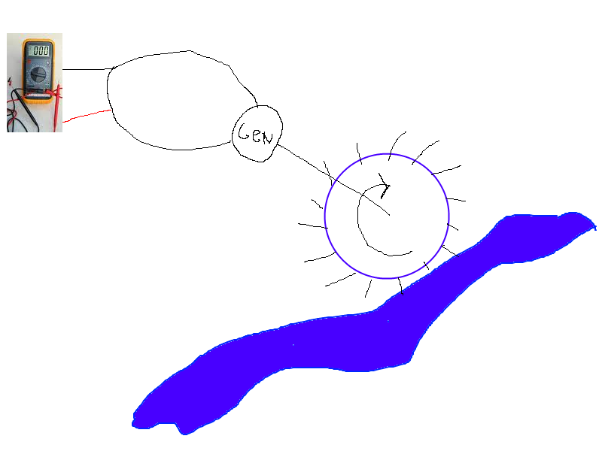
Instructing Concepts: (Who Turned on the Lights?)

Power

Putting “Power” in Recognizable terms: Power is the work done divided by the time to do that work. Since work is the amount of energy used this means is that power is the rate of change of energy or in other terms it is the rate at which energy is used.

Putting “Power” in Conceptual terms: Power is conceptually talking about the amount of work done over time. It is apparent that power present in a situation is dependant on the amount of energy expended (work) and the time that it takes to do that work. What this means is that if 100 Joules (J) of work are done in 10 minutes and 100 Joules of work are done in 1 minute the second case has a lot more power. If fact it has a factor 10 times more power.

Putting “Power” in Mathematical terms: Power can be mathematically represented by the formula P = W / t where P is the Power, W is the work done and t is time to do the work. The SI unit of work is the Watt (W), which means 1Joule per second. This means that power is directly proportional to the work done and inversely proportional to the time to do the work.

Remembering that work is force times displacement can derive a corollary for the power equation. Substituting this into the power equation we get P = F*d/t. Now since velocity is displacement divided by time, we can substitute one more time and get the equation Power = Force * Velocity (P = F * v)

Putting “Power” in Process terms: Thus, power is about doing work over time. From the mathematical analysis of this concept it is obvious that a bigger engine has more power because it can do more work in the same amount of time. It is also worth noting that since power = force * velocity something that is both strong (large force) and fast (high velocity) will involve a lot of power.

Putting “Power” in Applicable terms: Power applies in any situation where work is being done. Power is present in mechanical, electrical, pneumatic, and fluidic systems. Basically anywhere work is accomplished you can talk about the concept of power.

Related “I” pieces: Work, Force, Hooke’s Law
Organizing Learning: (Who Turned on the Lights?)

Summary: Students will modify their hydro-generator by changing the rate of incline of the water canal, thus changing the speed of the water.

Outline:
- Students will modify the speed of the water.
- Students will collect data

Activity: Students will increase the elevation of the intake side of their water canal. This will be done a minimum of three times. Then students will compare the power generation using the multi-meter readings.

Resources: Data Chart

Intake Height | Trial 1  Voltage | Trial 2  Voltage | Trial 3  Voltage | Total | Average

Understanding Learning: (Who Turned on the Lights?)

Summary: Students will write about the affect of changing something related to a hydro-electric dam and how that change affects the power output.

Outline:
- Formative assessment of power.
- Summative assessment of power.

Activity:
Formative Assessment
As students are engaged in the lesson ask these or similar questions:
- As the canal intake side is raised, how does that effect water flow?
- If the water flow is increased or decreased, how will that affect the generator?
- If the water flow is varied, how will that affect the generator? Energy production?

Summative Assessment
- Using your data, write a paper describing the effectiveness of a hydro-generator to replace other forms of electricity.
- List 5 variables that could affect the amount of power a hydro-generator could produce.
- Pick one of your variables and test it. Then write a paper comparing data to describe the benefit or loss of the modification.

Possible Extensions: Additional variables that could be tested include:
  - Gate height
  - Angle of Canal
  - Amount of water
  - Fins: size, number, angle, material
  - Gears

