Project SHINE / SPIRIT2.0 Lesson:
A “Salting” Solution
==========================Lesson Header ==========================
Lesson Title: A “Salting” Solution
Draft Date: 6-10-10
1st Author (Writer): Elissa Gilger
2nd Author (Editor/Resource Finder):
BD Medical Company
Instructional Component Used: Solubility
Grade Level: 9th
This Teacher was mentored by:


www.bd.com

In partnership with Project SHINE grant funded through the

National Science Foundation

Content (what is taught):
- Define solubility and solution
- Identify the parts to a solution
- Determine the factors that affect solubility

Context (how it is taught):
- Create a solution using salt and water
- Identify the solute and solvent in the solution
- Change factors related to solubility determining how each one affects the dissolving process
Activity Description:
In this lesson, students will investigate three factors affecting solubility by creating salt and water solutions. Different grains of salt, stirring, and heating will be used to speed up the rate of the dissolving process.

Standards:

Science: SB1 Technology: TD3

Engineering: EB1, EB2 Math: MD1, MD3

Materials List:

Exploring Activity Saline Solubility Lab
- Hot plate
- Small grained salt
(regular table salt without iodine)
- Large grained salt (rock salt)
- Two 250 mL beaker
- 800 mL distilled water
- Glass stirring rod, balance
- Thermometer
- Stop watch
- Protective safety goggles
- 600 mL beaker filled with tap water
to the 500 mL mark
- 2 clear plastic cups
- 2 grams small grained salt
(regular salt bought at the store)
- 2 grams large grained rock salt
(used for deicing)
- Glass stirring rod (similar tool)
- 50 mL of ice with pan
- Towel or paper towel
Asking Questions: A “Salting” Solution

Summary: Students will define the term “solution” and identify the parts to a solution.

Outline:
- Explain the production of “normal saline solution”
- Provide pictures or a sample of the product
- Provide uses of the product

Activity: The teacher will explain the production of a “normal saline solution” by a medical manufacturer, which is simply a mixture of salt and water.

Questions | Answers
What is a solution? | A solution is a homogeneous mixture or one throughout which two or more substances are uniformly dispersed.
What are the parts to a solution? | The solute or the substance that dissolves or breaks a part in the mixture. The solvent is the substance that dissolves the solute in the mixture.
How is the solute and solvent determined in the solution? | Solute is the substance in the mixture with the smaller amount. Solvent is the substance in the mixture with the larger amount.  In a “normal saline solution” (9 grams of salt per 1000 mL of water) the salt is the solute and the water is the solvent.
More in Depth  What four key characteristics distinguish a solution mixture from other types of mixtures? | 1. Appears even or uniform under a microscope.  2. Does not separate into distinct layers over time.  3. Does not filter apart.  4. Light can pass through (without being scattered)

Attachments:
More In-Depth ASKING Component: S064-SHINE-A_Salting_Solution-A-Extended.doc
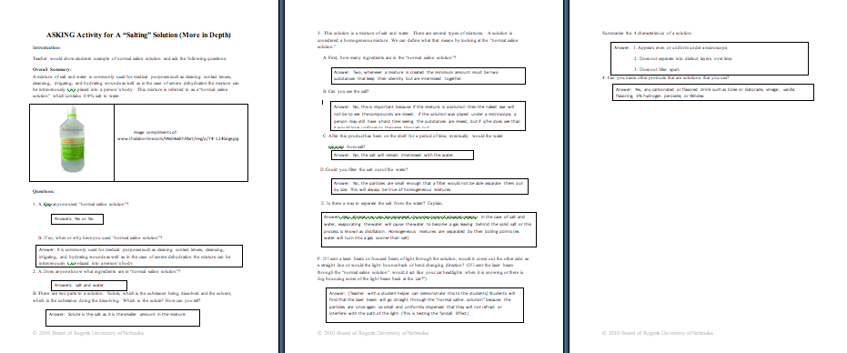

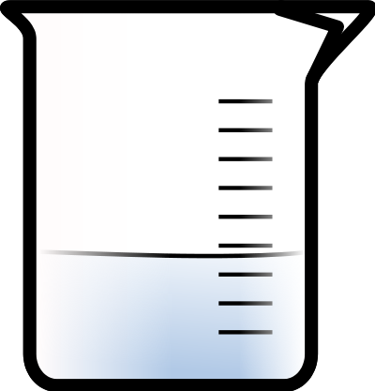

Exploring Concepts: A “Salting” Solution

Summary: Students will investigate the factors affecting solubility or the rate of the dissolving process.

Outline:
- Explain how the manufacture keeps up with supply and demand as well as makes more of a profit by decreasing the time required to produce the “normal saline solution”.
- Investigate the factors that speed up the rate of the dissolving process.

Activity: The students will be provided with materials to create a salt solution. Each group will use the supplies provided to manipulate solutions created to determine what changes or factors will speed up the rate of the dissolving process. The lab exercise can be found in the attached file: S064-SHINE-A_Salting_Solution-E-lab.doc

Attachments:
See attached file: S064-SHINE-A_Salting_Solution-E-lab.doc
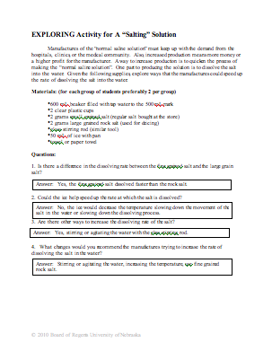

Instructing Concepts: A “Salting” Solution

Solubility

Solubility is the ability of one substance to dissolve (intermix) into another substance. When a substance is dissolved into another substance a mixture is created.

Type of Mixture: When salt is added to water the mixture created is a known as a solution. A solution is a homogeneous mixture or one throughout which two or more substances are uniformly dispersed. A solution type of mixture can be distinguished from other types of mixtures by four consistent characteristics:
1. Appears even or uniform under a microscope.
2. Does not separate into distinct layers over time.
3. Does not filter apart.
4. Light can pass through (without being scattered) also known as the Tyndall Effect

Parts to a Solution: There are two parts to a solution. First there is the solute or the substance that dissolves and is determined as being the smaller amount. Secondly there is the solvent or the substance that dissolves the solute and is determined as being the larger amount.

Dissolving Process: The dissolving process occurs when collisions happen between the solute and solvent forcing them to intermix. To increase the rate of the dissolving process (or make it faster), one must increase the collisions occurring between the solute and solvent. This can be done in three ways:

1. Stirring or shaking allows the particles to spread out (diffuse) more in the solution
forcing more contact or collisions to occur between the solute and solvent

2. Increasing the temperature allows particles to move faster (more kinetic energy), which
creates more contact or collisions between the solute and solvent

3. Larger surface area (for a solid solute) means smaller pieces of a solid will dissolve
faster than larger pieces, smaller pieces increase the amount of surface area which increases the amount of particles coming in contact or colliding with the solvent
Organizing Learning: A “Salting” Solution

Summary: Students will answer questions related to solubility topics learned. They will investigate three factors affecting solubility by creating salt and water solutions. Different grains of salt, stirring, and heating will be used to speed up the rate of the dissolving process.

Outline:

Worksheet
- Students will take notes over the solubility related content in a designated notebook
- Students will use the notes taken to answer the questions on the worksheet
Lab
- Student pairs will gather supplies for the lab
- Collect data about the time differences between stirring and heating different grains sizes of salt
- Record their results in a data table
- Analyze the data to answer questions

Activity: In this lesson, the students will take notes over the solubility related content. The next day, students will measure out exact amounts of different grains sizes of salt. The salt will be added to distilled water to dissolve. They will stir each grain size at eye level recording the amount of time each takes to dissolve. Next, the process will begin again except students will heat each solution using a hot plate and record the amount of time each takes to dissolve. For the laboratory procedure and questions see the attached file.

Attachments:
Lab Procedure and Questions: S064-SHINE-A_Salting_Solution-O-lab_exercise.doc
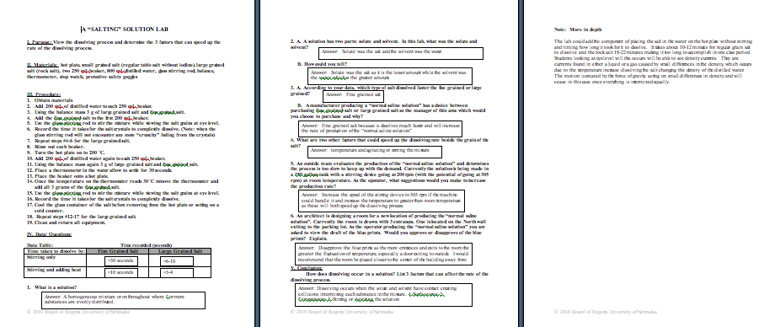

Understanding Learning: A “Salting” Solution

Summary: Students will answer questions related to solubility topics learned. They will investigate three factors affecting solubility by creating salt and water solutions. Different grains of salt, stirring, and heating will be used to speed up the rate of the dissolving process.

Outline:
- Formative assessment of solubility
- Summative assessment of solubility

Activity:
Formative Assessment
As students are engaged in the lesson ask these or similar questions:
- Can students distinguish a solution mixture from other types of mixtures?
- Can students determine the solute of a mixture?
- Were students able to identify the factors affecting solubility and apply them to real life situations?

Summative Assessment
Students can answer the following writing prompt:
In a paragraph, define solubility, what makes up a solution, and list examples of solutions that are utilized in everyday life.

Students will complete a worksheet reviewing the concepts related to solubility.
- Define solubility and solution.
- Determine if a substance is soluble or a solution.
- Distinguish between the solute and solvent in a solution.
- Identify factors affecting solubility and apply them to real life situations.

Attachments:
Solubility Review: S064-SHINE-A_Salting_Solution-U-assess.doc
