Project SHINE / SPIRIT2.0 Lesson:
“Blood Tonic”
==========================Lesson Header ==========================
Lesson Title: Blood Tonic
This Teacher was mentored by:


www.bd.com

In partnership with Project SHINE grant funded through the

National Science Foundation

Draft Date: 6-15-2010
1st Author (Writer): Elissa Gilger
2nd Author (Editor/Resource Finder): BD Medical
Instructional Component Used: Osmosis, Tonicity
Grade Level: 11-12th

Content (what is taught):
- Define plasma membrane, selectively permeable, passive transport, osmosis, and tonicity
- View osmosis and tonicity
- Identify the type solutions: hypertonic, hypotonic, and isotonic
- Explain the affects of tonicity on red blood cells in the human body

Context (how it is taught):
- Rehydrate raisins to explain the principles of osmosis and tonicity
- Place fresh potato cuttings into different concentrations of saline solutions and measure the size changes to view the affects of tonicity on potato cells
- Compare the results of the lab to the affects of saline solution on red blood cells in the human body
Activity Description:
In this lesson, students will investigate the cause of dehydration and rehydration of raisins due to the movement of water through osmosis. Later, students in pairs will perform a lab measuring the results of fresh potato cuttings in different concentrations of saline solutions. Then, the students will use the results from the lab to explain the affects of concentration of saline solutions on human red blood cells.

Standards:

Science: SC1, SF1 Technology: TD3

Engineering: EA1 Math: ME1

Materials List:
- Plastic wrap
- Salt (NaCl)
- Plastic spoon
- Distilled water
- Paper towel
- Raisins
- Water in clear container

- Sliced fresh potato
- Cupcake holder (for salt)
- Scalpel or razor
- Balance
- Four 50 mL beakers
- Pencil or marker/masking tape
- 50 mL graduated cylinder
Asking Questions: (Blood Tonic)

Summary: Students will distinguish between dehydration and rehydration and determine the cause and process of osmosis.

Outline:
- Discuss the differences between dehydration and rehydration.
- Discuss the flow of water in and out of cells relating to the process of osmosis.

Activity: The teacher will show pictures of dehydrated food or ask students about being dehydrated. Ask these questions:

Questions | Answers
Explain the difference between dehydration and rehydration? | Answer: Dehydration is water being removed and rehydration is water being added.
In an organism, where does the water come from when an organism becomes dehydrated or where does the water go when an organism becomes rehydrated? | Answer: Water enters or exits the cells through the plasma or cell membrane.
What cell process moves water from an area of high concentration to low concentration? | Answer: Osmosis occurs as water is allowed to enter or exit the plasma or cell membrane.
More in Depth  So, why is it if humans are extremely dehydrated the hospital will give them an iv (intravenous) bag filled with 0.9% saline solution rather than pure water to rehydrate them? | Answer: A person’s red blood cells contain a 0.9% saline solution on the inside. A 0% saline solution or pure water would create a higher concentration of water on the outside of the cells than inside causing the water to flow inside the cells potentially bursting them.

Exploring Concepts: (Blood Tonic)

Summary: Students will discover the process of osmosis by viewing a dehydrated grape (raisin) and rehydrated raisin once placed in water.

Outline:
- Explain how as raisin is produced
- View a raisin being rehydrated
- Discuss the process of osmosis through a cell membrane

Activity:
The teacher will provide students with raisins and water. The student pairs will place the raisins in the water. Then, the students will answer questions discovering the process and principles of osmosis.

Attachments:
S065-SHINE-Blood_Tonic-E-Activity.doc
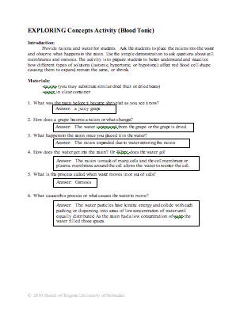

Instructing Concepts: (Blood Tonic)

Osmosis/Tonicity

Plasma membrane: All cells have a protective covering known as the plasma membrane or cell membrane. The plasma membrane has more than one role, but an important role is that it controls what enters or exits the cell.

Semi-permeable or Selectively permeable: Semi-permeable or selectively permeable is a term used to describe the plasma membrane’s control to allow some substances into or out of the cell, but not others.

Cell transport: Cell transport is the process through which molecules move in or out of the cell.

Types of Cell Transport: There are two main types of cell transport; passive transport and active transport each with different forms. For this lesson, we will only focus on passive transport of water.

Passive Transport
- molecules move from an area of high concentration to an area of low concentration until equal
- this is caused by particles containing kinetic energy causing them to collide pushing each apart until they have dispersed equally
Forms of Passive Transport
- Osmosis: movement of water from high to low concentration until equal.
- Diffusion: movement of particles (solutes) dissolved in water from high to low concentration until equal.

Solution Types affecting Osmosis in Cells: Solutions are homogeneous mixtures or one throughout which two or more substances are uniformly dispersed. As the cell contains water inside and outside with dissolved particles it is surrounded by solutions. The cell must balance the amount of water inside and outside the cell to keep it equal as water moves using passive transport. Different types of solutions can create different types of tonicity.

Tonicity: Tonicity measures osmotic pressure differences or the potential for water to move across the plasma membrane. The osmotic pressure is created from concentration differences of solutes unable to pass through the plasma membrane within cells forcing the water to either flow in or out of the cell to create a balance. An example would be if the inside of cell contained a 6 % glucose solution, but the outside had a 2% glucose solution the water would move to the outside creating a balanced 4% glucose solution in and out of the cell. However as the water moves this can affect the shape or size of the cell causing the cell to expand or shrink.
- Isotonic Solution (isos means “equal”)
  - A type of solution in which the dissolved solutes in the solution are the same or equal.
  - There is no movement of water in or out of the cell allowing the cell to keep its shape.
- Hypotonic Solution (hypo means “under”)
  - A type of solution in which the dissolved solutes is lower outside the cell than inside the cell (meaning there is more water on the outside of the cell).
  - Therefore there is movement of water from outside to inside the cell creating more pressure forcing the cell’s membrane to expand and possibly burst.
- Hypertonic Solution (hyper means “over”)
  - A type of solution in which the dissolved solutes is higher outside the cell than inside the cell (meaning there is more water on the inside of the cell).
  - Therefore there is movement of water from inside to outside the cell creating less pressure forcing the cell’s membrane to contract or shrivel.
Organizing Learning: (Blood Tonic)

Summary: Students will investigate, take notes, and apply the principles of osmosis and tonicity in a lab.

Outline:
- Students will take notes over the osmosis and tonicity.
- Student pairs will collect data comparing the affects of different concentrations of saline solutions on fresh potato cuttings or potato cells.)
- Analyze their results to explain what affects similar concentrations of saline solutions would have on human red blood cells.

Activity: In this lesson, student pairs will measure and produce four different concentrations of saline solutions. One lab criteria is that the students must be provided distilled water to accurately make the solutions (NOTE: one solution is 0% or only distilled water). Students will measure the initial mass of freshly cut potato sections and then place them into each solution, cover the solutions, and measure the final mass 24 hours later. From the results, students will be asked to identify which solutions were hypertonic, hypotonic, and isotonic and compare the affects to the potato cells to those of human red blood cells.

Attachments:
Lab Instructions: S065-SHINE-Blood_Tonic-O-Lab.doc
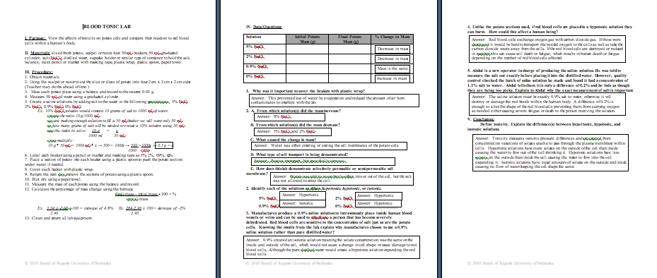

Understanding Learning: (Blood Tonic)

Summary: Students will answer questions related to osmosis and tonicity after analyzing the data collected during the lab.

Outline:
- Formative assessment of osmosis and tonicity
- Summative assessment of osmosis and tonicity

Activity:
Formative Assessment
As students are engaged in the lesson ask these or similar questions:
- Can the students identify the location of the high and low concentration in relationship to the cell?
- Were the students able to determine the direction of water flow based on concentration differences?
- Can students determine which substances will move through the cell membrane via passive transport and which cannot?

Summative Assessment
Students will be asked to complete questions related to osmosis/tonicity.
- Define the difference between hypertonic, hypotonic, and isotonic solutions and how you can tell the difference.
- Compare the results of the potato cells to human red blood cells that you worked with in the lab.
- Why do manufactures choose to make 0.9% “normal saline solution” to rehydrate humans?
- Explain to a worker in manufacturing the importance measuring the exact amount of salt to produce the “normal saline solution” at 0.9%.

