Project SHINE / SPIRIT2.0 Lesson:
“Ranking Salinity”
==========================Lesson Header ==========================
Lesson Title: Ranking Salinity
This Teacher was mentored by:


www.bd.com

In partnership with Project SHINE grant funded through the

National Science Foundation

Draft Date: 6-19-2010
1st Author (Writer): Elissa Gilger
2nd Author (Editor/Resource Finder): BD Medical
Instructional Component Used: Titration
Grade Level: 11-12th Chemistry

Content (what is taught):
- Define titration
- Use titration to determine the concentration of saline solutions

Context (how it is taught):
- Discover the definition of titration and its usage
- Apply the principles of titration to determine the concentrations of saline solutions
Activity Description:
In this lesson, student pairs will investigate the definition of titration by combining food coloring into specific drop ratios. Then, student pairs will perform a lab using a defined concentration of silver nitrate to react with an unknown concentration of saline solution to determine the percentage of salt to water in each solution.

Standards:

Science: SB1 Technology: TD3

Engineering: EA1 Math: MD2, ME1

Materials List:
Lab Activity
- 5 samples of saline solution A-E (NaCl + H₂O)
- 1 M Silver Nitrate
- Distilled water (rinse)
- Dichlorofluorescein
- 95% ethanol
- Distilled water (rinse)
- 5 test tubes, Test tube rack, 5 rubber stoppers
- Graduated pipettes
- 250 mL Erlenmeyer flask
- Balance
- Burette clamp, Burette, Ring stand
- Splash Protective Safety Goggles
- Pencil
Exploring Activity
- 4 clear plastic cups or beakers,
- 50 mL graduated cylinder
- Tap water source
- Food coloring droppers
(red, green, blue, and yellow)

Asking Questions: (Ranking Salinity)

Summary: Students will determine the concentration of “normal saline solution” and the importance of manufacturers’ quality checking this concentration using titration.

Outline:
- Show the students picture of sample of “normal saline solution”
- Discuss the concentration and importance keeping the solution at the specified concentration
- Discuss the use of titration to quality check the “normal saline solution”

Activity: The teacher will show a sample or picture of “normal saline solution”. Ask students the following questions:

Questions | Answers
Does anyone know the concentration of “normal saline solution”? | Answer: 0.9% salt to water
Why is it important that the concentration remains the same? | Answer: “Normal saline solution” is used to clean contacts and wounds, but also intravenously (iv) to rehydrate a person. The solution must 0.9% salt to water otherwise it will cause damage to cells in the body such as skin cells, eye cells, and blood cells. If manufactures make a solution too concentrated they will be liable for lawsuits.
How does a company manufacturing “normal saline solution” check to make sure it produced a solution with 0.9% salt to water? | Answer: Manufacturer quality checks each batch of “normal saline solution” using a process known as titration.
Exploring Concepts: (Ranking Salinity)

Summary: Students will investigate the importance of adding the correct ratio of ingredients to create a product as well as discover the process of titration.

Outline:
- Student pairs will add drops of food coloring to discover the correct ratio and formula for making a specific color
- Student pairs will create three concentrations using only two colors
- Teacher will provide students with a sample of only one color with an unknown concentration
- Student pairs will determine the unknown concentration by adding a second color and comparing the sample to previously made concentrations

Activity: In this lesson, students will investigate correct ingredient ratios by creating a specific color assigned by the teacher. Then, students will explain the formula and discuss the significance of concentrations in a solution. Next, students will create three concentrations using only two colors. Students will be asked to determine an unknown concentration. After group discussion, they should add a second color and compare the concentration color to previously made concentrations. Finally, students will be asked to define titration based on their experience in the activity.
Example: One container with 1 yellow drop and 1 blue drop; next 1 yellow drop and 2 blue drops; and finally 1 yellow drop and 3 blue drops. Teacher will give the students an unknown sample containing 3 blue drops. The students would add 1 drop yellow drop and compare to the previously made concentrations.
For a detailed description of the lab activity see file: S066-SHINE-Ranking_Salinity-E-Activity.doc

Attachments:
S066-SHINE-Ranking_Salinity-E-Activity.doc
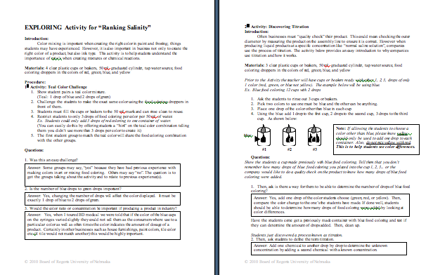

Instructing Concepts: (Ranking Salinity)

Titration

Titration Definition: Titration comes from the Latin word titulus meaning “inscription” or “title”. The French developed the word titre, from this origin, meaning “rank”. Titration is now a common laboratory technique used to determine the “rank” or concentration of an unknown solution.

Titration Technique: Titration is performed only with liquid solutions. The volume measurements of these solutions are critical. A controlled addition or volume of a solution with a known concentration (called the titrant or titrator) is required to react completely with a measured amount of a solution with an unknown concentration (called the analyte or titrand). Addition of the titrator continues until an endpoint is reached.

Determining the Endpoint: How the endpoint is determined depends on the types of solutions involved. If strong acid and strong base solutions are involved the endpoint is determined when the pH reach 7 or neutral. It may also be revealed by an indicator which changes color or the formation of a precipitate once the chemical reaction is completed.
The endpoint can be determined by looking for:
1. pH change,
2. Color change caused by a pH indicator or redox indicator added to the titrand,
3. Precipitate formed,
or by changes in conductivity, spectrometry, or thermodynamics of the solution.

Burette: Tall, thin, cylindrical instruments used in titrations. It is tapered to a miniature funnel at one end, which is designed to slowly release a liquid solution drop by drop as well as accurately measure the amount of volume released.
When using a burette follow these setup instructions:  - Rinse the burette 3 times with the solution intended to be used in the titration. (Ensures contaminates are removed)  - Fill the burette to a point above the 0 mL calibration point.  - Release some of the solution to remove any air bubbles.  - Record the volume to the nearest 0.01 mL. | 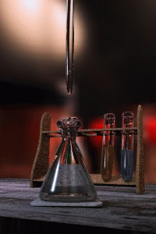  Image Source: Wikipedia.com
Organizing Learning: (Ranking Salinity)

Summary: Students will take notes and answer questions related to titration in their textbooks. Next, students will perform a titration lab collecting data about 5 different saline solutions and calculate the concentration of each.

Outline:
- Student pairs will record the data collected in a data table
- Use the data collected to calculate the concentration of each saline solution
- Analyze the results to determine if the saline solutions will meet the expectation of a quality control check at a manufacturer

Activity: In this lesson, students determine the concentration of 5 different saline solutions by using the process of titration. They will add a known concentration of silver nitrate into each solution and record the volumetric amount added to each. Next, they will calculate the percentage of salt to water in each using the recorded volumetric amount added as well as the mass of each saline solution. For a detailed description of the lab and questions see attached file:
S066-SHINE-Ranking_Salinity-O-lab.doc

Attachments:
S066-SHINE-Ranking_Salinity-O-lab.doc
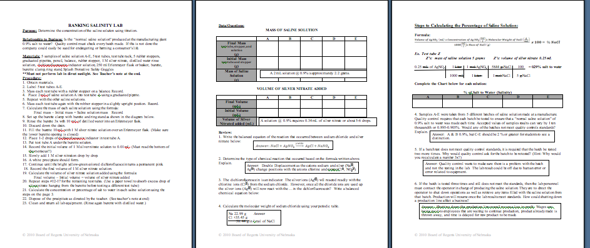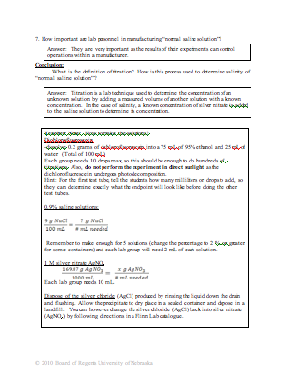

Understanding Learning: (Ranking Salinity)

Summary: Students will answer questions defining titration, analyzing data collected, calculating concentrations of unknown solutions, as well as evaluating how titration can be used in a quality check situation at a manufacturer.

Outline:
- Formative assessment of titration
- Summative assessment of titration

Activity:
Formative Assessment
As students are engaged in the lesson ask these or similar questions:
- Were students able to use the terms concentration, percentage, and molarity correctly when discussing solutions?
- Can students explain the process of titration?

Summative Assessment
Students can answer the following writing prompt:
- Explain the process of titration and how it is used.
- Evaluate the repercussions for a company if a batch of “normal saline solution” does not meet quality control standards.

Students can answer the following quiz questions:
  - In a titration, 20 mL of 2 M H₂SO₄ is added to a 12 mL sample of Mg(OH)₂ solution of unknown concentration until the equivalence point is reached. What is the molarity of the base solution?
  - Calculate the percentage of sodium hydroxide in an aqueous solution knowing that 2 grams of sodium hydroxide reacted with 0.5 mL of hydrochloric acid.

Performance Assessment
- Students will measure the mass and volume of solutions.
- Calculate the percentage of salt to water in each solution.
- Analyze the data to determine if the saline solution would meet a quality check of a manufacturer for “normal saline solution”.

