Project SHINE / SPIRIT2.0 Lesson:
“Is There Life After 121?”
==========================Lesson Header ==========================
Lesson Title: Is There Life Before 121?
This Teacher was mentored by:

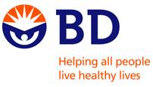
www.bd.com

In partnership with Project SHINE grant funded through the

National Science Foundation

Draft Date: 6-23-2010
1st Author (Writer): Elissa Gilger
2nd Author (Editor/Resource Finder): BD Medical
Instructional Component Used: microbes (bacteria, mold, or yeast), sterilization, and bioburden testing
Grade Level: Middle School Life Science or High School Biology

Content (what is taught):
- Define bioburden testing and sterilization
- Microbial growth conditions

Context (how it is taught):
- Discover the microbial growth conditions by investigating the theoretical growth of bacteria on a student’s desk
- Discuss and take notes over bioburden testing and sterilization
- Perform a bioburden test on a product prior to and after sterilization
Activity Description:
In this lesson, students will investigate microbial growth conditions by determining what environment would increase or decrease the growth of bacteria on their desk. Students will discuss the definitions, usage, and methods of sterilization and bioburden testing. Then, student pairs will perform a lab simulating a bioburden test on a product before and after sterilization to determine if “there is life after 121˚C” in an autoclave.

Standards:

Science: SC2, SC4 Technology: TC4, TD3

Engineering: EB1 Math: ME2

Materials List:
Lab Activity
- Two glass petri dishes filled with 50 mL of Tryticase Soy Broth with tops
- Scalpel blade (if middle school, change to decorative gem)
- Autoclave (if middle school change to alcohol wipes)
- Petri-seal tape (similar sealant)
- Incubator
- Gloves, Masking tape, Marker
Exploring Activity
- Spray bottle with water
- Sugar
- Towel
- Metric ruler
- Student desk
- Calculator
- Container with 300 dried beans
Asking Questions: (Is There Life After 121?)

Summary: Students will determine the definition for bioburden and sterilization.

Outline:
- Show students a scalpel blade sealed in an air tight package
- Ask leading questions to determine the definitions of bioburden and sterilization as well as their importance

Activity: The teacher will show students a scalpel blade sealed in an airtight package. Ask the students the following questions:

Questions | Answers
Why is the scalpel blade in a sealed container? | To prevent contamination from microbes like bacteria, mold, or yeast. If contaminated a person or organism could become sick if the blade was used on them during surgery.
How did the company kill the microbes or bacteria before placing the blade in a sealed container? | The company sterilized the blade possible through an autoclave (boiling water), flaming (heating with a flame), or radiation (x-ray, UV rays, or gamma rays).
How does a company ensure that their sterilization process is working? | Perform a bioburden test. Basically, take a sample of product off the assembly line and test in a lab for microbial growth.
More in Depth:  In a company, where do the bacteria or microbes come from that could contaminate the blade? | From the air, dust particles, but primarily from the employees working on the assembly line.
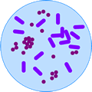
Exploring Concepts: (Is There Life After 121?)

Summary: Students will investigate factors increasing the rate of microbial growth.

Outline:
- Students will discuss factors promoting microbial reproduction on a student desktop
- Students will calculate microbial coverage of a student desktop surface

Activity: In this lesson, students will investigate the amount of bacteria found on a student desk top. They will begin by discussing what factors promote microbial growth or reproduction. Student pairs will calculate the theoretical amount of bacteria on the top of the student desk using the surface area and the estimated amount of bacteria found in 1 cm². Finally, students will discuss disinfectant methods as well as sources of microbe contamination. For a detailed description of the activity that explores the amount of bacteria on a desk see attached file: S067-SHINE-Life_After_121-E-Activity.doc

Attachments:
S067-SHINE-Life_After_121-E-Activity.doc
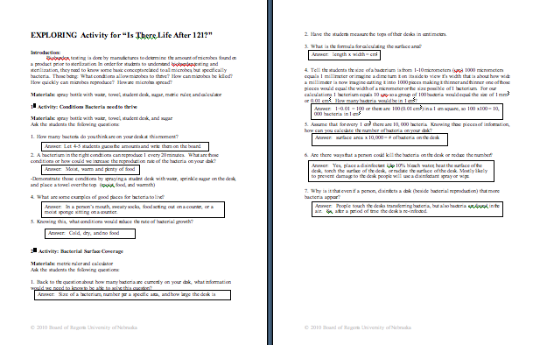

Instructing Concepts: (Is There Life After 121?)

Conditions Promoting Microbial Growth: Microbial growth refers to how fast yeast or bacteria can reproduce making another yeast or bacterium. Most microbes reproduce faster in environments, which are warm, moist, and have plenty of food.

Bioburden: Bioburden is microbial testing done on a product before it is sterilized. Bioburden testing ensures that a product does not exceed the amount of microbial standards set by the FDA (Food & Drug Administration) or USP (United States Pharmacopeia).

Methods of Performing Bioburden: Bioburden testing can be performed in many ways. The type of method used is determined by the type of microorganism manufacturers are seeking to reveal as well as the type of product being produced (example: raw meat vs. plastic syringes).
Examples of some methods:
1. Immerse product in media: check for growth after incubation for several days
2. Swab product and place swab on media: check for growth after incubation for several days
3. Rinse product and filter: check filter for colonies

Sterilization: A process used to destroy living organisms like bacteria, mold, or yeast on an object.

Methods of Sterilization: Similarly to bioburden testing the method will vary depending on the type of microorganism sought to be destroyed as well as the type of product.
1. Heat sterilization: -uses heat to kill the microorganisms
- Some examples are boiling in water or flaming which involves heating the metal item in a flame
2. Chemical sterilization: -uses chemicals to destroy the microorganisms
- Some examples are alcohol, hydrogen peroxide, and bleach
3. Radiation sterilization: -uses high-energy waves or particles to destroy microorganisms
- Some examples are gamma rays, x-rays, UV rays, or electron beams
Organizing Learning: (Is There Life After 121?)

Summary: Students will view the microbial growth prior to sterilization and after sterilization in a bioburden test lab.

Outline:
- Determine the definitions of bioburden testing and sterilization
- Perform a bioburden test on a product before and after sterilization
- Analyze the data collected by the class to determine if the bioburden test meets product safety standards.

Activity: In this lesson, students will determine the definitions of bioburden and sterilization through class discussion and notes. Then, student pairs will be given two containers of media to grow microbes. They will place an exposed or used scalpel blade into one container of media labeled “non-sterile” and place an autoclaved scalpel blade into another container of media labeled “sterile”. After incubation of 2-5 days, student pairs will look for the turbidity of media and particulates to indicate growth of microbes. The class will record the results from each group on a chart to calculate the total or average growth. Then, students will analyze their data to determine if the bioburden test meets product safety standards for the pre-sterile and sterile scalpel blades. For a detailed explanation of the lab and questions see attached file: S067-SHINE-Life_After_121-O-lab.doc

Attachments:
S067-SHINE-Life_After_121-O-lab.doc
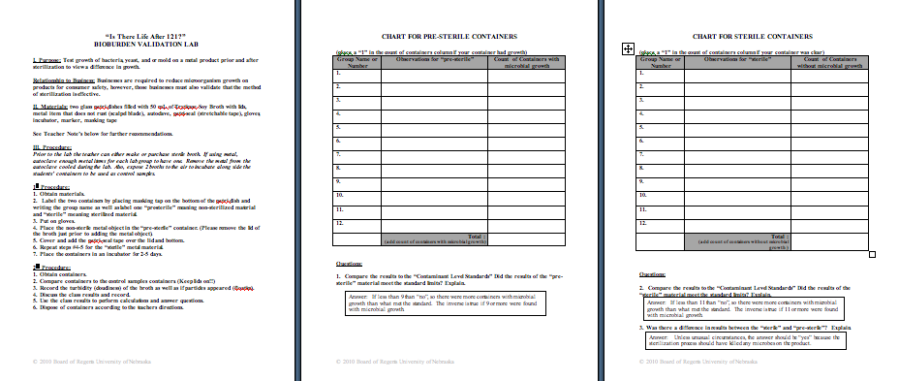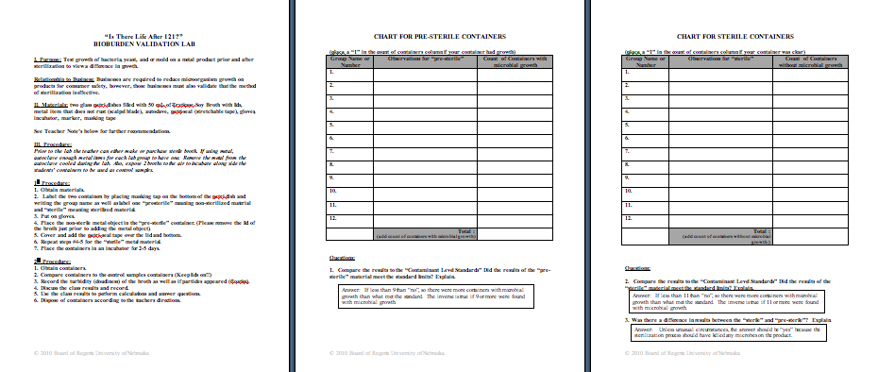

Understanding Learning: (Is There Life After 121?)

Summary: Students will analyze data collected to answer questions over topics involving bioburden testing and sterilization.

Outline:
- Formative assessment of bioburden testing and sterilization
- Summative assessment of bioburden testing and sterilization

Activity:
Formative Assessment
As students are engaged in the lesson ask these or similar questions:
- Were students able to communicate that sterilization destroys microbes by placing them in environments not conducive for microbial growth?
- Can students describe a situation when bioburden testing would be performed?

Summative Assessment
Students can answer the following writing prompt:
- Define what bioburden testing is and what is its primary purpose.
- You are working for a medical materials company. Discuss microbes, bioburden testing and sterilization as it relates to your business.

Students can answer the following questions related to the lab that they completed.
- Calculate the total and average growth of the microbes.
- Analyze the data to answer questions relating if the bioburden test met quality standards for the product before and after sterilization.

