Project SHINE / SPIRIT2.0 Lesson:
This Teacher was mentored by:


www.nppd.com

In partnership with Project SHINE grant funded through the

National Science Foundation

Convert This!
=========================Lesson Header ==========================
Lesson Title: Convert This!
Draft Date: 7/06/2010
1st Author (Writer): Kim Wilson
2nd Author (Editor/Resource Finder): NPPD
Instructional Component Used: Dimensional Analysis
Grade Level: 9th grade

Content (what is taught):
- How to use conversion factors to convert from one unit to another

Context (how it is taught):
- Measure the same thing in both metric and English units
- Use measurements to make conversion factors

Activity Description:
Students will work together to measure the length of their book one will measure in metric units and the other will measure in English units. As a class, students will discuss how to make a conversion factor from that information. Students will measure the mass, length, and volume of a variety of items and will also measure the force of gravity (weight) of the items. Students will use both metric and English units to measure each item. They will record their measurements in the data table. After completing the measurements they will make conversion factors using the equivalent amounts. Examples of items to measure include the classroom, a cup of water, a block of wood, a cylinder of metal, a rock, etc.

Standards:

Science: SB1 Math: MD1, MD2

Materials List:
- Rulers
- Measuring cups in ounces
- Graduated cylinders
- Scales that measure in grams and ounces
Asking Questions: (Convert This!)

Summary: Students will read an article on a website about windmill generators and then discuss questions about unit conversion and where it is applicable.

Outline:
- Students will read background information on windmill generators
- The necessity for learning how to make unit conversions will be discussed
- Students will think about other places it might be necessary to do unit conversions

Activity: Students will read background information on wind energy. After reading the background information, students will discuss why it is necessary to make conversions when working with windmills in the United States. Finally, as a class, list other possible applications where unit conversion might be required.

Questions | Answers
Where did wind generators originate? | In Europe
What units are used when working with wind generators? | Metric
What is the standard system of units used to measure in the United States? | English
What are some problems that companies owning wind farms in the United States might encounter due to the differences in units? | Not being able to find replacement parts, technicians not familiar with the units in plans and spec sheets

Resources:
For background information on wind energy, go to http://www.re-energy.ca/wind-turbine and click on wind energy backgrounder under ‘Downloads’.
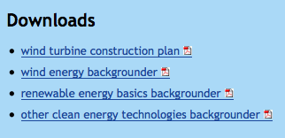

Exploring Concepts: (Convert This!)

Summary: Students will make measurements in metric units and English units. Then, students will try and come up with the metric equivalent to the English units.

Outline:
- Measure mass, length, volume, and force in metric units
- Measure mass, length, volume, and force in English units
- Make conversion factors

Activity: Students will work together to measure the length of their book one will measure in metric units and the other will measure in English units. As a class, then discuss how to make a conversion factor from that information. Students will measure the mass, length, volume, and force of gravity (weight) of a variety of items. Students will use both metric and English units to measure each item. They will record their measurements in the data table below. After completing the measurements, students will make conversion factors using the equivalent amounts. Examples of items to measure include the classroom, a cup of water, a block of wood, a cylinder of metal, a rock, etc.

Item
Mass
(metric)
Mass
(English)
Conv. Factor
(with units)
Length
(metric)
Length (English)
Conv. Factor
(with units)
Volume (metric)
Volume (English)
Conv. Factor
(with units)
Force (weight) (metric)
Force (weight) (English)
Conv. Factor
(with units)
Instructing Concepts: (Convert This!)

Dimensional Analysis

Dimensional Analysis (or the Factor-Label Method or Unit Factor Method) is a problem solving method that exploits the fact that you can multiply any number by one and not change the value of the number. It involves looking at the labels on the known physical quantities and manipulating them by multiplying by unit factors that effectively equal one. Unit factors are equivalent in value but different units. Some examples of unit factors are:
1) 2) 3) 4) 5)

These are varied examples of unit factor and it is impossible to write all unit factors down. Remember that as long as the numerator and denominator of the fraction are the same quantity with different units it is a valid unit factor.

Applications of Dimensional Analysis (or the Factor-Label Method or Unit Factor Method)
Dimensional Analysis (or the Factor-Label Method or Unit Factor Method) can be utilized in unit conversion problems, stoichiometry problems from chemistry, and it can aide in the solving of mathematical story problems. Numerous other applications are not listed here.

Method of Dimensional Analysis (or the Factor-Label Method or Unit Factor Method)
There are numerous methods that teachers utilize to teach Dimensional Analysis (or the Factor-Label Method or Unit Factor Method). This I component will explain the method called the train track method. In this method, a horizontal line is drawn and the physical quantity you want to convert is put on the left side. Unit factors are put next to the starting physical quantity.

Here is an example:

Convert to

You will notice that all the units will cancel except the expected final results (mm/year). To find the answer you multiply by all the numbers in the numerators and divide by all the numbers in the denominators.
Organizing Learning: (Convert This!)

Summary: Students will organize their learning by working conversion problems through a guided practice exercise.

Outline:
- Work a problem together with all students.
- Students work problems on the conversion problem worksheet.
- Go over answers together when students have had time to work problems.

Activity: The teacher will work some dimensional analysis problems with the class to demonstrate the process. Then, students will have guided practice working conversion problems that relate to real world applications. Finally, answers will be checked and questions about the problems will be answered. For the worksheet see attached file: S068-SHINE-Convert_This-O-Practice.doc

Attachments:
S068-SHINE-Convert_This-O-Practice.doc
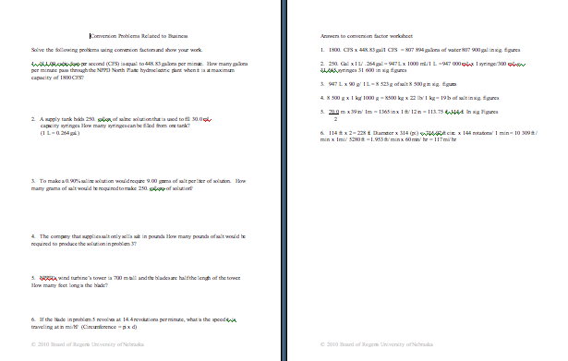

Understanding Learning: (Convert This!)

Summary: Students will be assessed on dimensional analysis by completing a writing and performance assessment.

Outline:
- Formative assessment of dimensional analysis
- Summative assessment of dimensional analysis

Activity: Students will write about the process of dimensional analysis and answer quiz questions applying dimensional analysis to the real world.

Formative Assessment
As students are engaged in the lesson ask these or similar questions:
- Do students understand when dimensional analysis is necessary?
- Are students able to find/use the correct conversion factors?
- Do students understand the process of dimensional analysis?

Summative Assessment
Students can answer the following writing prompt:
- Describe the process of dimensional analysis including why it is necessary and one particular thing you must be careful to watch for when doing the process.

Students can answer quiz questions related to applications of dimensional analysis. For a possible quiz see attached file: S068-SHINE-Convert_This-U-Quiz.doc

Attachments:
S068-SHINE-Convert_This-U-Quiz.doc
