Project SHINE / SPIRIT2.0 Lesson:
How Big Is That?
==========================Lesson Header ==========================
Lesson Title: How Big Is That?
This Teacher was mentored by:


www.behlenmfg.com

and


www.vishay.com

In partnership with Project SIn partnership with Project SHINE grant funded through the

National Science Foundation

Draft Date: June 29, 2010
1st Author (Writer): Kay Strecker
2nd Author (Editor/Resource Finder):
Instructional Component Used: dimensional analysis (converting measurements)
Grade Level: 7-8

Content (what is taught):
- Measurement
- Metric to customary conversions, customary to metric conversions

Context (how it is taught):
- Students will make approximate conversions between centimeters and inches using mental math
- Students will use calculators to make exact conversions between centimeters and inches
Activity Description:
Students will be given the lengths of common objects like a pencil in inches and estimate its length in centimeters. Students will make approximate conversions between inches and centimeters using mental math to match corresponding measurements on cards. Students will then make exact conversions between inches and centimeters and millimeters using calculators to convert measurements in real-life situations.
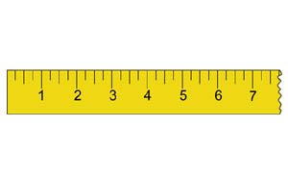
Standards:

Math: MD1, MA3

Materials List:
- Calculators
- Matching measurement cards
Asking Questions: (How Big Is That?)

Summary: Students will estimate the length of common objects in inches and centimeters.

Outline:
- Show students common items and ask them to guess the length in inches
- Ask students to guess the same lengths in centimeters
- Tell students the measure of a common item in centimeters and then ask them to guess the length in inches

Activity: Share with students the need for being able to convert between metric and customary measurements. Many companies make products that are sold in countries that use metric measurements. For example, a manufacturer of fencing would need to be able to give the measurements in meters for customers in Europe, but American customers would want to know the measurements in feet.
Show students common items such as a pencil, sheet of paper, classroom door, etc. and ask them the questions below. Answers may vary, but suggested answers are given.

Questions | Answers
How long is this pencil in inches? In cm? | answers will vary
How wide is this sheet of paper in inches? In cm? | 8.5 in, 21 cm
How tall is the door in feet? inches? cm? | 7 feet, 84 inches, 210 cm
This book is 22 cm tall. How long is that in inches? | about 8 or 9 inches

Materials:
- Common objects to measure such as paper, pencils, crayons, etc.
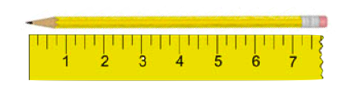
Exploring Concepts: (How Big Is That?)

Summary: Students will use estimation skills to convert measures of inches to centimeters and millimeters.

Outline:
- Find conversion facts for inches to centimeters and centimeters to inches
- Decide how to approximate the conversion with mental math
- Match cards with inch measures to cards that have corresponding centimeters and millimeter measures

Activity: Have students find conversion facts for converting back and forth between inches and centimeters. Demonstrate a few conversions as you decide how to get approximate answers using mental math.
Example: 1 inch is approximately 2.54 centimeters. If an object is 8 inches, you can estimate it by multiplying by 2.5…mental math: double the amount, then add half the amount…8 x 2 = 16, 16 + 4 = 20, so it is about 20 cm

In pairs or small groups, students will estimate conversions between centimeters and inches to match measures on cards. Each group will be given a set of 10 or 12 cards with corresponding inch and centimeter measurements. Students can mentally convert inches to centimeters or centimeters to inches to match the cards.

5 in. | 12.7 cm
12 in. | 30.48 cm
½ in. | 1.27 cm
10 in. | 25.4 cm
8 in. | 20.32 cm
Instructing Concepts: (How Big Is That?)

Dimensional Analysis

Dimensional Analysis (or the Factor-Label Method or Unit Factor Method) is a problem solving method that exploits the fact that you can multiply any number by one and not change the value of the number. It involves looking at the labels on the known physical quantities and manipulating them by multiplying by unit factors that effectively equal one. Unit factors are equivalent in value but different units. Some examples of unit factors are:
1) 2) 3) 4) 5)

These are varied examples of unit factor and it is impossible to write all unit factors down. Remember that as long as the numerator and denominator of the fraction are the same quantity with different units it is a valid unit factor.

Applications of Dimensional Analysis (or the Factor-Label Method or Unit Factor Method)
Dimensional Analysis (or the Factor-Label Method or Unit Factor Method) can be utilized in unit conversion problems, stoichiometry problems from chemistry, and it can aide in the solving of mathematical story problems. Numerous other applications are not listed here.

Method of Dimensional Analysis (or the Factor-Label Method or Unit Factor Method)
There are numerous methods that teachers utilize to teach Dimensional Analysis (or the Factor-Label Method or Unit Factor Method). This I component will explain the method called the train track method. In this method, a horizontal line is drawn and the physical quantity you want to convert is put on the left side. Unit factors are put next to the starting physical quantity.

Here is an example:
Convert 4 inches to mm

More complex:
Convert to

You will notice that all the units will cancel except the expected final results (mm/year). To find the answer you multiply by all the numbers in the numerators and divide by all the numbers in the denominators.
Organizing Learning: (How Big Is That?)

Summary: Students will convert between centimeter and inch measurements.

Outline:
- Four different stations outlining a real life situation where measurement conversions are needed
- Students work their way through each station in groups, pairs, or individually
- Students may use calculators and they will record their answers on an answer sheet

Activity: The teacher will set up four stations with a real-life work scenarios for students to read. Each station has six problems for students to complete where they convert centimeters or millimeters to inches or convert inches to centimeters or millimeters. Students will record their answers on an answer sheet. Students may use calculators.

Resources:
- Calculators
- Answer sheet

Attachments:
S073-SHINE-How_Big_Is_That-O-Stations.doc
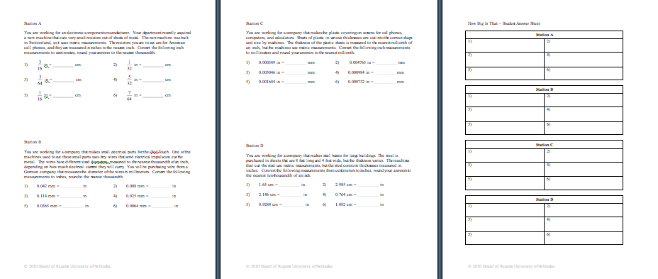
Understanding Learning: (How Big Is That?)

Summary: Students will demonstrate their understanding of measurement conversions by taking a quiz.

Outline:
- Formative assessment of dimensional analysis (unit conversion)
- Summative assessment of dimensional analysis (unit conversion)

Activity:
Formative Assessment
As students are engaged in the lesson ask these or similar questions:
- Do students understand the need to convert units?
- Are student able to reasonably estimate the length of objects?
- How can you convert from inches to centimeters if you just need an approximate answer?
- How do you convert from inches to centimeters if you need an exact answer?
- How can you convert from centimeters to inches if you need an approximate answer?
- How do you convert from centimeters to inches if you need an exact answer?
- How do you convert from inches to millimeters? From millimeters to inches?

Summative Assessment
Students can answer the following writing prompt:
- Explain a situation where it is necessary to convert between units of measure. Then create and solve a unit conversion problem related to that situation.

Students will take a quiz with questions that ask for approximate conversions and exact conversions between inches and centimeters and millimeters. For an example see attached file: S073-SHINE-How_Big_Is_That-U-Quiz.doc

Attachments:
S073-SHINE-How_Big_Is_That-U-Quiz.doc
