SPIRIT 2.0 Lesson:
Solar Power Lifting
==========================Lesson Header ==========================
Lesson Title: Solar Power Lifting
Draft Date: June 3, 2010
1st Author (Writer): Peter Gomez
2nd Author (Editor/Resource Finder):
Instructional Component Used: Power
Grade Level: grade 10-12

Content (what is taught):
- Simple Machines
- Power
- Design

Context (how it is taught):
- Design a solar power simple machine to lift a mass
- Computations of work and power

Activity Description:
In this activity, the students will be challenged to construct a simple machine powered by a solar car that will lift a 200-gram mass 1 meter. The design will be documented as construction occurs. Finally, the machine will be tested and the amount of work and power produced by the machine will be calculated.

Standards:

Science: SA1, SE2 Technology: TA1, TB4, TD2, TD4, TF2

Engineering: EA2, EA4, EB5 Math: MA, ME1

Materials List:

- Solar cars
- Various pulley systems
- Inclined planes
- Wheel and axles
- String
- Paper clips
- 200 gram masses
- Stopwatch
- Meter stick
- Markers, hot glue gun
- Ring stand
- Ring stand clamp
- Spring loaded force gauge
- Other construction materials such a cardboard or wood.

Asking Questions: (Solar Power Lifting)

Summary: The concepts of work, power, and simple machines will be explored. A solar car that can power a machine will be demonstrated.

Outline:
- The concepts of work and power will be defined
- Students will do an online tutorial on simple machines
- Solar car will be demonstrated

Activity: The teacher will define the concepts of power and work. This can be done in a combination of student input and guided questioning. Next, the students will complete an on-line tutorial about simple machines at the COSI Columbus site (http://www.cosi.org/). As students work on the tutorial, they will complete a worksheet that will help them understand simple machines better (see attached file: S078-SHINE-Solar_Power_Lifting-A-Machine_wrksht.doc). Strengths and weaknesses will be analyzed. Finally, the teacher will demonstrate a solar car that can serve as a power source to drive a simple machine.

Questions | Answers
What is work? | Energy transferred by force over a distance
What is power? | Work done over time
What variables affect power output? | Mass, distance, time and efficiency of system
What types of simple machines are there? | Levers, wedges, wheel & axle, inclines, screws, block and tackle systems
What is the trade-off of each type of simple machines? | Levers the increase in force is offset by a longer distance it’s applied.  Inclines and Wedges decrease the force applied, but require it to be applied over a longer distance.  Wheel and axle systems manipulate the output speed at the cost of requiring a greater torque being applied to the axle, or can create a greater torque, but reduce the overall rotational speed of the axle.  Block and tackle systems multiply the lifting force applied to the object, but the length of string is increased.

Resources:
Access to Internet and the following URL: http://www.cosi.org/files/Flash/simpMach/sm1.swf)

Attachments:
S078-SHINE-Solar_Power_Lifting-A-Machine_Worksheet.doc
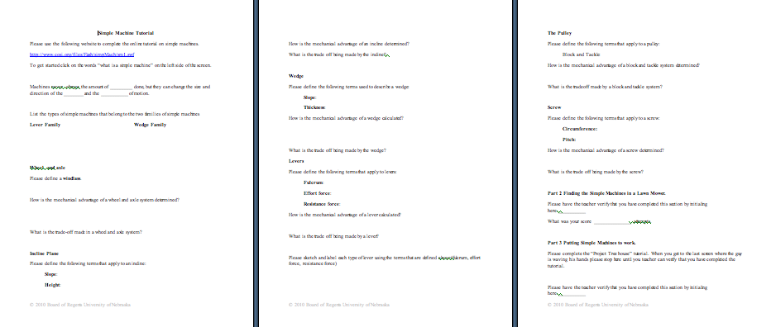

Exploring Concepts: (Solar Power Lifting)

Summary: Students will be asked to design a simple machine whose power source will be a solar car. The simple machine will be asked to lift a 200-gram mass 1 meter.

Outline:
- Students will be given the challenge to create simple machines that will life 200-grams one meter
- The building process should be documented in an engineering notebook

Activity: Students will be divided into groups and given the challenge to build a simple machine that can lift 200-grams, 1 meter. All simple machines should be considered a possibility for this task. Most groups may want to use pulleys but other simple machines should be considered. For instance, the car could pull the weight up an incline, or a wheel and axle could be turned raising the weight. Encourage “out of the box” thinking. The project will be graded and creativity should be a significant part of the grade. As the building process takes place, students should document what they are doing and why. Documentation should include text, sketches and digital pictures.
200 grams
1 meter
Instructing Concepts: (Solar Power Lifting)

Power

Putting “Power” in Recognizable Terms: Power is the work done divided by the time to do that work. Since work is the amount of energy used this means is that power is the rate of change of energy or in other terms it is the rate at which energy is used.

Putting “Power” in Conceptual Terms: Power is conceptually talking about the amount of work done over time. It is apparent that power present in a situation is dependant on the amount of energy expended (work) and the time that it takes to do that work. What this means is that if 100 Joules (J) of work are done in 10 minutes and 100 Joules of work are done in 1 minute the second case has a lot more power. If fact it has a factor 10 times more power.

Putting “Power” in Mathematical Terms: Power can be mathematically represented by the formula P = W / t where P is the Power, W is the work done and t is time to do the work. The SI unit of work is the Watt (W), which means 1 Joule per second. This means that power is directly proportional to the work done and inversely proportional to the time to do the work.

Remembering that work is force times displacement can derive a corollary for the power equation. Substituting this into the power equation we get P = F*d/t. Now since velocity is displacement divided by time, we can substitute one more time and get the equation Power = Force * Velocity (P = F * v)

Putting “Power” in Process Terms: Thus, power is about doing work over time. From the mathematical analysis of this concept it is obvious that a bigger engine has more power because it can do more work in the same amount of time. It is also worth noting that since power = force * velocity something that is both strong (large force) and fast (high velocity) will involve a lot of power.

Putting “Power” in Applicable Terms: Power applies in any situation where work is being done. Power is present in mechanical, electrical, pneumatic, and fluidic systems. Basically anywhere work is accomplished you can talk about the concept of power.
Organizing Learning: (Solar Power Lifting)

Summary: Students will test the machines that were built. The power output of each machine will be calculated to see which machine produced the most power.

Outline:
- The students will be asked to test and time their lifting devices to determine the actual power output achieved.
- The force applied by the solar car will be measured using a spring force gauge.
- The height (displacement) of the weight will be measured.
- Work and power will be calculated.

Activity: The challenge will be realized when students take the machines that were created and test them. Since power = work/time, the work that each machine does must be calculated. The displacement will be one meter if the machine performs the task successfully or the measured height the weight was lifted. The force applied should be the 200-gram mass times the 9.8 m/s². The actual force exerted by the solar car can be found by hooking it up to a spring-loaded force gauge. This number can be used to see how much mechanical advantage the simple machine produced. All results from the trial should be recorded in a data table. After attempting the challenge, the work and power that each solar car produced will be calculated.

Group # | Simple Machine | Force of Solar Car | Displacement | Work | Time | Power
1
2
3
4
5
Understanding Learning: (Solar Power Lifting)

Summary: Students will be assessed on their understanding of power.

Outline:
- Formative assessment of power
- Summative assessment of power

Activity: Students will be assessed on power by answering a writing prompt and completing quiz questions.

Formative Assessment
As students are preparing for the summative assessment ask these or similar questions:
- Do students understand the concepts of work and power?
- Are students able to incorporate a simple machine into their design?
- Do students understand the pros/cons of each type of simple machine?

Summative Assessment
Students can answer the following writing prompt:
Explain power and cite at least 3 examples where power can be measured. Be sure to include the formula and define each variable in the formula.

Students can answer the following quiz questions:
- A 50-gram objected is lifted straight up to a height of 2 meters in 20 seconds. How much power was used to lift the object?
- A lever raised an object off the ground completing 60 joules of work in 75 seconds. How much power was created by the lever?

