Project SHINE / SPIRIT2.0 Lesson:
This Teacher was mentored by:

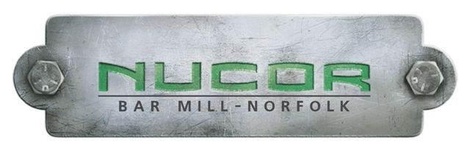
www.nucorbar.com

In partnership with Project SHINE grant funded through the

National Science Foundation

Mixtures
==========================Lesson Header ==========================
Lesson Title: Mixtures
Draft Date: 07/28/2010
1st Author (Writer): Jane Brockman
Industry Partner: Nucor Steel
Instructional Component Used: Mixtures
Grade Level: Middle School

Content (what is taught):
- To understand and describe what a mixture is
- To distinguish between the two types of mixtures: heterogeneous and homogeneous
- To discover how Nucor Steel puts different materials together to make a final product we know as steel

Context (how it is taught):
- Students are going to create flashcards about different words dealing with mixtures.
- Students will create their own mixtures.
- A metallurgist from Nucor Steel in Norfolk, Nebraska, will present information to the students about mixtures and how mixtures are involved in the steel production process.

Activity Description:
As an introductory activity, students are going to create flashcards about mixtures. Students will then explore different mixtures by creating their own mixtures and classifying them as homogeneous or heterogeneous. A metallurgist from Nucor Steel in Norfolk, Nebraska will present information to the students about mixtures and the steel process. The metallurgist will then walk students through modules and a simulation dealing with mixtures and the steel process. Lastly, students will separate mixtures by the different procedures we have discussed in this lesson.

Standards:

Science: A1, B1 Technology: A3, C4

Engineering: A1, C1 Math: A1, B1

Materials List:
- Food coloring
- Kool-aid packets
- Sand
- Dish detergent
- Glue
- Iron filings
- Wood chips
- Computer
- Funnel
- Magnets
- Tweezers
- Pipettes
- Coffee filters
- Paper towels
- Beakers
- Hot plate
- Test tube
- Goggles
- Flashcard materials
- Dictionary
- Markers
- Salt
- Pepper
- Water
- Magnifying glass
- Thermometer
- Lab coat
Asking Questions: (Mixtures)

Summary: Students are going to create flashcards of “mixture” vocabulary. The students will participate in class discussion to review vocabulary.

Outline:
- Students create flashcards from the sixteen mixture vocabulary words the teacher has given them
- The flashcard must have the word, definition and illustration
- Entire class participates in class discussion using their knowledge about mixtures

Activity: Students will create flashcards from seventeen “mixture” vocabulary words the teacher has given them. Below is a complete listing of the words:

Atom
Boiling Point
Chemical Property
Chemistry
Compound
Distillation
Element
Energy
Filtration
Heterogeneous
Homogeneous
Magnetic Properties
Matter
Mixture
Physical Property
Substance

For flashcards that are ready to cut out, see attached file: S083-SHINE-Mixtures-A-Vocabulary.doc The flashcard must have the word, an original definition written by the student, and an illustration. The entire class participates in class discussion, using their knowledge about mixtures.

Questions | Answers
What are some methods you can separate mixtures? | Filtration, different boiling points, distillation and magnetic properties
What are the two types of mixtures? | Heterogeneous and homogeneous
Why are mixtures important? | Mixing often creates a new thing with unique properties. For instance, steel, a mixture of iron and other metals is much stronger than its components.

Attachments:
Ready to Cut Out Vocabulary Cards: S083-SHINE-Mixtures-A-Vocabulary.doc
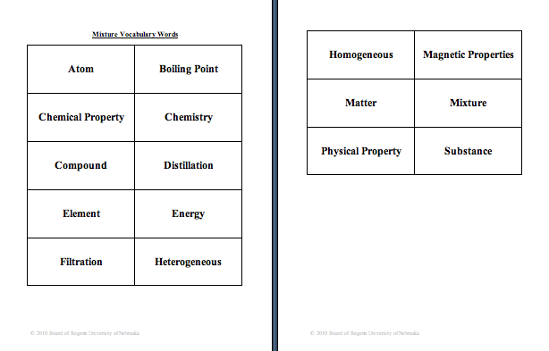

Exploring Concepts: (Mixtures)

Summary: During the exploring phase, the students will create their own mixtures. After creating their own mixtures, they will describe both verbally and in written form what a mixture is.

Outline:
- In lab groups, create seven different mixtures with the materials the teacher has supplied.
- After creating the mixtures, look at the mixture record your observations and explanations.
- Distinguish between homogeneous and heterogeneous mixtures
- Whole group discussion of matter and the activity

Activity: Each team will make seven different mixtures. The mixtures are listed below. Each mixture is made in a plastic cup and can be stirred with a plastic spoon. Each student will create a chart (shown below). The team will then create the mixture while each student fills out their own chart. When finished, have a discussion about what was learned.

Mixture #1---Salt and Pepper
Mixture #2---Pepper and Water
Mixture #3---Food Coloring and Water
Mixture #4---Kool-Aid and Water
Mixture #5---Sand and Water
Mixture #6---Dish Detergent and Water
Mixture #7---Glue and Food Coloring

Mixture # | Observations | Type of Mixture | State of Matter | Explanations
1
2
3
4
5
6
7
Instructing Concepts: (Mixtures)

Mixtures

Definition: Mixtures are the combination of two or more substances each retaining their own separate identity. So, each substance maintains its own physical and chemical properties, but their combination may result in varied physical properties of the mixture (ie melting point, viscosity, density etc.).
Distinguishing a Mixture from a Chemical Reaction: A mixture can involve two elements like zinc (Zn) and copper (Cu) in a penny or two compounds like table salt (NaCl) and water (H₂O). However once a chemical reaction or chemical bond occurs the substance is not a mixture! An example would be placing sodium (Na) in water (H₂O). Sodium creates a new chemical bond producing a new substance with new physical and chemical properties known as sodium hydroxide (NaOH). So, if a new chemical formula must be written after two or more substances combine it is not a mixture.
Separating Mixtures: Mixtures can always be separated by physical means as each component in the mixture retained its physical properties. Common methods: filtration (particle size), distillation (boiling points), chromatography (rates of migration in a mobile stage), solubility (ability to dissolve in a solvent), or magnetism.
General Types of Mixtures: Mixtures can be most broadly classified as homogenous or heterogeneous. In a homogeneous mixture, the components are evenly distributed or appear uniform even under a microscope, while in a heterogeneous mixture the components are irregularly distributed and appear varied.
Identifying the Type of Mixture:
1. Heterogeneous Mixtures are typically easier to identify than homogenous mixtures as the combination of substances does not appear uniform. There are two kinds of heterogeneous mixtures suspensions and colloids.
A. Suspensions often involve particles large enough to settle out of the liquid or gas with which they are intermixed. So, these mixtures can be identified by their ability to settle into layers or filter apart. They often need to be shaken or stirred to remain mixed. Examples of suspensions are a snow globe, some salad dressings, and most paint.
B. Colloids have intermediately sized particles that do not settle a part. These are identified by their size, varied distribution of substances, and the Tyndall effect. To test the Tyndall effect a focused beam of light is directed onto the substance, if the light becomes scattered or appears cloudy while attempting to pass through the substance it is likely a colloid (if the particles are intermediately sized). Examples of colloids are milk, deodorant, and fog.
2. Homogenous Mixtures are typically called solutions and often are mistaken for pure substances. They can be distinguished from heterogeneous mixtures in that they do no separate into distinct layers over time, do not filter apart, and will let light pass through them (Tyndall effect). Examples of solutions are salt water, carbonated beverages, and vinegar.

Picture of the Tyndall Effect: Picture complements of: http://image.tutorvista.com/content/surface-chemistry/tyndall-effect.jpeg | 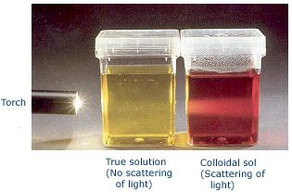
Organizing Learning: (Mixtures)

Summary: A metallurgist from Nucor Steel will present information about how mixtures are used to come up with the final product---steel. The metallurgist will guide the students through a simulation. Students will complete simple mixture problems with the metallurgist.

Outline:
- Metallurgist from Nucor Steel presents basic information about metals, mixtures, and the steel production process
- Metallurgist walks students through simulation at www.steeluniversity.org
- Students gain hands on experience by working with actual samples that Nucor Steel uses and conduct simple mixture problems

Activity: A metallurgist from Nucor Steel will present information about metals, mixtures and the steel production process. Students will be given time to answer questions after the presentation. The metallurgist will guide the students through the modules and simulations at the website www.steeluniversity.org. These modules further explain how mixtures are involved in the steel production process. Students will gain hands on experience working with actual samples from Nucor Steel while solving simple mixture problems using these samples. The entire process should be documented in an engineering notebook. The documentation should include: vocabulary, processes, drawings, and questions to ask/research.
Understanding Learning: (Mixtures)

Summary: Students will be given a written assessment in the form of a worksheet. Students will be given a mixture that needs to be separated. Finally, students will convey the result of the lab activity by typing a paragraph giving their explanation.

Outline:
- Formative assessment of mixtures
- Summative assessment of mixtures

Activity: The students will be assessed on mixtures by completing a worksheet and a performance assessment with a writing component.

Formative Assessment
As students are engaged in the lesson, the teacher can walk around and ask these or similar questions:
- Do students understand what a mixture is?
- Can students create and separate mixtures?
- Can students list applications of mixtures?

Summative Assessment
Students can complete the attached worksheet on mixtures. See attached file:
S083-SHINE-Mixtures-U-worksheet.doc

Performance Assessment
Provide students with the mixture comprised of iron filings, wood chips, sand, salt and water. You should allow student teams time to make observations about the mixture. Then students should generate a hypothesis on how the mixture can be separated. Finally, students should be provided materials to test their hypothesis. All materials that will be provided are listed on page 1 of this lesson.

Written Assessment of Activity
Type a summary of the activity from the summative assessment. Include any observations, hypotheses, discussion of what went on within your lab team, and a reflection of the plan. Lastly, give an explanation of the benefits of separation of a mixture.

Attachments:
S083-SHINE-Mixtures-U-worksheet.doc
