Project SHINE / SPIRIT2.0 Lesson:
“CD Slide”
==========================Lesson Header ==========================
Lesson Title: “CD Slide”
This Teacher was mentored by:

www.kawasakilincoln.com

In partnership with Project SHINE grant funded through the

National Science Foundation

Draft Date: 7-3-2010
1st Author (Writer): Elissa Gilger
2nd Author (Editor/Resource Finder): Kawasaki
Instructional Component Used: Force, Friction, Weight, Normal Force F_{w}=mg, F_{f} = μF_{N}
Grade Level: High School/adaptable for Middle School

Content (what is taught):
- Forces are any push or pull on an object
- Three types of friction: sliding, rolling, and fluid friction
- Application of Force of Weight formula: F_{w}=mg and Friction formula: F_{f} = μF_{N}

Context (how it is taught):
- View the movement of a CD and how the forces of friction and weight affect the movement
- Investigate the types of friction and which creates the least amount of resistance
- Calculate the Force of Weight for each CD device using the formula: F_{w}=mg
- Calculate the Coefficient of Friction by rearranging the Friction formula

Activity Description:
In this lesson, students will investigate the types of friction by exploring friction between a textbook and a student’s desk. Students then will take notes over the types of friction and force involved (Weight & Normal). Finally, student pairs will perform a lab attaching a spring scale to a CD device with a balloon implanted in its center. They will calculate the force of weight or normal force as well as the coefficient of friction for each CD balloon device. Then, they will slide the CD, roll the CD (over friction beads), and finally glide the CD across the counter (after filling the balloon with air and releasing it). Analyzing their results, student pairs will determine that fluid friction creates the least amount of resistance as well as increase of weight relates to an increase of friction.

Standards:

Science: SB2, SE2 Technology: TD3

Engineering: EB1, EB2 Math: MC1, MD2

Materials List:
Exploring Activity Lab Activity
- 2 mini CD devices
- Tape
- Large pan (short sides)
- Slim Pen spring scale
- Textbook
- Balance
- Friction beads
- 12 in. balloon
- Regular CD device
- Twisty tie
- Student desk
- Several pencils
Asking Questions: (CD Slide)

Summary: Students will determine the cause of friction, factors that can increase friction, and the three types of friction.

Outline:
- Demonstrate a car brake using sand paper and clothing
- Draw a picture of rough surfaces microscopically
- Show pictures or provide examples of the different types of friction

Activity: The teacher will demonstrate a car brake, draw picture of rough surfaces microscopically on the board, and show pictures of the different types of friction.

Questions | Answers
What causes a car to stop? | Answer: Brakes apply a rough surface to the wheel forcing them to stop due friction.
What causes friction? | Answer: roughness of surfaces between objects or electromagnetic force
What factors can increase friction? | Answer: increase the roughness of the surface, or coefficient of friction, increase the surface area (if air resistance), increase the force pushing the surfaces together
There are three types of kinetic friction: sliding, rolling, and fluid. What would be an example for each? | Answer: Sliding…going down a slide, sliding into base at a baseball game, Rolling…wheels on a cart, rollers on a conveyor belt, Fluid…melted water between ice skates and ice, hovercraft
Of the three types, which one creates the least amount of friction? | Answer: Fluid friction as there is less of a rough surface when an objects slides over a liquid or a gas.
weight
pulling force
rolling resistance
Exploring Concepts: (CD Slide)

Summary: Students investigate the types of friction as well as the relationship between friction and weight.

Outline:
- Students will discuss the types of friction relating to how to move a textbook across a desk.
- Students will discuss the relationship between weight and friction after placing several books on top of the one textbook and attempting to slide the books across the desk.

Activity: In this lesson, students will investigate the three types of friction and how the force of weight can impact friction. A student will slide a textbook across his or her desk. Students watching will be asked to come up with other ways to move the textbook that will reduce the friction. The teacher will demonstrate rolling and fluid friction after students have shared their ideas. Finally, the teacher will place several books on top of the initial book and ask the same student to slide the books. Students watching will view a noticeable difference and will be asked to relate the Force of Weight or Normal Force to friction. For a detailed write-up of the activity see attached file: S084-SHINE-CD_Slide-E-Activity.doc

Attachments:
Activity Write-Up: S084-SHINE-CD_Slide-E-Activity.doc
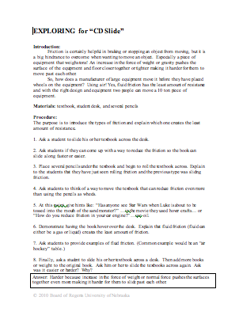
Instructing Concepts: (CD Slide)

Friction

Putting “Friction” in Recognizable Terms: Friction is a force between two objects that tends to “damp out” or oppose motion. It always acts in complete opposition to another force applied to an object. There are two main types of friction. Static friction is the frictional force opposing putting an object at rest into motion. Kinetic friction is the frictional force which tends to slow an object in motion. Usually static friction is higher than kinetic friction meaning it takes a greater force to put an object into motion than it does to maintain motion. Cases where kinetic friction is higher than static friction can occur with the use of lubricants which create a drag force that increases with velocity.

Putting “Friction” in Conceptual Terms: Friction opposes the force required to start or maintain an object in motion. It is dependent on the surfaces that are in direct contact. Friction is created by the rubbing or dragging of the surfaces across each other. Friction can be increased or decreased by modifying the surfaces.

Putting “Friction” in Mathematical Terms: The coefficient of friction must be calculated for any surface because different surfaces provide different amounts of friction. The coefficient of friction, µ, can be found by taking the force of friction, F_{f}, divided by the normal force, F_{n}, written as: µ = F_{f} / F_{n}. When the force to start an object in motion is used, the “static” coefficient is found. If the force to keep an object in motion is used, the “kinetic” coefficient is found. The normal force is the force component of the surface, perpendicular to the surface, acting on the object. If the surface and applied forces are horizontal, the normal force will be equal and opposite to the force of gravity, which is the weight of the object. If the surface and applied forces are NOT horizontal you must resolve the forces perpendicular to the surface.

Putting “Friction” in Process Terms: Friction is the force that allows us to move. Without friction there would be no force to act in opposition to our desired motion. Thus friction is the force that fulfills Newton’s 3rd law - for every action there is an opposite and equal reaction. We cannot move in a desired direction unless friction works against us in the opposite direction. Friction is desirable and necessary for motion as we understand it and yet we are always trying to reduce friction in many instances because it requires less energy to move an object. At other times we want to increase friction to keep an object at rest.

Putting “Friction” in Applicable Terms: Friction is the force that allows us to walk, climb, drive, throw, or put any object in motion. Without friction we couldn’t move objects. Friction is both desirable and undesirable depending on if you want an object to move or stay at rest. Higher friction requires more energy input. Lower friction requires less energy input.
Organizing Learning: (CD Slide)

Summary: Student pairs will perform a lab collecting data about the three types of friction, calculating the force of weight or normal force and coefficient of friction, as well as answer questions related to their application.

Outline:
- Students will perform a lab viewing the cause of friction and the three types of friction as well as how weight affects friction.
- Students will calculate the Force of Weight (Normal Force) and the coefficient of friction.
- Students will relate the concepts explored to how manufactures move large pieces of equipment using air bladders.

Activity: Student pairs will perform a lab attaching a spring scale to a CD device with a balloon implanted in its center. They will calculate the force of weight or normal force, as well as the coefficient of friction for each CD balloon device. Then, they will slide the CD, roll the CD (over friction beads), and finally glide the CD across the counter (after filling the balloon with air and releasing it). Analyzing their results, student pairs will determine that fluid friction creates the least amount of resistance as well as increase of weight relates to an increase of friction. For the complete lab exercise, see attached file: S084-SHINE-CD_Slide-O-lab.doc. NOTE: The last half of the lab exercise is devoted to the building of the CD balloon device that will have fluid friction.

Attachments:
S084-SHINE-CD_Slide-O-lab.doc
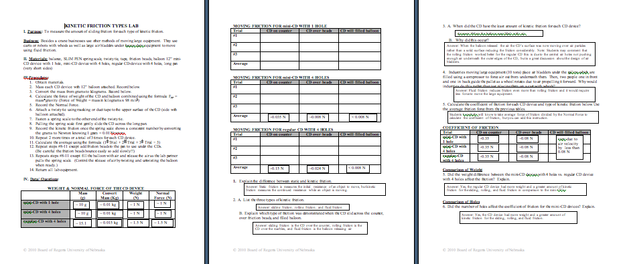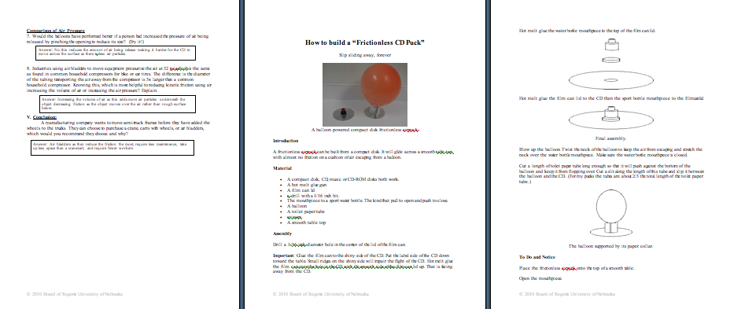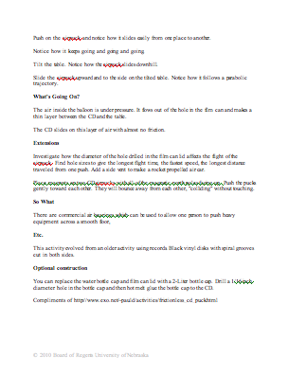
Understanding Learning: (CD Slide)

Summary: Students will answer essay questions and perform calculations relating to friction.

Outline:
- Formative assessment of friction
- Summative assessment of friction

Activity: Students will be assessed on friction by completing a performance assessment with a writing component relating to friction.

Formative Assessment
As students are engaged in the lesson ask these or similar questions:
- Can students determine the type of kinetic friction during a demonstration or example?
- Can students explain why fluid friction provides the least amount of resistance?
- Were students able to apply the weight or friction formulas?

Summative Assessment
Students can answer the following performance assessment questions:
- Many historians have theorized about how the Egyptians were able to accurately place the building stones to construct the pyramids. Some believe that many slaves working together pushed or slid them into place and others believe they used logs to roll the stones into place. What types of friction would these methods require? Which would require the least amount of effort for the slaves? Is it possible that the Egyptians could have used another method? Explain.
- If a pyramid stone had a mass of 1,050 kg, calculate its force of weight on Earth.
- If the same pyramid stone was being pushed through the sand by slaves, calculate the coefficient of friction knowing that the Force of friction is equal to 5.2 x 10³ N.
- If the slaves had a choice of taking a water break in the midst of sliding a block across the sand (start moving the block, stop, and start again) or after moving a block (start moving the block and stop), which would you recommend the slaves choose to do? Explain.

