SPIRIT 2.0 Lesson:
Power to the Robots!
==========================Lesson Header ==========================
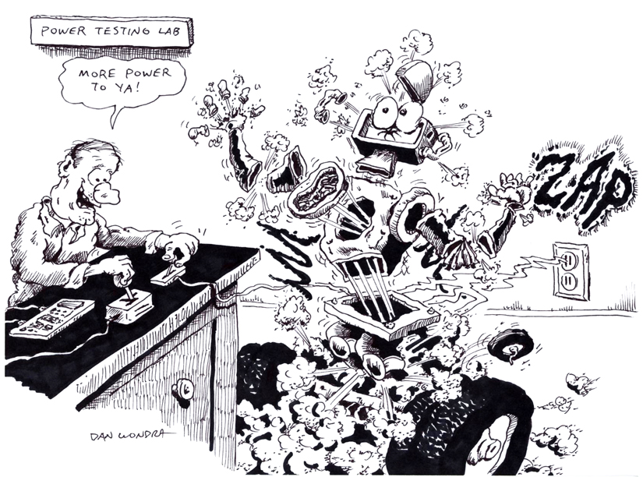
Lesson Title: Power to the Robots!
Draft Date: October 3, 2010
1st Author (Writer): David Porter
Instructional Component Used: Power
Grade Level: 6-8

Content (what is taught):
- The concepts of work and power
- A simplified computation of power.

Context (how it is taught):
- Classroom discussions will outline the concepts of work and power
- An active inquiry will be conducted to demonstrate the differences between work and power
- A classroom robot will be used to provide data in order to calculate the value of power
Activity Description: Students will do work at different rates of speed in order to better understand the time aspect of power. Students will time a classroom robot as it completes a course. The robot will complete the course several times, at varying weight loads and operated velocity in order to create sets of data. The students will use the data to determine the value for power in each case.

Standards:

Science: SA1, SB2 Technology: TC1, TC4

Engineering: EA1, EB2 Math: MA1, ME1

Materials List:
- Classroom robot
- Stopwatch
- Data collection sheet
Asking Questions: (Power to the Robots!)

Summary: Students will experience and explore the concepts of power and work.

Outline:
- Questions about the nature of power.
- Questions will explore the work done by a classroom robot and the relationship between that work and the time in which it was done.

Activity: The teacher will begin with the following questions:

Questions | Answers
What does “work” mean? | Expected responses might be along the lines of using energy to get something done, completion of a task, etc.
People can work. Can work be done using other forms of energy? | Students will probably will reach a consensus that water, wind, fossil fuels, etc can all be used to accomplish work. However, it is important for the teacher to know at this point that work is defined as energy used to move something. If no movement occurs, no work has either.
What does “power” mean? | Answers will vary. There will probably be some agreement that power has something to do with the ability to do a certain task.
Is there any difference between work and power? If so, what is the difference? | This is not an intuitive answer, do not expect any correct answers, but make note of them.
If you hold a weight over your head is energy being used? | Yes
Is more, less, or the same amount of energy used if you raise a weight from the floor to over your head? | More energy is used. In fact, in the first example, even though it may take energy to hold that weight, no work has been done! For scientific purposes, work is only done if energy is used to move something!
Is work done if you push against a car to keep it from moving? | No, work is not done! Since power is defined as work done over time, no power was used either.
So, what is power? | Work is energy used to move something.  Power adds the factor of time. Power is defined as the force times the distance divided by the time it took to do it.
Exploring Concepts: (Power to the Robots!)

Summary: Students will do an inquiry to explore the concept of power, and review the meaning of work.

Outline:
- Students will perform a task both slowly and then quickly in order to better understand power.
- A classroom discussion will help students understand the variables in power and their relationship to classroom robots.

Activity: The teacher will ask for volunteers to perform a task. The task could be most anything such as ascending several flights of stairs, carrying a weighted bucket (one that won’t make a mess if sloshed around), or traveling around a playground or track. The essential element is that it will be a relatively easy task if done slowly, but strenuous if done quickly. Have all of the volunteers do it slowly and then quickly, or divide in half and have the groups do the different tasks.

Questions | Answers
Both groups did the same activity. What was different about what each group experienced? | The group which had to perform more quickly was more fatigued because they had a more difficult task.
Think carefully about this: Was more energy expended by one group over another? | No! It takes approximately the same amount of energy to walk a certain distance as it does to run that same distance.
Was more work done by one group than the other? | Again, no. Work is defined as force times distance applying a force to an object to displace it. Both groups did the same amount of work.
Is work done if you try to push something but do not move it? | No, work is not done.
What is the importance of the concept of power? | Power includes the factor of time. Power is defined as the force times the distance divided by the time it took to do it—Power = Work divided by Time. This helps us understand that more power is involved to do a task more quickly than it does to do them slowly. See more complete explanation in the “Power” I component of this lesson.
Suppose that each of you repeated the experiment we started with, but this time you had to wear a backpack with 50 pounds of weight in it. Would more power be needed? | Yes, since the amount of work being done would increase, the amount of power would also increase if the amount of time stayed the same. The teacher might demonstrate sample equations and then have students do the same.
A classroom robot is provided a basket with which to carry tools. Would you expect the amount of power consumed to change? What would be the evidence of a change in power need? | Yes. The battery would likely wear down more quickly.
Instructing Concepts: (Power to the Robots!)

Power

Putting “Power” in Recognizable terms: Power is the work done divided by the time to do that work. Since work is the amount of energy used, this means is that power is the rate of change of energy or in other terms, it is the rate at which energy is used.

Putting “Power” in Conceptual terms: Power is conceptually talking about the amount of work done over time. It is apparent that power present in a situation is dependant on the amount of energy expended (work) and the time that it takes to do that work. What this means is that if 100 Joules (J) of work are done in 10 minutes and 100 Joules of work are done in 1 minute the second case has a lot more power. If fact it has a factor 10 times more power.

Putting “Power” in Mathematical terms: Power can be mathematically represented by the formula P = W / t where P is the Power, W is the work done and t is time to do the work. The SI unit of work is the Watt (W), which means 1Joule per second. This means that power is directly proportional to the work done and inversely proportional to the time to do the work.

Remembering that work is force times displacement can derive a corollary for the power equation. Substituting this into the power equation we get P = F*d/t. Now since velocity is displacement divided by time, we can substitute one more time and get the equation Power = Force * Velocity (P = F * v)

Putting “Power” in Process terms: Thus, power is about doing work over time. From the mathematical analysis of this concept, it is obvious that a bigger engine has more power because it can do more work in the same amount of time. It is also worth noting that since power = force * velocity something that is both strong (large force) and fast (high velocity) will involve a lot of power.

Putting “Power” in Applicable terms: Power applies in any situation where work is being done. Power is present in mechanical, electrical, pneumatic, and fluidic systems. Basically anywhere work is accomplished you can talk about the concept of power.

Related “I” pieces: Work, Force, Hooke’s Law
Organizing Learning: (Power to the Robots!)

Summary: Students will determine the power used by a classroom robot in several situations including unloaded, timed over a course at a slow velocity, and timed over the same course at a higher rate of speed.

Outline:
- Classroom robots are timed at varying weight levels and operated at different velocity levels in order to provide data for determining the power used by the ‘bots.

Activity: A basket will be attached to a classroom robot, such as a CEENBoT. Students will prepare a very simple course for the robot to traverse. It is recommended that the course be as close to a straight line as possible, since turns would introduce a variable as to how accurately turns are made and will influence the distance traveled/time taken by the robot. A relatively long course is desirable (perhaps 10 meters or more) in order to provide a clear difference in the time measurements. Students will time the robot as it completes the course with no additional weight and with varying loads in the basket. These trials will be repeated with the robot operated at different rates of speed. Students will carefully record each trial with the differences regarding weight load and velocity noted. Finally, students will use the formula for power in order to determine the power demonstrated in each trial.

For example:
A robot weighs 3 pounds. It moves 30 feet in 12 seconds.
P = 3 * 30 / 12 = 7.5 foot pound/second. The value for power is 7.5.

Two pounds are added to this same robot. It covers the same course in 15 seconds.
P = 5 * 30 / 15. The value for power is now 10 foot pound/second.

Note that this is a simplification of the force required to move the robot. This ignores friction in several places and motor efficiency. The actual value would differ from the simple weight of the robot. It is useful, however, in understanding the forces involved and the manner in which they are related in computing force.

Also, please note that if a new CEENBoT is used which includes the display which monitors power usage, the expected relationship between the speed/weight of the ‘bot and the power used is not realized. The CEENBoT uses a special type of electric motor, stepper motors, which use greater levels of power at slower velocities. The students, therefore will be able to determine power, but will find that it does not change appreciably despite the amount of weight on the robot and, in fact, decreases as the CEENBoT’s velocity increases! This will be a point of discussion and research (about stepper motors) rather than an invalidation of the formula to determine power.

Resources:
- Classroom robots
- A means of attaching weights to the robots (such as a basket fixed to the bot)
- Stopwatches

Attachments: S095_Power_to_the_Robots_O_Data_Form.doc
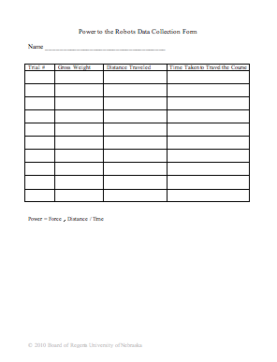
Understanding Learning: (Power to the Robots!)

Summary: The teacher will determine the level of understanding by students of this lesson through a combination of questioning and accuracy of computing the value of Power in several given situations.

Outline:
- Formative assessment of power
- Summative assessment of power

Activity: Students will complete a variety of assessment activities to demonstrate their understanding of power.

Formative Assessment
As students are engaged in the lesson ask these or similar questions:
- What is the formula to determine power?
(Power = Work divided by time OR Power = Force * Distance / Time.)
- Is more or less power used when the same amount of work is done in less time?
- Is more or less power used when more work is done in the same amount of time?
- With great effort, a student is able to keep a wall from falling and crushing his beloved teacher. Why is this not an example of power?

Summative Assessment
Students can answer the following writing prompt:
- Define power and give an example of where power can be used.
- Explain how the concept of power and work are related.

Students can complete the following quiz questions:
- A CEENBoT, which weighs 2.5 pounds, carries a 4-pound set of tools, 26 feet to an engineer in 24 seconds. What is the value for Power?
- A man lifts a 25 pound bucket of water to a 5-foot ledge in 2 seconds. What is the value for Power?

Students can complete the following performance assessment:
Students will create a new set of data using classroom robots in a fashion similar to the “O” component in this lesson. In each case, they should determine the value for Power. The teacher should make sure that instances in which no work is done due to their having been no movement.

