Project SHINE / SPIRIT2.0 Lesson:
HOW CLEAN IS YOUR ROOM?
==========================Lesson Header ==========================
Lesson Title: How Clean is Your Room?
Draft Date: May 30, 2011
1st Author (Writer): Elissa Gilger
Associated Business: BD Pharmaceutical
Instructional Component Used: Microorganisms
Grade Level: High School and/or could easily be modified for Middle School
This Teacher was mentored by:


www.bd.com

In partnership with Project SHINE grant funded through the

National Science Foundation

Content (what is taught):
- Microbiology
- Measurement
- Mathematics of volume and area

Context (how it is taught):
- Collect, grow, and analyze a microbe sample
- Measure the length, width, and height of a location and surface
- Apply the mathematics formula of volume and area to determine the theoretical amount of microbes in a location

Activity Description:
In this lesson, students investigate how pharmaceutical companies determine the cleanliness of their production line. Students will explore the types of microbes, and discuss factors that increase the reproduction rates of microbes. Next, air and surface samples will be taken using petri dishes in a specified location. Students will take measurements of the room and surface and calculate area of the surface and volume of the room. After placing the samples in an incubator for a day or two, students will count the number of microbial growths. They will then theoretically calculate the number of microbes in that location and compare the amounts with pharmaceutical standards.

Standards:

Science: SA1, SA2, SC2, SC4 Technology: TC2, TC4

Engineering: EA1,EB1, EE5 Math: MC1, MD1, MD2, ME3

Materials List:
- Lysol wipe
- 1 Regular petri dish with “Tryticase Soy Agar”
- Later: autoclave (with autoclave bag)
- Meter stick
- Marker
- Petri-seal or parafilm
- Masking tape
- Incubator
- 1 Rodac or contact plates “Tryticase Soy Agar”
Asking Questions: (How Clean is Your Room?)

Summary: Students will determine when and why a “cleanroom” is necessary.
Note: Cleanroom in business or scientific research is a title given to a location where extra care is given to restrict contamination via air, human contamination, or chemical vapors. Often, the room is enclosed from the rest of the production floor in a manufacturing plant, and employees are required to wear a specialized suit if entering that area.

Outline:
- Students discuss the definition of a “cleanroom” as well as why and where one would be needed

Activity: The teacher will show a picture of a suit required by an employee to wear in a cleanroom environment. As students become interested, ask these questions:

Questions | Answers
Would anyone have to wear this? | Yes! (I like to start off with a simple question just to get them talking.)
Alright, why would anyone have to wear this? | Limit the contamination, especially microbes they may carry into a restricted area.
What are microbes? | Most commonly bacteria, yeast, and mold carried on the person’s skin, clothing, or hair.
When would an environment have to be so clean that person would be required to wear a suit like this? | Manufactures of pharmaceutical products or researchers developing products to study diseases prevention, treatment, or cures.

Resources:
- There are many images of “cleanroom suits” on the Internet.
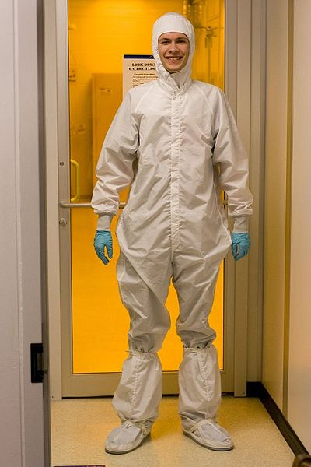

Image Courtesy of Wikimedia Commons
http://commons.wikimedia.org/wiki/File:Bunny_suit.jpg
Exploring Concepts: (How Clean is Your Room?)

Summary: Students will view a petri dish and discuss what conditions are needed to grow and view microbes.

Outline:
- Define the terms “medium” and “petri dish”
- Determine the conditions need to grow microbes
- Discuss different ways to view the microbes

Activity: In this lesson, students will view a petri dish and discuss how to grow and view microbes.

Resources:
- Pictured below is a petri dish with medium (food) and a fungus colony growth. There are 19 colonies or colony forming units (CFU) pictured.
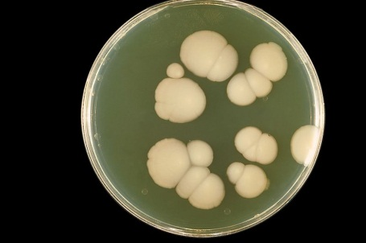

Image Courtesy of Wikimedia Commons
http://commons.wikimedia.org/wiki/File:Candida_albicans_PHIL_3192_lores.jpg
Instructing Concepts: (How Clean is Your Room?)

Microorganisms: Microorganisms or microbes are living creatures unseen to the naked eye. They can often only be viewed with the assistance of a microscope. Several organisms fall into this classification: bacteria, archaea (archeon), some fungi, and many protists. They tend to be unicellular (single-celled) but no exclusively so.

Types of Microorganisms:
1. (Monera) are unicellular, prokaryotic (no nucleus), and are ubiquitous in every habitat or biome on Earth.
2. Archaea are unicellular, prokaryotic, and were originally classified as bacteria known as archaebacteria. However, arachaea differ from bacteria in their lack of organelles, metabolic pathways, and reproduction methods. They are also found in a wide variety of biomes. Some are even referred to as extremophils because of their ability to live in harsh environments like hot springs.
3. Fungi includes two varieties of microscopic organisms: yeast and mold.
A. Yeast are unicellular, eukaryotic (nucleus present), and typically oval or spherical in shape. They are found in soils or as powdery coating on plant material in nature. However, they are important anaerobes fermenting ethyl alcohol for wines and beer as well as producing carbon dioxide used in the raising of bread dough.
B. Mold (includes mildews, rusts, and smuts) are multicelluar, eukaryotic and are filamentous in shape. They often live on the surface of another organisms or food sources and are referred to as saprobes (consumers of dead organic matter).
4. Protists includes some 30-40 dissimilar phyla loosely defined as unicellular or multicellular organisms without specialized tissue. They vary in food cycle types, life cycle types, and mechanisms of movement.

Colony Forming Units (CFU’s): Microbes as stated earlier can often only be viewed using a microscope. However, another technique can be used by allowing the microbes to reproduce into colonies. These colonies can then be viewed and counted using the naked eye. Each growth is known as a Colony Forming Unit or CFU.

Conditions need to Grow Microbes: Microbes require three conditions to be met to grow or reproduce rapidly. They are the following:
1. Plenty of food known as “medium”.
2. Moist conditions.
3. An adequate temperature. (neither too cold nor too hot often the ideal incubation temperature for growing microbes is 32˚C or 90˚F)
Organizing Learning: (How Clean is Your Room?)

Summary: Students will investigate, take notes, and apply the principles of microbiology, mathematics, and measurement.

Outline:
- Students will take notes over classification of microbes
- Student pairs will collect microbe samples, incubate, and later analyze
- Students will calculate the area of a surface and volume of a room to aid in analyzing their microbe sample

Activity: In this lesson, student pairs will collect air and surface samples in a room. As students wait for the air sample, they will take measurements of the room and a surface. Later they will calculate the area of the surface and volume of the room. Next, students will place the samples in an incubator and after a day or two they will count the number of microbial growths or colony forming units (CFU’s). Finally, they will theoretically calculate the number of microbes in that location and compare the amounts with pharmaceutical standards.

Attachments:
S097_Medical_Cleanroom_O_lab.doc
S097_Medical_Cleanroom_O_labsolution.doc



Understanding Learning: (How Clean is Your Room?)

Summary: Students will answer questions related to microbes contamination, area, volume, and pharmaceutical classification of locations based on the samples collected.

Outline:
- Formative assessment of Microorganisms
- Summative assessment of Microorganisms

Activity: Students will complete quiz and writing assessments about microorganisms.

Formative Assessment: As students are engaged in the lesson ask these or similar questions:
- Can students define “microbe”?
- Can students recognize suitable conditions for growing microbes?
- Are students able to explain how areas are contaminated by microbes?
- Were the students able to give suggestions for how homes, schools, and businesses can limit or reduce microbe contamination?

Summative Assessment: Students will be asked to complete questions related to analysis of the lab data.
- If there surface area of a desk is 0.6 m², and the colony forming units grown from the sample are 8. Determine the “cleanroom” grade and theoretical amount of microbes that could possible cover the full surface of the desk.
- If a bowl of mash potatoes is left sitting over night on the counter, should a person eat them? Explain why or why not.

Students can complete the following writing prompt:
A microbiologist takes samples of a “cleanroom” Grade A where medical syringes are made and the samples indicate the quality has down graded to Grade C. She asks the plant manager to shut down production and require the workers to wear sterile shoe coverings and face masks. The plant manager denies her request stating her concerns are minimal in comparison to the loss of profit and high demand for syringes due to an immediate vaccination of a rampant disease. Would you agree or disagree with the microbiologist or plant manager? Defend your answer by providing three support reasons.

