Project SHINE Lesson:
Gott-berg?
==========================Lesson Header ==========================
Lesson Title: Gott-berg?
Draft Date: 6/2011
1st Author (Writer): Jessica A Eckman
Instructional Component Used: Mixtures
Grade Level: 6-8
This Teacher was mentored by:

and

http://www.dustersrestaurant.com/index.htm

In partnership with Project SHINE grant funded through the

National Science Foundation

Content (what is taught):
- Definition and properties of mixtures
- Distinguish between types of mixtures

Context (how it is taught):
- Tour of commercial root beer production
- Lab creating root beer
- View examples of types of mixtures
Activity Description:
First, students will discuss mixtures and properties of mixtures. Then, explore mixtures by touring a local restaurant that produces its own root beer. Students will complete a lab and create their own root beer while completing the attached lab guide. They will indicate at the end of each step whether the mixture is homogeneous or heterogeneous at that point. Finally, students will demonstrate understanding of homogeneous and heterogeneous mixtures and will be able to identify examples of each.

Standards:

Math: MD1 Science: SB1

Technology: TB4 Engineering: EA1, ED3

Materials List:
- 2 2/3 cups granulated sugar
- 2 teaspoon McCormick root beer concentrate
- 2 cups very hot water
- 2 cups corn syrup
- Ice for cups
Asking Questions: Gott-berg?

Summary: Students will discuss mixtures and properties of mixtures.

Outline:
- Students will view a short clip on the history of root beer
- Students will discuss how root beer is a mixture
- Students will discuss the definition of mixtures and properties of mixtures

Activity: Students will view a short clip (see link below) on the history of root beer. Next, a class discussion of the video will be conducted where the concept of mixtures and properties of mixtures should be discussed.

Questions | Answers
Is root beer a pure substance? If not, what type of matter is it? | Root beer is not a pure substance, it’s a mixture!
What is a mixture? | Mixtures are the combination of two or more substances each retaining their own separate identity.
What makes it a mixture? | A mixture can involve two elements like zinc (Zn) and copper (Cu) in a penny or two compounds like table salt (NaCl) and water (H₂O). However once a chemical reaction or chemical bond occurs the substance is not a mixture!
What types of mixtures are there? | Heterogeneous and Homogeneous.
What are examples of heterogeneous mixtures? | Mixing coffee cake, root beer float etc.
What are examples of homogenous mixtures? | Mixing Kool-Aid, vinegar, etc.

Resources: Root Beer History Video Clip: http://www.facebook.com/video/video.php?v=95386472104
Exploring Concepts: Gott-berg?

Summary: Students will explore mixtures by touring a local restaurant that produces its own root beer.

Outline:
- Students will experience “Root Beer” production tour
- Students will complete tour guide worksheet

Activity: Students will tour a restaurant that manufactures its own root beer. Students will record steps in the process they observe while on the tour. Students will also make note of safety features and sanitary precautions they observe along the way. Students will record a list of ingredients used that includes the amount/proportions.

Attachments: Tour Worksheet Guide: S098_SHINE_Gott_Berg_E_Tour.doc
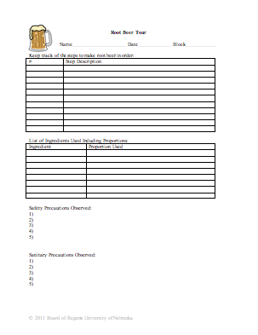

Instructing Concepts: Gott-berg?

Mixtures

Definition: Mixtures are the combination of two or more substances each retaining their own separate identity. So, each substance maintains its own physical and chemical properties, but their combination may result in varied physical properties of the mixture (ie melting point, viscosity, density etc.).

Distinguishing a Mixture from a Chemical Reaction: A mixture can involve two elements like zinc (Zn) and copper (Cu) in a penny or two compounds like table salt (NaCl) and water (H₂O). However once a chemical reaction or chemical bond occurs the substance is not a mixture! An example would be placing sodium (Na) in water (H₂O). Sodium creates a new chemical bond producing a new substance with new physical and chemical properties known as sodium hydroxide (NaOH). So, if a new chemical formula must be written after two or more substances combine it is not a mixture.

Separating Mixtures: Mixtures can always be separated by physical means as each component in the mixture retained its physical properties. Common methods: filtration (particle size), distillation (boiling points), chromatography (rates of migration in a mobile stage), solubility (ability to dissolve in a solvent), or magnetism.

General Types of Mixtures: Mixtures can be most broadly classified as homogenous or heterogeneous. In a homogeneous mixture, the components are evenly distributed or appear uniform even under a microscope, while in a heterogeneous mixture the components are irregularly distributed and appear varied.

Identifying the Type of Mixture:
1. Heterogeneous Mixtures are typically easier to identify than homogenous mixtures as the combination of substances does not appear uniform. There are two kinds of heterogeneous mixtures suspensions and colloids.
A. Suspensions often involve particles large enough to settle out of the liquid or gas with which they are intermixed. So, these mixtures can be identified by their ability to settle into layers or filter apart. They often need to be shaken or stirred to remain mixed. Examples of suspensions are a snow globe, some salad dressings, and most paint.
B. Colloids have intermediately sized particles that do not settle a part. These are identified by their size, varied distribution of substances, and the Tyndall effect. To test the Tyndall effect a focused beam of light is directed onto the substance, if the light becomes scattered or appears cloudy while attempting to pass through the substance it is likely a colloid (if the particles are intermediately sized). Examples of colloids are milk, deodorant, and fog.
2. Homogenous mixtures are typically called solutions and often are mistaken for pure substances. They can be distinguished from heterogeneous mixtures in that they do no separate into distinct layers over time, do not filter apart, and will let light pass through them (Tyndall effect). Examples of solutions are salt water, carbonated beverages, and vinegar.
Organizing Learning: Gott-berg?
Summary: Students will complete a lab and create their own root beer.

Outline:
- Instructor will give lab overview
- Instructor and students will discuss lab safety and sanitation precautions
- Students will break into assigned lab groups
- Students will complete the recipe and lab worksheet

Activity: Students will complete the root beer recipe while completing the lab guide (see attached file: S098_SHINE_Gott_Berg_O_Lab.doc). Students will indicate at the end of each step whether the mixture is homogeneous or heterogeneous.

Attachments: Root Beer Lab and Lab Guide: S098_SHINE_Gott_Berg_O_Lab.doc
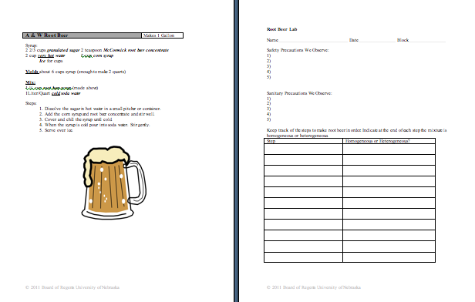

Understanding Learning: Gott-berg?

Summary: Students will demonstrate understanding of homogeneous and heterogeneous mixtures and will be able to identify examples of each.

Outline:
- Formative assessment of mixtures
- Summative assessment of mixtures

Activity: Students will complete writing and quiz assessments over their understanding of mixtures.

Formative Assessment: As students are engaged in the lesson ask these or similar questions:
- Can students identify a homogeneous vs. heterogeneous mixture at each step of the lab?
- Are students aware of safety and sanitation issues involved with manufacturing consumable products?
- Are students able to identify similarities and differences between our lab and commercial root beer production?

Summative Assessment: Students can complete the following writing prompt:
Explain the difference between a homogeneous and heterogeneous mixture and provide at least one example of each.

Students can complete the attached quiz over homogeneous vs. heterogeneous mixtures.

Attachments: Quiz and Answer Key: S098_SHINE_Gott_Berg_U_Assessment.doc
