Root Beer Tour
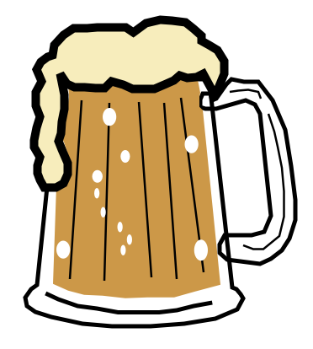

Name_____________________ Date_____________ Block____________

Keep track of the steps to make root beer in order:
# | Step Description

List of Ingredients Used Including Proportions:
Ingredient | Proportion Used

Safety Precautions Observed:
1)
2)
3)
4)
5)

Sanitary Precautions Observed:
1)
2)
3)
4)
5)

