Project SHINE Lesson:
Light Turning on Light
==========================Lesson Header ==========================
Lesson Title: Light Turning on Light
This Teacher was mentored by:


www.behlenmfg.com

and

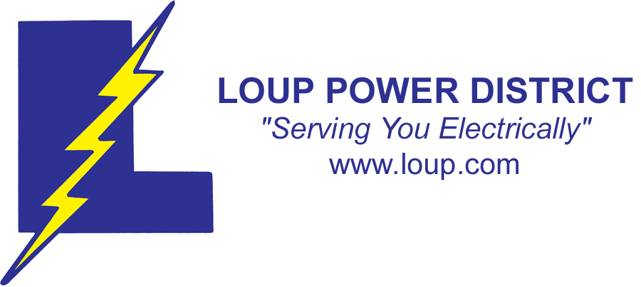
www.loup.com

In partnership with Project SIn partnership with Project SHINE grant funded through the

National Science Foundation

Draft Date: 13 June 2011
1st Author (Writer): Russell Kreis
Associated Business: Behlen Mfg. Co. and Loup Power District
Instructional Component Used: Photovoltaic Cells
Grade Level: Collegiate

Content (what is taught):
- Basic parts of an atom
- Light is energy and creates current flow
- Measurement of output energy from photovoltaic cell

Context (how it is taught):
- Light strikes the photovoltaic cell and creates energy
- Amount of light and angle of light striking cell affects energy output
- Multi-meter will verify and confirm output
Activity Description:
The student will gain an understanding of photovoltaic cells and how they can create energy from light striking them. By using a multi-meter, students can verify the production of energy and see how it could be used to augment a business / home with extra energy.

Standards:

Math: MD1 Science: SB1

Technology: TF1 Engineering: EB1, EB2

Materials List:
- Photovoltaic Cell
- Multi-meter
- Circuit Connection Components
Asking Questions: (Light Turning on Light)

Summary: Students are asked to analyze and measure the energy output of a photovoltaic cell. They should understand the theoretical operation of how a photovoltaic cell works.

Outline:
- Discuss the sub-atomic structure of an atom and how light can produce current
- Demonstrate how a photovoltaic cell operates and how to connect into a circuit
- Use a multi-meter to measure the output of the photovoltaic cell
- Connect the photovoltaic cell to a circuit and observe its ability to create energy

Activity: Connect a photovoltaic cell to a circuit and observe its output with varying light conditions. Connect a multimeter to the circuit across the photovoltaic cell and confirm results.

Questions | Answers
How does light create current? | Light is energy that knocks an electron into the conduction band for current flow.
If you increase the light, what happens to the current? | More light, more current
Do you have current flow if no light is received? | No
Does the angle of the light striking the photovoltaic cell matter? | Yes
Can photovoltaic cells augment power consumption by a business? | Yes
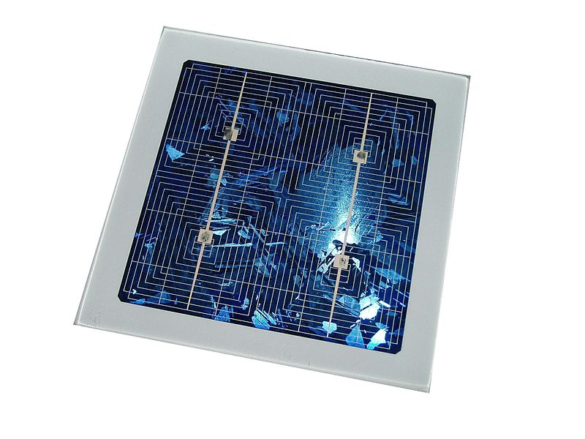
Image Source: Wikimedia Commons
http://commons.wikimedia.org/wiki/File:Silicon_photovoltaic_array.jpg

Resources:
- Photovoltaic Cell
- Multi-meter
Exploring Concepts: (Light Turning on Light)

Summary: Students will be using a photovoltaic cell and multi-meter to verify and confirm the production of current as light is striking the cell. The light should be varied so the student can analyze the best practice for maximum output potential.

Outline:
- The photovoltaic cell creates current when light is shined on the cell
- The multi-meter will confirm energy generation
- Varying the light strength and angle will affect the amount of energy produced
- A chart can record angles for every 10 degrees to find the 6 best angles for energy produced

Activity: Create a chart starting with 0 degrees and going through 90 degrees in 10 degree increments. Attach a photovoltaic cell to a multimeter and place it horizontal to a light source and measure the output of the cell. After recording the voltage, tilt the cell 10 degrees towards the light source and measure again, and through all angles in the chart.

Resources:
- Photovoltaic Cell
- Multi-meter
Instructing Concepts: (Light Turning on Light)

Photovoltaic Cells (Solar Cells)
Photovoltaic (PV) cells are structures designed to allow light to be directly converted into electricity at the atomic level.

Components to Photovoltaic Cells:
- Photovoltaic Effect: PV cells are able to create electricity at the atomic level using the photovoltaic effect. Often the photovoltaic effect is confused with the photoelectric effect. One is related to the other as both begin with the basic understanding that the universe is created of two core entities: matter and energy. Matter is anything that has mass and takes up space. In physics energy is defined as a source providing the ability to do work (e.g. light, heat, sound, electricity). In the photoelectric effect, there are two components: photons (energy) and electrons (matter). Photons are light “packets”. Each one carries a specific quantity (quanta) of energy revealed in different frequencies of light (higher energy photons are found in higher frequencies of light waves). Using the correct light frequency (photons) focused on a material (usually metal), it is possible to knock off or release electrons. So, the photoelectric effect uses light to eject electrons. Similarly, in the photovoltaic effect photons are used to eject the electrons, but these electrons are harnessed to produce an electric current or electricity.
- Semi-Conductor: The flow of electrons or an electric current is possible within the photovoltaic effect if a conductor is present. Electricity is conducted through a material by moving electrons through orbitals at varying energy levels in atoms. Electrons move from lower energy levels (valance band) to higher energy levels (conduction band). The energy difference between these levels is known as the band gap. Semi-conductors have an intermediate band gap. Meaning they require more energy to move electrons than a conductor, but less than an insulator. Once electrons are moved they create electron “holes” or unoccupied orbitals in the valance band and easily released electrons in the conduction band. In PV cells, semi-conductors are often used because they can regulate conduction band electrons and electron “holes” more readily, especially if the semi-conductor is “doped” or impurities are added.
- P-N Junction (Photodiode): The photovoltaic effect within a PV cell is able to produce an electric current by using a P-N junction. The P-N Junction is made of two kinds of semi-conductors. The N-type (N for Negative or electron-rich) is doped to have a high density of electrons and few holes, while the P-type (P for Positive or electron-poor) is doped to be the opposite. Electrons flow from areas of high to low concentration. The difference between these concentrated areas is known as voltage. A P-N junction regulates the voltage, so current only flows in one direction resulting in an electric current.

Operation of Photovoltaic Cells (Solar Cells):
PV Cells are able to convert light into electricity by first allowing radiant energy from the sun to pass through a transparent layer (glass). A small portion of the light frequencies (10 – 17% with technology commercially available in 2011) (photons) are absorbed ejecting electrons from the doped N-type semiconductor layer. The amount depends on intensity and angle of light sent and the continuing development of the manufacturing technology. These electrons are passed to a conductor, which completes a circuit back to the P-type semiconducting layer. After transporting electrical energy utilized by electrical devices or stored in batteries, the electrons will fill “holes” in the P-type semiconducting layer. Due to electrons being deposited in P-type semiconductor layer the voltage increases forcing the electrons to move across the junction into the N-type semiconductor allowing the process to repeat itself. As technology advances, improvements in conversion efficiencies demonstrated in the laboratory (some approaching 40%) may become commercially available, subsequently lowering costs.
Organizing Learning: (Light Turning on Light)

Summary: The student will connect a photovoltaic cell to a circuit and verify all aspects of operational characteristics.

Outline:
- Light creates current in the photovoltaic cell, which can be used by a load device
- Varying the angle of the light can increase and decrease the energy produced
- Varying the amount of light striking the photovoltaic cell can change the amount of energy produced

Activity: Connect a photovoltaic cell to a load device, and place a multimeter in parallel across the photovoltaic cell. Measure and record the voltage produced by the cell. Vary the angle of the light striking the cell and also the amount of light able to strike the cell. Use a different chart to vary the distance of the light source to the cell. Compare the two charts and write down all varied aspects of the light in reference to the voltage produced by the cell.

Resources:
- Photovoltaic Cell
- Multi-meter

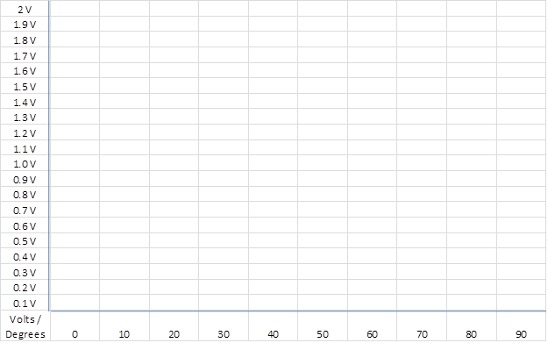
Understanding Learning: (Light Turning on Light)

Summary: The students will write a one page report (containing three paragraphs) on the creation of current in a photovoltaic cell, the effect of varying the light striking the photovoltaic cell, and theorizing why a light in the circuit cannot power itself.

Outline:
- Formative assessment of photovoltaic cells
- Summative assessment of photovoltaic cells

Activity:
Formative Assessment: As students are engaged in the lesson ask these or similar questions:
- Can the student describe how light creates current in the photovoltaic cell?
- Does the student understand why varying the angle of the light, and the amount of light changes the amount of current produced?
- What was the maximum energy output of the photovoltaic cell recorded by the student?
- Did the student hook up the test equipment properly and read the multi-meter properly?

Summative Assessment: Students will prepare a paper to describe the creation of current in the photovoltaic cell from the sub atomic level in a paragraph. The student will then describe how they obtained the maximum output of the cell, and what variations of the light striking the cell did to its output. In the last paragraph, they will theorize why the light from the circuit cannot fully power the circuit by itself.

