Project SHINE Lesson:
Using Inquiry in Business
==========================Lesson Header ==========================
Lesson Title: Using Inquiry in Business
Draft Date: June 15, 2011
1st Author (Writer): Teresa Walters
Associated Business: Kawasaki
Instructional Component Used: Scientific Inquiry
This Teacher was mentored by:

www.kawasakilincoln.com

In partnership with Project SHINE grant funded through the

National Science Foundation

Grade Level: 7-12

Content (what is taught):
- Using and applying the scientific inquiry process
- How scientific inquiry is used in business

Context (how it is taught):
- The students will be given remote control vehicles that are malfunctioning
- The students will use scientific inquiry to try to solve the problem

Activity Description:
The students will be given remote control vehicles that are not functioning properly. They will use scientific inquiry to determine why the vehicle is not working correctly.

Standards:

Math: ME1, ME2 Science: SA1, SA2, SB1

Technology: TD3 Engineering: EA1

Materials List:
- Remote control vehicles
- Kawasaki Video:
http://www.motorbiketv.info/video/fuel-motorbike/jet-ski-ultra-300xlx-manufacturing-the-king-of-watercraft
- Index cards
Asking Questions: (Using Inquiry in Business)

Summary: The students will be shown a video highlighting the Kawasaki Company. Students will be asked questions about scientific inquiry and how is it used in a business (such as Kawasaki). The students will look at a section of the video and they will list the steps they would use to solve a hypothetical problem with a machine.

Outline:
- Students will be asked how they have used scientific inquiry
- Students will watch a video on Kawasaki
- Students will be asked why scientific inquiry is important to them, as well as how it could be used to solve problems in industries (such as Kawasaki)
- Students will be asked to list the steps of the scientific process

Activity: Students will be asked to describe how they have used scientific inquiry and why it is an important process to use. Students will watch a video on Kawasaki. Then they will be asked to view one section of the video and list the steps they would use to solve a “problem” with the machine. As a class, compile a list of steps used in the scientific inquiry process.

Questions | Answers
Can you think of some ways you have used scientific inquiry? | Problem solving at school, home, etc.
Why is the scientific inquiry process important? | Great way to solve problems
Can you think of some ways a business, such as Kawasaki, might use scientific inquiry? | If something doesn’t work (machine, product, etc.) what can be done?
Can you list the steps of the scientific inquiry process? | - Question  - Observations  - Hypothesis  - Test Hypothesis  - Analyze/Draw Conclusions  - Communicate

Resources: Kawasaki Video
http://www.motorbiketv.info/video/fuel-motorbike/jet-ski-ultra-300xlx-manufacturing-the-king-of-watercraft
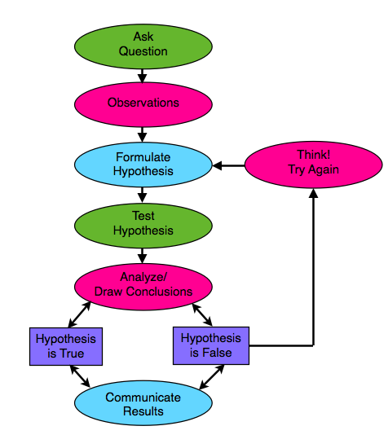
Exploring Concepts: (Using Inquiry in Business)

Summary: Students will be given index cards with each step of the scientific inquiry process listed on it. They will also have corresponding cards with the description of each step. The goal is to try and match up the correct description with the correct step.

Outline:
- Students will be given index cards with each step of the scientific inquiry process listed on it
- Students will also be given index cards with descriptions of each step
- The students will try to match each step with the correct description

Activity: The students will be exploring the definitions of each step of the scientific inquiry process. They will be given a set of index cards with each step listed on a separate card. They will also be given a set of cards with a definition of each step. The students will try to match the correct step to the correct definition. For the information that goes on the cards see the table below.

Cards-Steps | Cards-Definition
Ask a question | Can be measured,  usually the first step
Observations | Made regarding the  phenomenon being studied
Hypothesis | Might explain  observations
Test Hypothesis | Experiment
Analyze/Draw Conclusions | Used to see if hypothesis is supported,  may be retested and/or revised
Communicate | Publish in an article  (scientific journal, etc.)
Instructing Concepts: (Using Inquiry in Business)

Scientific Inquiry

Scientific Inquiry Process
Scientific Inquiry is a very systematic process that scientist use to understand phenomena that are present in the world. The process must be followed exactly without any deviation or any results that are obtained might not be valid. There are six basic steps to the scientific inquiry process.

Step One: Ask a Question
In this step you ask a question that you want answered about something that you have observed. If scientific inquiry is to provide an answer, the question must be framed in such a way that it can be measured preferably with a number.

Step Two: Make a Set of Observations Regarding the Phenomenon being Studied
The scientist will observe the phenomenon that is being studied without out any bias. It is important that the phenomena be researched in addition to observing it so that past information will be noted and past mistakes will not be repeated.

Step Three: Form a Hypothesis That Might Explain the Observations
The hypothesis should be framed in a format like “If I do this, then this will happen”. This hypothesis must be measurable and should help you answer your original question.

Step Four: Test your Hypothesis by Doing an Experiment
You will conduct an experiment that will prove your hypothesis true or false. It is important that the experiment be unbiased and fair. To do this you can only change one variable at a time and keep everything else the same. Doing this insures that any change observed will be as a result of your experiment and not some other factor.

Step Five: Analyze your Data and Draw Conclusions
Once your experiment is done you need to analyze your measurements and see if your hypothesis is true or false. If your hypothesis is false (a common occurrence), you should start the entire process again with a new hypothesis. Even if you find your hypothesis to be true you may want to devise another experiment to test your hypothesis again. Multiple experiments that validate your hypothesis make your conclusion stronger.

Step Six: Communicate your Results
If your hypothesis stands up to multiple tests you should report your results in a final report. This might take the form of a journal article in a professional or scientific journal.
Organizing Learning: (Using Inquiry in Business)

Summary: Using the scientific inquiry process, the students will try to determine why the remote control vehicle is not working properly.

Outline:
- The students will be given remote control vehicles that have “problems”
- The students will use scientific inquiry to try to figure out why the vehicles are not functioning properly
- The students will write a report summarizing their results
- The students will share their results with the class

Activity: The students will be given remote control vehicles that are not functioning properly. The students will use the scientific inquiry process to try to determine the cause of the malfunctions. This will simulate what might happen in the business industry, either on new products or current products. After finishing their testing, the students will write a report summarizing their results. Each student will share his or her results with the class.
Understanding Learning: (Using Inquiry in Business)

Summary: Students will write a summary of the steps they followed to complete the remote control vehicle testing. Students will also think of ways scientific inquiry can be used in the business industry.

Outline:
- Formative assessment of scientific inquiry
- Summative assessment of scientific inquiry

Activity: Students will complete writing assessments relating to scientific inquiry.

Formative Assessment: As students are engaged in the lesson ask these or similar questions:
- Did the students ask a question and form a hypothesis?
- Did the students test their hypothesis?
- Did the students formulate a conclusion?

Summative Assessment: The students will complete the following essay questions.
- Explain the process you followed to determine why your remote control vehicle did not function properly.
- Explain how scientific inquiry is used in the business industry. Give specific examples in your answer.

