Project SHINE Lesson:
This Teacher was mentored by:


www.loup.com

In partnership with Project SHINE grant funded through the

National Science Foundation

If A Tree Falls In A Forest…?
==========================Lesson Header ==========================
Lesson Title: If A Tree Falls In A Forest...?
Draft Date: 6/13/11
1st Author (Writer): Bob Talbitzer
Associated Business: Loup Power District
Instructional Component Used: Community Ecology
Grade Level: 9th & 10th Life Science

Content (what is taught):
- Primary Succession
- Secondary Succession

Context (how it is taught):
- Creating a grass/hay infusion and observing the change in microbial life that occurs over time
Activity Description:
In this lesson students will investigate what happens to the forms of life over time in a hay infusion. Students will create an ecosystem, examine the change that occurs over time, and draw conclusions on the succession of life that they witness.

Standards:

Science: SC4, SC5

Materials List:
- 300 ml glass beaker
- Hay, grass or leaf litter
- H₂O
- Compound microscope
- Eye dropper
- Microscope slides
- Cover slip
- Protist identification keys/guides
Asking Questions: (If a Tree Fell In A Forest...?)

Summary: Students will watch a segment of the History Channel’s program entitled “Life After People”.

Outline:
- Show the segment “Life After People” 150 years (link below).
- Have students generate a list of potential changes they witnessed to the life over this time frame.

Activity: Students will be shown a segment of the History Channel’s program entitled “Life After People”. This particular segment deals with what happens to the Earth 150 years after people. Upon completion of the video students will be asked various questions dealing with potential changes that life on Earth will exhibit during this time.

Questions | Answers
What happens to an ecosystem when it is disturbed by a natural or manmade action? | Organisms are destroyed.
What might be some examples of natural and manmade interactions? | Fire, Hurricanes, Floods, Deforestation, etc.
Does the type of life change in the disturbed areas? | Yes
Is the change that occurs predictable? | It depends on whether the other abiotic and biotic parameters remain constant in the years after the disturbance.
How long might this change take to occur? | Again depends on the abiotic and biotic parameters.

Resources: Life After People 150-300 Years After
http://www.youtube.com/watch?v=JlA74uyhxXg&feature=related
Exploring Concepts: (If a Tree Fell In A Forest...?)

Summary: Students complete the introductory activity on primary and secondary succession.

Outline:
- Students read the scenario dealing with a volcanic eruption
- Students answer the questions based on their understanding of the scenario and its application to ecological succession
- Students discuss their answers with the class

Activity: Students will read a brief description of what happened on the Island Krakotoa after a volcanic eruption. After they read the activity, students will be asked various questions on what they thought might have happened to the plant life on the island in the years that followed the eruption. Students will then discuss their opinions with the class.

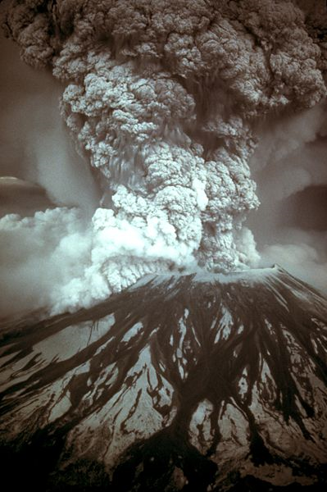
Image Source: Wikimedia Commons
http://commons.wikimedia.org/wiki/File:MSH80_eruption_mount_st_helens_05-18-80-dramatic-edit.jpg

Attachments: S105_SHINE_If_Tree_Falls_in_Forest_E_Krakota.doc
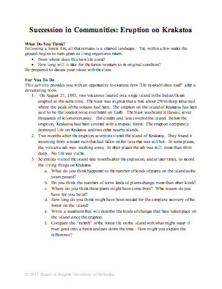
Instructing Concepts: (If a Tree Fell In A Forest...?)

Community Ecology

Ecology: is the scientific study of interactions of wild life and their environment.
Levels of Organization for Ecology: Each level is designated by its focus of study from one organism, groups of organisms, or an entire planet’s biological system.
- Species: encompasses only a set of organisms with enough similarities that they are able to breed and produce fertile offspring.
- Population: encompasses several individuals of the same species living in the same location.
- Community: encompasses multiple species populations living simultaneously in a defined location
- Ecosystem: encompasses all the communities or organisms along with the nonliving, environmental components (air, soil, sunlight, water etc.) within a specific area, which affect those organisms
- Biosphere: encompasses an entire planet’s features relating to living organisms such as the air, land, and water
Energy Flow: There are two general kinds of energy organisms: producers and consumers. Producers create their own energy or food supply from a non-living source using either photosynthesis or chemosynthesis. On the contrary, consumers rely on other organisms for their energy or food supply. There are several different types such as: herbivores, carnivores, omnivores, detritivores, and decomposers. Ecologists will often study the interaction between them and develop food chains or food webs based on the trophic structure or feeding relationships.
Community Interactions: There are three primary interactions: competition, predation, and symbiosis. Competition occurs when organisms of the same or different species attempt to use a resource (water, nutrient, food, or space) in the same place at the same time. Predation is when one organism captures and feeds on another organism. This interaction involves a predator, the organism that does the killing and eating, and a prey, the organism consumed by the predator. Symbiosis is any relationship in which two species live closely together. There are three varieties of symbiosis: mutualism, commensalism, and parasitism each differing by how organisms involved benefit.
Ecological Succession: Ecological succession studies the series of predictable changes that occur in a community. These changes maybe as a response to a natural or human disturbance, which may have occurred slowing or rapidly. Often, in either case the older inhabitants gradually die out and are replaced by new inhabitants. There are two kinds of successions: primary and secondary. Primary succession studies the changes that occur to a surface where no soil currently exists such as a land laid bare by volcanic eruptions (covered only in lava rock and volcanic ash). Secondary succession studies changes in an existing community due to a disturbance without soil being removed such as a wild fire. The survival and growth of organisms or ecosystems going through a succession are determined by looking at two main types of factors: biotic and abiotic. Biotic factors are the biological influences on the organism or ecosystem from birds to bacteria. Outside of living organisms there are the nonliving or abiotic factors such as climate (temperature, precipitation, humidity), wind, nutrient availability, sunlight and soil type to consider.
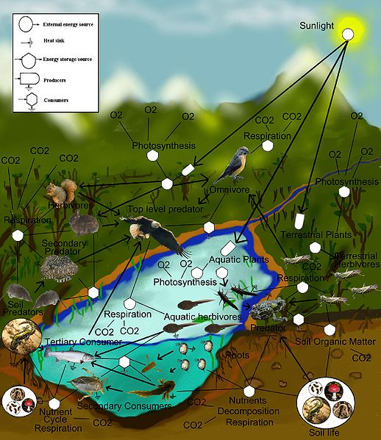
Image Source: Wikimedia Commons
http://commons.wikimedia.org/wiki/File:FoodWeb.jpg

Organizing Learning: (If a Tree Fell In A Forest...?)
Summary: Students will create a hay/grass infusion microhabitat to study the microbial succession.

Outline:
- Students will complete a lab exercise on ecological succession
- Analyze results and draw conclusions on the changes in microbial life that occurred over time
- An extension activity relating to bacteria is possible

Activity: Students will collect a sample of leaf or hay material and place it in a beaker with distilled water. Students will initially sample the solution in the beaker. A wet mount slide will be created of the solution. The slide will be observed under both low and high power. All protist observed will be identified and sketched. Congruent samples will be then taken and observed on day 4, 7, 10, and 13. For a detailed laboratory exercise see attached file: S105_SHINE_If_Tree_Falls_in_Forest_O_Lab.doc. As an extension, instructors could have students observe bacteria by following guidelines on staining protocols (see Resources below).

Resources:
- http://www.cliffsnotes.com/study_guide/Staining-Techniques.topicArticleId-8524,articleId-8413.html
- Protists: Algae, Amoebas, Plankton, and Other Protists (A Class of Their Own) by Rona Arato

Attachment: S105_SHINE_If_Tree_Falls_in_Forest_O_Lab.doc
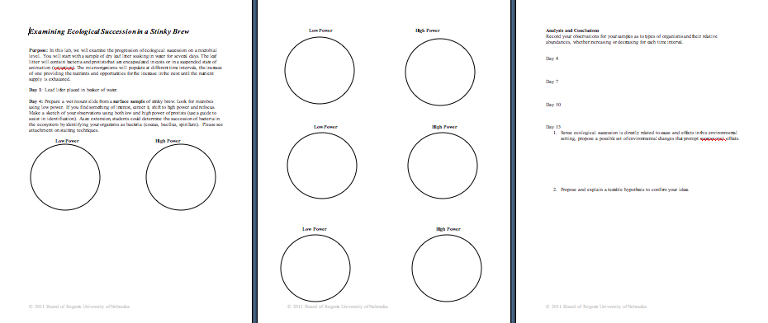
Understanding Learning: (If a Tree Fell In A Forest...?)

Summary: Students will demonstrate their understanding of the process of secondary succession by utilizing an online computer applet which includes a summative quiz.

Outline:
- Formative assessment of community ecology
- Summative assessment of community ecology

Activity:
Formative Assessment: As students are engaged in the lesson ask these or similar questions:
- Can the students explain the similarities and differences between primary and secondary succession?
- Can students identify the causes of secondary succession?

Summative Assessment
- Students will access http://www.mrphome.net/mrp/succession.swf and run through the tutorial. Students will take the quiz at the end of the program.
- Students will take a quiz over primary and secondary succession (attached).

Attachments:
- Student Quiz: S105_SHINE_If_Tree_Falls_in_Forest_U_Quiz.doc
- Quiz Answer Sheet: S105_SHINE_If_Tree_Falls_in_Forest_U_QuizAnswers.doc
