Project SHINE Lesson:
Predator vs. Prey
==========================Lesson Header ==========================
Lesson Title: Predator vs. Prey
Draft Date: June 10, 2011
1st Author (Writer): Suzy Goedeken
Associated Business: Loup Power District
This Teacher was mentored by:


www.loup.com

In partnership with Project SHINE grant funded through the

National Science Foundation

Instructional Component Used: Community Ecology
Grade Level: Middle School

Content (what is taught):
- Understand the relationship between predator and prey
- Describe how habitat can help or hinder predation

Context (how it is taught):
- A predator prey simulation will be completed using the computer
- An owl pellet dissection will be completed and analyzed

Activity Description:
In this lesson, students will investigate the relationship between the predator and prey. The computer will be used to complete a simulation, and an owl pellet will give a hands-on approach to this topic.

Standards:

Math: ME1, ME2 Science: SC4

Materials List:
- Owl Pellets
- Camera
- Computer or iPad
- Colored Toothpicks
- Timer
Asking Questions: (Predator vs. Prey)

Summary: Loup Power District is in a 30-year license renewal process. Through this process, many ecological studies have been completed and two endangered species have been found on their property. With these endangered species present, Loup is finding they need to be environmentally conscious and adjust their dredging schedule to accommodate the species mating seasons.

Outline:
- Demonstrate an understanding of predator
- Demonstrate an understanding of prey
- Demonstrate and understanding of the predator-prey relationship
- Determine vocabulary

Activity: Students will be shown a video clip of a wolf hunting for dinner (link below). After this experience, key vocabulary (predator, prey, ecosystem, and habit) will be discussed. The vocabulary words will be put on a whiteboard and students will write down what they think each of these terms represent. The teacher should guide the discussion.

Questions | Answers
What is a predator? | Organism that is hunting
What is a prey? | Organism that is being hunted
What is an ecosystem? | All organisms living in a particular area.
What is a habitat? | Natural home or environment of an organism

Resources:
- Wolf Hunting Dinner Video: http://www.youtube.com/watch?v=2jXxtQRy47A

Exploring Concepts: (Predator vs. Prey)

Summary: Students will complete a toothpick activity to represent a predator prey situation.

Outline:
- Students will complete a toothpick activity that simulates predator/prey
- Students will analyze and discuss the results of the activity
- Discussion about how this is related to the predator prey relationship will be conducted

Activity: Place twenty multicolored colored toothpicks in a one-meter section of real grass. Students are given 5 seconds to collect the most toothpicks they can. The students with largest number of toothpicks can be given a prize. Analysis and discussion will be made about the color(s) that are picked up first and the color of toothpicks that are left in the grass. The colors that blend in with the grass (greens) will be the ones that are left in the grass. The blues, reds, and yellows will be the ones picked up first do to standing out from the environment.

Materials:
- Colored Toothpicks
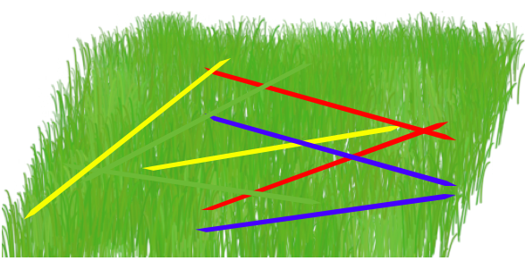
Instructing Concepts: (Predator vs. Prey)

Community Ecology

Ecology: Ecology is the scientific study of interactions of wildlife and their environment.
Levels of Organization for Ecology: Each level is designated by its focus of study from one organism, groups of organisms, or an entire planet’s biological system.
- Species: encompasses only a set of organisms with enough similarities that they are able to breed and produce fertile offspring.
- Population: encompasses several individuals of the same species living in the same location.
- Community: encompasses multiple species populations living simultaneously in a defined location
- Ecosystem: encompasses all the communities or organisms along with the nonliving, environmental components (air, soil, sunlight, water etc.) within a specific area, which affect those organisms
- Biosphere: encompasses an entire planet’s features relating to living organisms such as the air, land, and water
Energy Flow: There are two general kinds of energy organisms: producers and consumers. Producers create their own energy or food supply from a non-living source using either photosynthesis or chemosynthesis. On the contrary, consumers rely on other organisms for their energy or food supply. There are several different types such as: herbivores, carnivores, omnivores, detritivores, and decomposers. Ecologists will often study the interaction between them and develop food chains or food webs based on the trophic structure or feeding relationships.
Community Interactions: There are three primary interactions: competition, predation, and symbiosis. Competition occurs when organisms of the same or different species attempt to use a resource (water, nutrient, food, or space) in the same place at the same time. Predation is when one organism captures and feeds on another organism. This interaction involves a predator, the organism that does the killing and eating, and a prey, the organism consumed by the predator. Symbiosis is any relationship in which two species live closely together. There are three varieties of symbiosis: mutualism, commensalism, and parasitism each differing by how organisms involved benefit.
Ecological Succession: Ecological succession studies the series of predictable changes that occur in a community. These changes maybe as a response to a natural or human disturbance, which may have occurred slowing or rapidly. Often, in either case the older inhabitants gradually die out and are replaced by new inhabitants. There are two kinds of successions: primary and secondary. Primary succession studies the changes that occur to a surface where no soil currently exists such as a land laid bare by volcanic eruptions (covered only in lava rock and volcanic ash). Secondary succession studies changes in an existing community due to a disturbance without soil being removed such as a wild fire. The survival and growth of organisms or ecosystems going through a succession are determined by looking at two main types of factors: biotic and abiotic. Biotic factors are the biological influences on the organism or ecosystem from birds to bacteria. Outside of living organisms there are the nonliving or abiotic factors such as climate (temperature, precipitation, humidity), wind, nutrient availability, sunlight and soil type to consider.
Organizing Learning: (Predator vs. Prey)

Summary: Students will use a predator-prey simulation to find the best balance of the variables. Student will then complete an owl pellet dissection collecting data on the bones that are found.

Outline:
- Use the computer to complete the predator-prey simulation
- Complete owl pellet dissection
- Collect data on bones found in pellet
- Analyze data from pellet
- Create a graph describing data

Activity: Students will complete the predator-prey simulation online at http://nortonbooks.com/college/biology/animations/ch34a03.htm. The student will control three variables (reproductive rate of prey, number of prey eaten by each predator, reproductive rate of predator). A hypothesis will be drawn based on the variables to predict the effect on predator and prey populations. Data will be collected during the simulation process. The idea is to find the correct balance. A small lab report of the activity and results will be completed and shared with the class. For lab template see attached file: S106_SHINE_Predator_v_Prey_O_Lab.doc

The second step of this activity will be to dissect an owl pellet keeping track of the bones that are found in the pellet. Data on the bones will be collected, graphed, and analyzed. The results will be reported to the class.

Owl Pellet Data Table
Object | Size | Origin

Attachments:
- Lab activity: S106_SHINE_Predator_v_Prey_O_Lab.doc
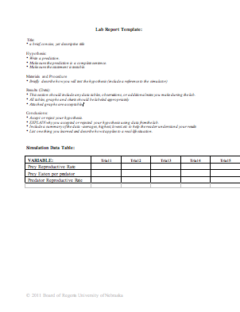
Understanding Learning: (Predator vs. Prey)

Summary: Students will create a PowerPoint presentation that explains the Predator-Prey relationship. These PowerPoint presentations can be used to teach younger students about this concept.

Outline:
- Formative assessment of community ecology
- Summative assessment of community ecology

Activity: Students will complete a multimedia and written assessment relating to community ecology.

Formative Assessment: As students are engaged in the lesson ask these or similar questions:
- Can the students determine the difference between a predator and a prey?
- Do students explain how predatory or prey reproduction rate effect the relationship?
- Where in life do you see the predatory prey relationship?

Summative Assessment: Students will create a PowerPoint presentation that explains the Predator-Prey relationship.

Students can answer the following writing prompt:
- Define the predator-prey relationship.
- You are working for the Department of Environmental Quality collecting weekly data on an endangered species. Discuss the predator-prey relationship and how it relates to your job.

