Project SHINE Lesson:
Never Fear Safety is Here!
==========================Lesson Header ==========================
Lesson Title: Never Fear Safety is Here!
Draft Date: 06-13-2011
1st Author (Writer): Katie Misciskia
Associated Business: BD Pharmaceutical
Instructional Component Used: Laboratory Safety
Grade Level: 8
This Teacher was mentored by:

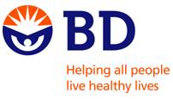
www.bd.com

In partnership with Project SHINE grant funded through the

National Science Foundation

Content (what is taught):
- Classroom dress code/proper use of equipment
- Manufacturing plant dress code/proper use of equipment

Context (how it is taught):
- Matching and fill in the blank worksheet related laboratory safety
- Poster or skit explaining the importance of following safety rules in classroom setting as well as in the work force
Activity Description:
In this lesson, students will be given a set of vocabulary words and will begin to explore connections between employees in a manufacturing plant to students in a science classroom. Students will understand the importance of following classroom procedures and how it ties into the adult work force.

Standards:

Science: SF1, SF4, SC3 Technology: TA1, TA2

Materials List:
- Beakers
- Tongs
- Hotplate
- Graduated Cylinders
- Construction Paper (to create BD equipment)
- Two Different Powders “For Chemicals”
- Aprons
- Smocks
- Dangling Jewelry

- Hairnets
- Boots
- Ear Plugs
- Gloves
- Safety Glasses
- Goggles
- Ponytail Fasteners
- Plastic Syringes
- Food Coloring
Asking Questions: (Never Fear Safety is Here!)

Summary: Students will be informed on safety procedures and use of equipment.

Outline:
- Show students two short videos-one on plant safety the other over classroom safety
- Ask questions to determine understanding and knowledge of the classroom and BD plant safety (or any manufacturing plant you find)

Activity: Students will view two videos-one on plant safety (search the internet for manufacturing plant safety in your area) and one on classroom safety (provided by your school). A group discussion will be conducted about the videos. After the discussing the videos, students will read over and discuss student safety contract (see attachment).

Questions | Answers
Why do you think it is necessary for the employees at BD manufacturing plant to follow safety rules? | To provide safe conditions and prevent injury to employees as well as informing them of all hazards.
What do you think the dress code is at BD manufacturing plant? | Blue smock, hair net, beard net, long pants, boots or tennis shoes, safety glasses, some rooms require full body suits as well as masks and gloves.
Why is it necessary for students during lab experiments to follow safety rules and handle the equipment properly? | To ensure a safe classroom environment and to avoid ruining the experiment and having to start all over.
What do you think the dress code will be for our science class during lab activities? | Hair pulled back – ponytail, long pants, closed toed shoes, goggles, aprons, no dangling jewelry, no loose clothing, etc.

Resources:
- Search “Manufacturing Plant Safety” on Google Video (http://video.google.com/)
- BD Website: http://www.BD.com

Attachment:
- Student Safety Contract: S107_SHINE_Never_Fear_Safety_Is_Here_A_Safety_Contract.doc
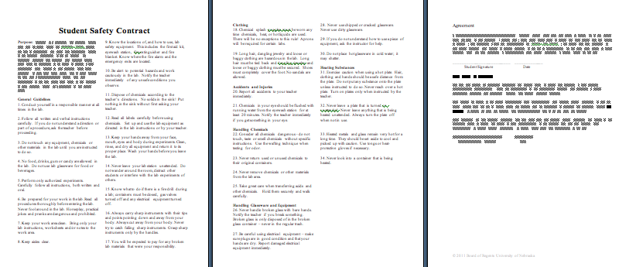
Exploring Concepts: (Never Fear Safety is Here!)

Summary: Students will match the type of equipment and dress code between BD manufacturing and your science classroom.

Outline:
- Students will discuss the dress codes of a manufacturing plant versus a science classroom
- Students will be given a matching and fill in the blank worksheet using vocabulary words provided

Activity: In this lesson, students will be given a set of vocabulary words related to dress code. They will have a small group discussion before the two worksheets are given. Students will work together to complete the worksheets. When completed, answers will be given and students will move on to the lab activity.

Attachments:
- Vocabulary Words and Worksheets: S107_SHINE_Never_Fear_Safety_Is_Here_E_Worksheet.doc
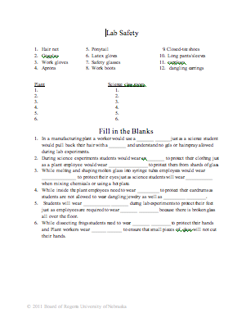

Instructing Concepts: (Never Fear Safety is Here!)

Laboratory Safety
There are several safety categories to consider when working in a classroom or in a business. The following are generalizations and not likely to be a complete list.

Biological Safety: A very broad safety area involving the proper procedures for handling living organisms or material from living organisms such as human body fluids or bacteria.

Eye Protection: Safety goggles are a must if handling chemicals, heating materials, or projectile hazards. Also, it is best if contact lenses are not worn as chemicals or particles can get between the lens and the eye causing damage.

Chemical Safety: There are many facets to chemical safety. Ultimately, handling the chemicals properly according to the Material Data Safety Sheets (MSDS) will cover any topic. (e.g. storage, usage, disposal, flammables, corrosives, pressurized gas, carcinogens, toxins, irritants)

Clothing Requirements: For personal protection, lab aprons, lab coats, closed-toed shoes, long skirts/ pants, or long sleeves can be worn. Avoid wearing nylon and polyester fabrics as they burn or melt more easily than cotton fabrics. It is also important to tie back hair or remove jewelry, ties, and watches as they may react with certain chemicals or easily catch on fire.

Glassware Safety: Glassware overall should be maintained in good condition without chips or cracks as well as clean. This avoids the shattering of glass while being heated as well as unwanted chemical reactions. Also, if glassware does break it should be properly placed in a glass disposal box.

Heating Safety: Whatever type of equipment used for heating, it is important to keep flammable items away as well as use correct safety procedures to avoid burns.

Hand Safety: Wear protective gloves when working with chemicals, use a hot mitt or tongs when handing heating equipment.

Hygiene Care: Keep hands away from the face and mouth while working as well as wash hands thoroughly before leaving the work area. Eating, drinking, chewing gum, and applying cosmetics are not allowed within a work area especially one where chemicals are being used.

Safety or Emergency Equipment: In work areas, participants should know the emergency procedures, evacuation routes, location of safety equipment, and how to use the safety equipment. (e.g. eyewash stations, gas shut off valves, fire extinguishers, fire blankets, safety showers, respirators, fume hoods)

Waste Disposal: Follow proper waste disposal to protect by-standers as well as the environment.

Work Area: Work areas should be clean and free of clutter to assist in maintaining safety.
Organizing Learning: (Never Fear Safety is Here!)

Summary: Students will present proper use of safety rules and equipment through presentations (skits) or posters.

Outline:
- Create poster or skit explaining proper dress code and use of equipment in classroom setting
- Create poster or skit explaining proper dress code and use of equipment in manufacturing setting (e.g. BD makes glass syringes)

Activity: In this lesson, students will break into small groups. Their task is to explain to other groups the proper dress code and use of equipment in the classroom and manufacturing setting. Each group will have a certain topic to explain (possible topics in attachment). Break up the students into dress code and equipment for each setting so that there are four topics to be covered. To keep their interest, you can have a group perform a parody of all the wrong things to do in each setting.

Materials:
- Food Coloring
- Beakers
- Tongs
- Hotplate
- Graduated Cylinders
- Construction Paper (to create BD equipment)
- Two Different Powders “For Chemicals”
- Aprons
- Smocks
- Hairnets
- Boots
- Ear Plugs
- Gloves
- Safety Glasses
- Goggles
- Ponytail Fasteners
- Plastic Syringes
- Dangling Jewelry

Sample Group Assignments:
Group One: Classroom dress code - read over safety contract

Group Two: Proper use of equipment - read over safety contract and look over notes previously provided by teacher

Group Three: BD Manufacturing dress code - read over BD worksheet

Group Four: BD manufacturing - read over their equipment safety article and look over notes previously provided by teacher

Group Five: Classroom and BD dress code and use of equipment - show how wearing the wrong clothing, shoes, glasses, jewelry, etc. and improper use of equipment can ruin your classroom experiment or job
Understanding Learning: (Never Fear Safety is Here!)

Summary: Students will be expected to explain in paragraph form the proper use of equipment, as well as dress code in a science classroom. They will include why it is important to be familiar with and understand the rules and regulations.

Outline:
- Formative assessment of laboratory safety
- Summative assessment of laboratory safety

Activity: Students will complete written assessments of laboratory safety.
Formative Assessment: As students are engaged in the lesson ask these or similar questions:
- Were students able to perform skit/poster while clearly explaining to other groups the topic given them
- Were students all actively engaged and involved in preparing poster/skit and did they understand the importance of safety rules/ use of equipment.

Summative Assessment: Students can complete the following writing prompts:
- Students will write two paragraphs explaining the importance of following the science safety contract as well as the importance of following rules in the manufacturing industry.
- Describe the safety procedures that you would need to follow to complete a lab in science class.

