Project SHINE Lesson:
This Teacher was mentored by:


www.behlenmfg.com

In partnership with Project SHINE grant funded through the

National Science Foundation

So Hot It’s Cool!
==========================Lesson Header ==========================
Lesson Title: So Hot It’s Cool!
Draft Date: 6-10-2011
1st Author (Writer): Larry St.Hilaire
Associated Business:
Instructional Component Used: Metallurgy
Grade Level: 10-12

Content (what is taught):
- Measuring
- Metallurgy
- Welding Equipment

Context (how it is taught):
- The use of rulers
- PowerPoint on Metal (Miller Electric)
- Miller Electric Website

Activity Description:
Students will discuss different types of welds and metal stocks. Then they will create a project one their own by trial and error. Instruction will be provided on metallurgy and then students will try to build the same project again noting the differences after instruction.

Standards:

Math: MD2 Science: SB1

Technology: TA1 Engineering: EB2

Materials List:
- PowerPoint
- Assortment of Steel 2 x 4 ½-1/8 Thickness
- Internet Connection
- Welding Equipment
Asking Questions: (So Hot It’s Cool)

Summary: Students will discuss different types of metal and how different welds work on each.

Outline:
- Students will be given different metal stock and thickness
- Students will discuss different welding options for current project
- Students will fill out KWL chart

Activity: Students will be given different types of metal stock and thickness. The teacher will facilitate the class filling out a KWL chart where students will list what they know about metal and welding and what they want to learn about metal and welding.

Questions | Answers
What type of metal will you use? | Steel with different thicknesses
What type of weld will be used? | Overlap type
How will you cut the rough metal to size? | Plasma cutter , Oxy-fuel cutter
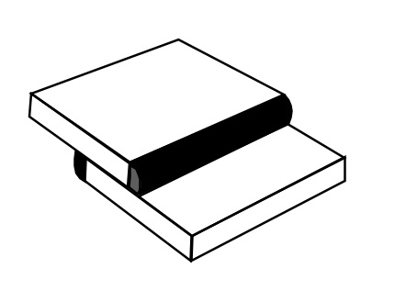

Resources: KWL Chart
K | W | L
What I Know | What I Want To Learn | What did I Learn
Exploring Concepts: (So Hot It’s Cool)

Summary: Students will build a candleholder out of metal and weld it using a welder.

Outline:
- Students will be given a variety of metal types to choice from to build a candle holder
- Students will be given the choice of different welding equipment

Activity: Students will build a candleholder out of metal sheets using a variety of metal (varying lengths and thicknesses) and choosing the appropriate welder based on the metal type. No formal instruction will be given. It is an exploration of the possibilities available to students.
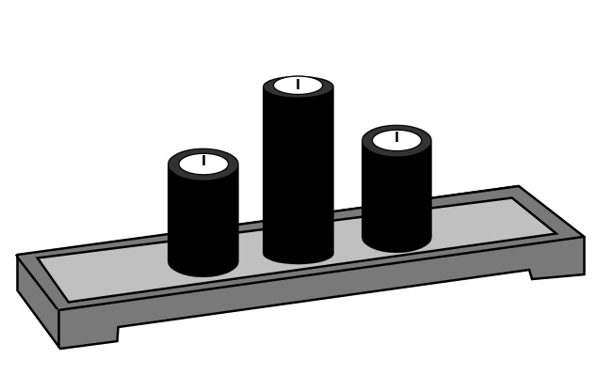
Resources:
- How To Arc Weld: http://youtu.be/hcyxcrZrrac
- How to Mig Weld: http://youtu.be/lzBGZaS1apw
- How to Gas Weld: http://youtu.be/uFX_RvWrzaQ
Instructing Concepts: (So Hot It’s Cool)

Metallurgy

Metallurgy is the science and technology of metal. It is the oldest of the sciences devoted to the study of engineering materials. Metallurgy has evolved into three separate groups: extractive, mechanical, and physical.

Extractive Metallurgy is the study of the extraction and purification of metals from their ores.
Extracting a metal from its ore is conducted in several process steps.
For example, the extraction route from ore to refined metal includes any or all of the following process steps. Beneficiation, mineral dressing, pyrometallurgy, hydrometallurgy, and electrometallurgy.

Mechanical Metallurgy is the study of the techniques and mechanical forces that shape or make finished forms of metal.

Physical Metallurgy is the study of the effect of structure on the properties of metals.
The two structures studied in physical metallurgy are the crystal structure and micro structure.
The crystal structure is the arrangement of atoms in the metal.
An atom is the smallest building block of matter that can exist alone or in combination.
It cannot be divided without changing its basic character.

The microstructure is the microscopic arrangement of the components, or phases, within a metal.
The technology of heat treatment of steels is based on a specific crystal structure and microstructure change that occurs when steel is rapidly cooled from a high temperature.
These changes lead to hardening and strengthening of steels.
Organizing Learning: (So Hot It’s Cool)

Summary: Students will modify their welding project by changing the type of welders or type of metal.

Outline:
- Students will modify their design project based on what they have learned
- Students will compare/contrast their experiences

Activity: Students will cut metal to size for the project they will be making. They will adjust the welder they use to affect the amperage, speed of wire, or wire type to understand what welder is best fit for the project that is being worked on. Students will journal what metal will work best with the type of welder they decide to use. Students will chart showing different welds used on different thickness of metal using different types of welders.

Resources:
- Data Chart
Mig Welding | Amperage Used? | Arc Welding | Amperage Used? | Gas Welding | Fusion/Wire/ Bronze?
½ inch  thick steel |  | ½ inch  thick steel |  | ½ inch  thick steel
¼ inch  thick steel |  | ¼ inch  thick steel |  | ¼ inch  thick steel
1/8 inch  thick steel |  | 1/8 inch  thick steel |  | 1/8 inch  thick steel
¼ inch  thick brass |  | ¼ inch  thick brass |  | ¼ inch  thick brass
Understanding Learning: (So Hot It’s Cool)

Summary: Students will write about the affect of changing something related to welding and how this will change the quality of a weld and the finish product.

Outline:
- Formative assessment of metallurgy
- Summative assessment of metallurgy

Activity: Students will complete a written assessment regarding metallurgy.

Formative Assessment: As students are engaged in the lesson ask these or similar questions:
- Did the students adjust the amperage by increasing or decreasing it?
- Did the line feed (too fast or too slow) affect the final product?
- If the students used metal that is too thick or too thin, did that affect the weld?

Summative Assessment: Students can answer the following writing prompts:
- Use your data and write a paper describing the effectiveness of one welder over another. Include what metal works best when using that particular welder.
- List 5 variables that could affect the quality of your weld.
- Pick one of your variables and test it. Then write a paper comparing data to describe the benefits of using one weld over another.

Attachments:
- Sample Rubric for Grading Welds: S111_SHINE_So_Hot_Its_Cool_U_Rubric.doc
