Project SPIRIT 2.0 Lesson:
Is Bill Ill?
==========================Lesson Header ==========================
Lesson Title: Is Bill Ill?
Draft Date: June 8, 2011
1st Author (Writer): Ken Swanson
This Teacher was mentored by:


www.bd.com

In partnership with Project SHINE grant funded through the

National Science Foundation

Associated Business: BD Pharmaceutical
Instructional Component Used: Human Immune System
Grade Level: 12

Content (what is taught):
● Human Immune System
● Preventable Diseases
● Immunization

Context (how it is taught):
- Students review Nebraska Department of Health and Human Service Immunization Requirements compared to a mock child’s immunization record
- Students will view slide presentations about preventable diseases and the human immune system response
- Students will research and write a report about an infectious disease on the slide presentation over preventable diseases

Activity Description:
In this lesson, students will discuss their experiences with sickness as well as the cause and prevention of illnesses. Then they will compare a simulated child’s immunization record with the states requirements. After viewing two power point presentations, students write a research paper about a preventable disease.

Standards:

Science: SC1

Materials List:
- Slide Presentation, Preventable Disease
- Slide Presentation, Acquired Immunity
- Nebraska Health and Human Services List of Required School Immunizations: http://www.hhs.state.ne.us/LifespanHealth/Immunization/docs/2011-2012_School_RR_English.pdf)
- Computer and Internet access for students to write a research paper
ASKING Questions: (Is Bill Ill?)

Summary: Teacher will lead discussion about students’ experiences of sickness, discussing the cause, and prevention of infection.

Outline:
- Discuss students’ experience with sickness
- Ask leading questions to develop knowledge about cause and prevention of infection

Activity: As students are comfortable, they can share their experiences with sickness leading into a discussion about causes and preventative methods of illness. A video of children receiving immunizations from YouTube will be viewed (see links below).

Questions | Answers
What did you have the last time you were sick? | Answer will vary
What are some consequences of “serious” illness? | Possible lack of energy, missing events, high fevers, scarring, coma, death
If you have an illness can you get it again? | Possible depending on the type of disease like the flu, but like chicken pox usually once a person has it as a child they will not have it again because they have developed immunity.
What causes an illness or disease? | Some outside agent infects the body like a virus, bacterium, protist, fungus, or worm.
What are ways to prevent illness? | Preventing the pathogens from entering the body by washing hands, good hygiene, proper food preparation, disinfecting items, as well as vaccines.
What is a vaccine? | Weakened, or synthetic form of the pathogen exposing the body to the foreign antigen without causing the disease, providing time to produce antibodies (memory) readying it for a future attack.
What about the equipment used to administer a vaccine? | Syringe, jet injectors (pressurized air), nasal distributors etc.
Pharmaceutical manufacturing companies spend much of their time and money making sure there product is sterile. Why? | They sterilize with water, steam, and gamma radiation in stages to prevent patients from being infected by their product as usage occurs when humans a very susceptible to an infection.
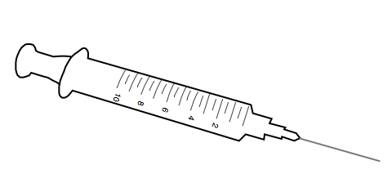
Resources: YouTube Immunization Clips:
- http://www.youtube.com/watch?v=kqBV2NaBPSQ
- http://www.youtube.com/watch?v=DocM0sppTX0

EXPLORING Concepts: (Is Bill Ill?)

Summary: Students will discover the types of preventable diseases and immunizations required by their state.

Outline:
- Read through a simulated immunization record
- Compare the immunization record with the state requirements
- Answer questions checking student understanding

Activity: Student pairs will read through a mock immunization record. They will compare the record to the state requirements and answer questions. A class discussion will follow about the types of diseases, number of doses, and state requirements. Students will then be encouraged to review their own immunization for their personal knowledge. (Note: immunization records are considered confidential.)

Resources:
- Nebraska Health and Human Services School Child Immunization List
http://www.hhs.state.ne.us/LifespanHealth/Immunization/docs/2011-2012_School_RR_English.pdf

Attachments:
Simulated Immunization Activity: S112_SHINE_Is_Bill_Ill_E_Activity.doc
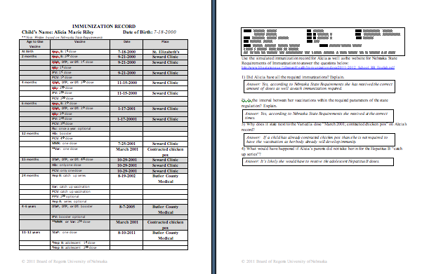
Instructing Concepts: (Is Bill Ill?)

Human Immune System

Immunity: In a human’s body, immunity means to develop either a natural or an acquired resistance to a particular disease.

Disease: In reference to human immunity, a disease is a malfunction of a structure within the body that is not simply a result of physical injury, but due to an infection from an outside source.

Causes of Diseases: There are several different kinds of infectors these are the general types:
1) Viruses: non-living particles typically consisting of a nucleic acid molecule in a protein coat,
that is able to multiply within invaded, living cells (e.g. chicken pox, measles, polio, AIDS)
2) Prion: non-living particles typically consisting of proteins in misfolded form causing neuro-
degenerative diseases(e.g. Creutzfeldt-Jakob disease (CJD) in humans; more commonly
known bovine spongiform encephalopathy [BSE, or "mad cow" disease] in cattle)
3) Bacteria (Monera): are unicellular, prokaryotic (no nucleus), and are ubiquitous in every
habitat or biome on Earth with only a portion causing harm to humans(e.g.strep throat,
diphtheria, whooping cough, tetanus)
4) Protists: includes some 30-40 dissimilar phyla loosely defined as unicellular or multicellular
organisms without specialized tissue. They vary in food cycle types, life cycle types, and
mechanisms of movement. There are, however, those that are human parasites.(e.g. malaria,
toxoplasmosis, sleeping sickness)
5) Fungi: are unicellular or multicellular, eukaryotic, heterotrophic organisms including
yeast, mold, mildew, and mushrooms (e.g. athlete’s foot, ring worm, yeast infection)
6) Small animals: multicellular, eukaryotic, heterotophic, organisms typically parasitic worms
(e.g tapeworms, trichinosis, and liver flukes)
Human Immune System: The human body may respond simply to an infection by having a fever or inflammation. It may, also, have a more complex response involving the white blood cells (leukocytes). First, antibodies (blood proteins) identify foreign antigens (components located on the outside of the infectors). They bond to the antigen signaling the white blood cells to come. Some white blood cells will then provide support, while others attack the microorganism by releasing chemicals either inwardly as they engulf the pathogen or outwardly destroying its protective barrier.
Disease Prevention: Ultimately, one of the pathogens listed above must enter the body through an opening: oral cavity, nasal cavity, middle ear cavity, anus, or a wound in the skin. Disease prevention begins by defending these entry points using the following: hand washing, proper food preparation, disinfecting commonly used items, and overall good hygiene. However, if an infector enters the body a vaccine is another effective means to prevent disease. A vaccine generates acquired immunity by stimulating the body to produce antibodies. Inside a vaccine is the disease causing agent, its products, or a synthetic substitute. These expose the body to the foreign antigen without causing the disease, providing the body time to produce the antibodies (memory) readying it for a future attack.
ORGANIZING Learning: (Is Bill Ill?)

Summary: Students view the slide presentations about various infectious diseases and the human immune system’s response. Students will research a disease and write a report.

Outline:
- Students will view the two PowerPoints
- Students will write a research paper about a disease especially explaining the means of infection for the disease

Activity: After viewing two PowerPoint slide presentations about types of preventable diseases and the human immune system’s response, students will research and write a paper about a disease. The paper will especially cover the means of infection including: type of disease causing agent involved, symptoms, cells targeted, infection spread, human immune system response, as well as prevention/treatment.

Attachments:
- Preventable Diseases PowerPoint: S112_SHINE_Is_Bill_Ill_O_Preventable_Disease.ppt
- Acquired Immunity PowerPoint: S112_SHINE_Is_Bill_Ill_O_Acquired_Immunity.ppt
- Rubric for Disease Paper Research: S112_SHINE_Is_Bill_Ill_O_Rubric.doc
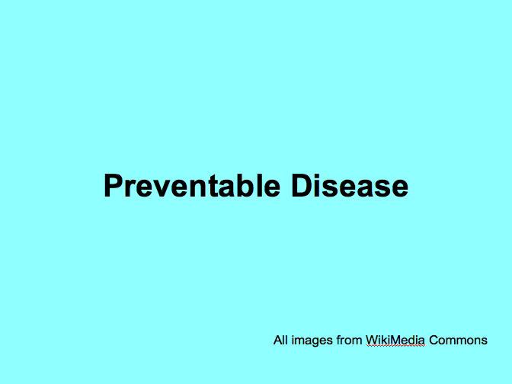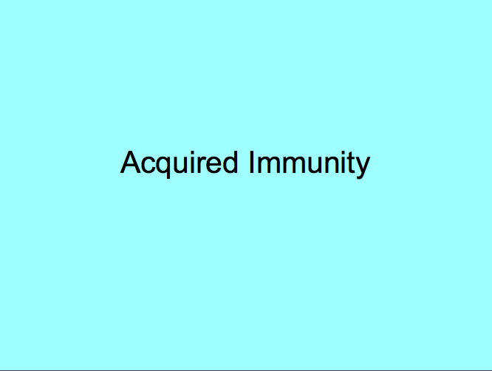
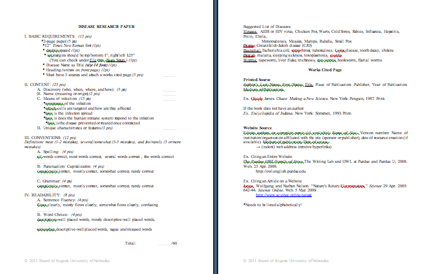
UNDERSTANDING Learning: (Is Bill Ill?)

Summary: Students will fill out a chart over the types of preventable diseases in a quiz format as well as write about how the human immune system responds to an infection.

Outline:
- Formative Assessment of Human Immune System
- Summative Assessment of Human Immune System

Activity: Student will complete writing prompts over the types of preventable diseases and human immune system response.

Formative Assessment: As students are engaged in the lesson ask these or similar questions:
- Are students able to distinguish between a disease and physical injury?
- Can students distinguish between the types of disease causing agents?
- Are students able to explain human immune system responses?

Summative Assessment: Students can complete the attached quiz:
See file: S112_SHINE_Is_Bill_Ill_U_Quiz.doc

Students can complete the following writing prompt:
When an infection occurs how does the human immune system respond? Provide three general responses as well as include an example of a disease (from research paper, discussion, or PowerPoint) about specific white blood cells (leukocytes) and their roles in the response to the disease-causing agent.

Attachments:
Quiz: S112_SHINE_Is_Bill_Ill_U_Quiz.doc
