Making Water Filtration Systems

For this demonstration the teacher will make two simple water filtration systems. Both filters use short sections of 4 inch PVC pipe.
Constructing a Sand and Gravel Filter
- Place one end cap securely on one end of each section of PVC pipe.
- Using a drill with an 1/8th inch drill place 20 holes in both end caps.
- Position the first pipe section upright and put about two inches of clean gravel in the bottom of the pipe.
- Now add about two inches of clean sand on to your first layer of gravel.
- Repeat steps 3 and 4 until the can is full to about 4 inches inch from the top.
- Place the sand and gravel filled can on 4 small wooden blocks in a clean deep plastic tray or cake pan.
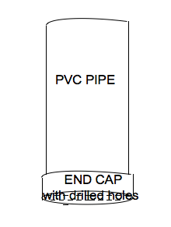
Water to be filtered.
- Fill a 500 ml beaker to the 300 ml line with cold water.
- Add ordinary dirt to your beaker of water until the beaker contains 400 ml of dirt and water. Stir until the dirt is completely suspended in the water.
Filtering the water.
Slowly pour your water into your filter being careful to not over flow the edges. Eventually water will work its way through the filter, out the holes in the bottom, and into your collection pan.

Possible Questions.
- Does the water produced by your filter appear cleaner than before it entered the filter? What does it smell like?
- Would it be safe to drink this water?
- What could you do to improve this filter?
Building an upgraded filter.
- Use the second 4 inch PVC pipe, begin by putting about two inch of sand in the bottom of the can.
- Now add about one inch activated charcoal.
- Repeat steps 1 and 2 until the can is full to about four inches from the top.
- Place the sand and activated charcoal filter on 4 small wooden blocks in a clean deep plastic tray or cake pan.
Prepare water to be filtered exactly as you did for the first filtration attempt.
Filter the water the same way as you did for the first filtration attempt.

Questions
1. Does the water produced by the second filter appear cleaner than before it entered
the filter? Does this water smell better than the "cleaned" water from the first filter?
2. Would it be safe to drink this water?
3. What could you do to improve this filter?

