Project SHINE Lesson:
This is Slimy!
==========================Lesson Header ==========================
This Teacher was mentored by:

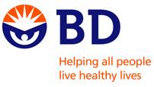
www.bd.com

In partnership with Project SHINE grant funded through the

National Science Foundation

Lesson Title: This is Slimy!
Draft Date: 6-15-2011
1st Author (Writer): Katie Misciskia
Associated Business: BD Medical - Pharmaceutical
Instructional Component Used: Physical and Chemical Properties/Changes
Grade Level: 8

Content (what is taught):
- Physical Properties and Changes
- Chemical Changes and Properties

Context (how it is taught):
- Question and answer worksheets
- Several labs dealing with physical and chemical changes
- Incorporate BD manufacturing into the classroom lesson to show real world situations and why it is important for students to learn the material being taught.
Activity Description:
In this lesson, students will be given a set of vocabulary terms and a variety of pictures with question and answers with partners as well as a worksheet before the actual lab activity is started. Students will then perform a series of lab experiments to insure knowledge and understanding along with worksheets to finish after each lab.

Standards:

Science: SA, SB, SB1 Technology: TD2, TD3

Materials List:
- Various Pictures and Index Cards for Physical and Chemical Properties and Changes
- Brownie/Cake Mix
- Small Aluminum Pans
- Glue
- Liquid Starch
- Water
- Measuring Cups
- Cotton Balls
- Fuzzy Craft Balls
- Metal Weighted Balls
- Edible Food of your Choice
- Worksheets
Asking Questions: (This is Slimy!)

Summary: Students will be introduced to physical and chemical properties.

Outline:
- In the front of the room, there will be a small bowl filled with Chex mix and a jar of slime
- Ask questions about physical and chemical properties
- Students will consider chemical and physical properties of slime and Chex mix.

Activity: The students will be presented with bowls filled with Chex mix and slime. A class discussion will be conducted around chemical and physical properties and what they are. Students should give their definitions and with teacher input be lead to the correct information. Finally, students will consider the Chex mix and slime and list chemical and physical properties and what physical and chemical changes are represented.

Questions | Answers
What is a physical property? | Readily observable, like; color size luster, or smell. Substances identity does not change.
What is a physical change? | Changes that do not result in a new substance. Ex: You cut a piece of wood into two halves. Still wood. Can keep cutting smaller and smaller =still wood.
What is a chemical property? | Are only observable during a chemical reaction. With these properties the matter changes into a completely different and new substance.
What is a chemical change? | Changes that result in the production on a new and different substance. Ex: you burn wood and it turns into smoke and ashes. Can’t get the wood back.
Exploring Concepts: (This is Slimy!)

Summary: Students will be engaged in station activities looking over various pictures showing physical/chemical changes in small group setting. After they are done observing they will go back to their desks and complete a worksheet.

Outline:
- Students will work at station activities looking over various pictures showing and explaining physical/chemical properties and changes
- Students will complete physical/chemical worksheet

Activity: In this lesson, students will be broken up into small groups and will be required to go to each lab station and will look over and quiz one another on several pictures at each station showing chemical/physical properties and changes. See a possible list of pictures below. On the back of the picture, it will tell them the physical or chemical property and the change occurring. After they have completed the stations, they will go back to their desks and complete a worksheet provided by the teacher and will test their knowledge gained on the topic being covered.

Resources:
- Physical Change Examples:
- Ripping a Piece of Paper in Half
- Painting a House
- Dissolving Salt in Water
- Conducting Electricity Through a Wire
- Gas From a Tea Kettle

- Chemical Change Examples:
- Burning a Candle
- Adding Vinegar to Baking Soda
- A Rusty Nail
- Staining a T-Shirt
- Lighting a Match Gas From a Tea Kettle

Attachment:
Exploring Worksheet: S114_SHINE_This_Is_Slimy_E_Worksheet.doc
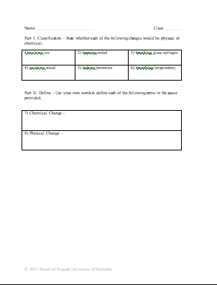
Instructing Concepts: (This is Slimy!)

Physical & Chemical Properties/Changes

Properties: Properties are qualities attributed to matter. There are two general kinds of properties: physical and chemical. Physical properties are characteristics that can be observed without changing the identity of the substance. While, chemical properties are characteristics observed when the identity of a substance changes or when chemical bonds between elements are changed. However, chemical properties are always considered intensive properties, but not always are physical properties. Intensive properties are qualities that will be exhibited no matter the amount of substance present such as boiling point. Conversely, if the property does vary with the amount of substance present it is known as an extensive property such as volume. If there is 5 milliliters of water versus 5 tons of water, the boiling point will always remain the same, but the volume differs.

Types of Physical Properties: There are several kinds of physical properties ranging from color, shape, size (volume, area, perimeter, etc.), brittle, flexible, malleable, ductile, or magnetic. Listed below are a few more defined:
1. Density: the ratio of mass of a substance to the volume of the substance
2. Conductivity: ability to transfer heat or electricity from one area to another
3. State of Matter: physical form in which a substance exists (solid, liquid, gas, or plasma)
4. Boiling Point: temperature at which a substance changes state from a liquid to a gas
5. Melting Point: temperature at which a substance changes state from a solid to a liquid
6. Solubility: ability to dissolve into another substance
7. Viscosity: a liquid’s resistance to flow

Types of Chemical Properties: There are only two kinds of chemical properties as these can be viewed when a substance breaks chemical bonds.
1) Flammability: ability to burn
2) Reactivity: the capacity of a substance to chemically combine with another substance

Changes: When a substance is altered a change occurs. There are two general kinds of changes: physical or chemical change (also know as a chemical reaction). Physical change is when one or more physical properties of a substance are adjusted without creating a new substance or transforming its identity. Cutting a piece of paper in half will change the size of the paper, but it is still paper. On the other hand if the paper was lit on fire, many changes in physical properties would occur, but also it would cease to be considered paper. This is known as a chemical change when one or more substances are altered entirely into new substances that have different properties due to the breaking or rearranging of chemical bonds between elements.
There are three key factors that help identify if a chemical change or reaction occurred:
1) Form a new substance (indicated by writing a new chemical formula)
Ex. H₂O goes through electrolysis to produce H_{2 &} O₂
2) The change cannot be reversed by physical means
Ex. burnt toast (burnt carbon remains cannot be reversed without more chemical reactions
back into the wheat flour) vs. bent penny (can easily be reversed by physical means)
3) New physical properties such as: different color, different odor, release of gas (fizzing or
foaming), production of sound heat, light, and solid (precipitate).
Organizing Learning: (This is Slimy!)

Summary: Students will complete three quick lab experiments over physical and chemical changes.

Outline:
- Slime experiment for physical and chemical changes
- Bake brownies/cake experiment for chemical changes
- Mixing different objects for physical changes
- Mixing different edibles for physical changes

Activity: In this lesson, students will be performing four quick experiments for a greater understanding of physical/chemical properties and changes. They will be broken up into small group and given separate worksheets for each lab experiment. The slime lab can be found online as well as a recipe for cake/ brownies. For the physical changes lab, students will be asked to mix a variety of objects for example cotton balls, fuzzy craft balls, and weighted balls together as well as nuts, mints, etc for edible lab then asked a series of questions on their worksheet about the changes they undergo.

Attachments:
Slime Lab: S114_SHINE_This_Is_Slimy_O_Slime_Lab.doc
Lab Worksheets: S114_SHINE_This_Is_Slimy_O_Lab_Worksheet.doc
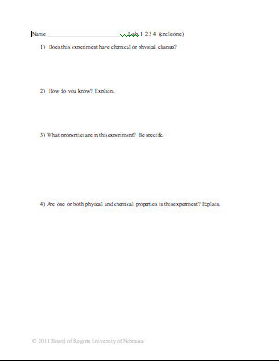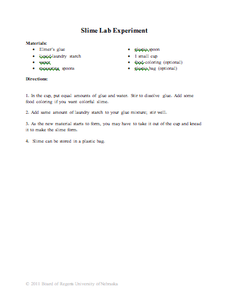
Understanding Learning: (This is Slimy!)

Summary: Students will be expected to explain what physical and chemical properties are as well as changes they undergo through worksheets and laboratory experiments.

Outline:
- Formative Assessment of Physical/Chemical Properties and Changes
- Summative Assessment of Physical/Chemical Properties and Changes

Activity:
Formative Assessment: As students are engaged in the lesson ask these or similar questions:
- Was each student actively engaged with their partner and able to explain the differences in physical and chemical changes during each lab?
- Was each student actively engaged with their partner and able to explain what physical and chemical properties are during each lab?

Summative Assessment: Students will be expected to answer worksheets correctly and in complete sentences as well as complete the lab experiments. The teacher will also look over each lab to make sure the students understand the subject being taught.

