Project SHINE Lesson:
Are You a Dip?
==========================Lesson Header ==========================
Lesson Title: Are You a Dip?
Draft Date: 6-15-11
1st Author (Writer): Nancy Boyle
Associated Business: Behlen Mfg. Co.
Instructional Component Used: Melting and Boiling Points
Grade Level: Middle School

Content (what is taught):
This Teacher was mentored by:

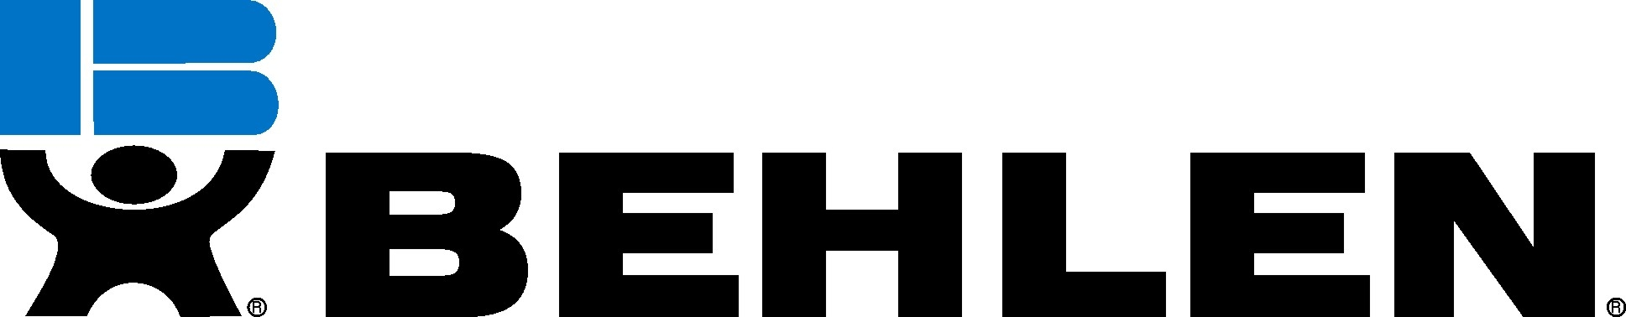
www.behlenmfg.com

In partnership with Project SHINE grant funded through the

National Science Foundation

- Melting Point
- Boiling Point
- To discover how Behlen Mfg. Co. uses the galvanization process to increase longevity of steel products

Context (how it is taught):
- Melting and boiling points will be understood using a video and lab activity
- Students will explore the galvanization process by using a model
- Students will view a You Tube video and discuss
Activity Description:
Students will discover physical and chemical changes that occur during melting/boiling points and students will be given materials to create a model of galvanization. Once they have explored the galvanization process, it will be compared to Behlen Mfg. Co.

Standards:

Math: MA1 Science: SB1, SB3

Technology: TC4 Engineering: EA1

Materials List:
- Pretzels (waffle shaped)
- Chocolate
- Crock Pot
- Cooking Thermometer
- Spray Water Bottle
- Paper Clip
Asking Questions: (Are you a dip?)

Summary: Students will view the 212 º Degrees video and engage in a discussion to explore the basic principles of melting and boiling point.

Outline:
- Students will view a You Tube video and reflect on effects of temperature on a solid
- Discussion questions below

Activity: Students will view a You Tube video that will get them thinking about the effects of temperature on a solid material. After watching, a class discussion will be conducted centering on the topics presented in the video.

Questions | Answers
Have you ever seen an ice cube melt? Describe it. Do you think all solids melt at the same temperature? | Yes, a solid warms and melts into a liquid. No, they melt at different temperatures based upon their properties.
Have you ever dipped a chip into melted cheese? What happens to the chip the longer the cheese stays on it? | The longer the cheese stays on the chip, the less crispy the chip becomes
What happens to a pot of water as you heat it? | The molecules become more active and water begins to boil.
When do you melt or boil things? How do these things change as they melt and near the melting point? | Answers will vary. Physical and chemical changes should be discussed.

Resources:
- You Tube Video: 212º – The Extra Degree: http://www.youtube.com/watch?v=FpJQqzJj534
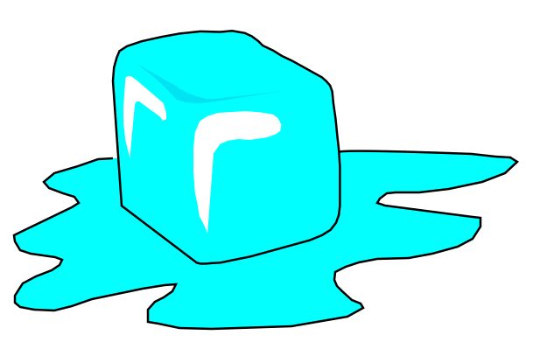
Exploring Concepts: (Are you a dip?)

Summary: Students will discuss physical and chemical changes of a solid and explore the graph of melting points.

Outline:
- Teachers will guide students in creating a T-chart of physical and chemical changes
- Students will view You Tube video
- Students will view and discuss a melting and boiling point chart, focusing on chemical changes and plateaus present as heating occurs to a substance

Activity: Begin by showing a You Tube video (see link below) of the galvanization process and discuss. The teacher will guide students as they melt a solid (i.e. chocolate, butter, processed cheese, etc.) and explore its physical and chemical properties during the process.

Resources:
- You Tube Video on Galvanization Process: http://www.youtube.com/watch?v=c2J07n5hSbs
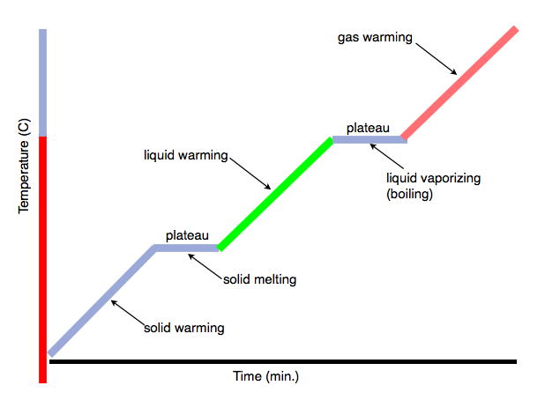
Instructing Concepts: (Are you a dip?)

Physical & Chemical Properties/Changes

Properties: Properties are qualities attributed to matter. There are two general kinds of properties: physical and chemical. Physical properties are characteristics that can be observed without changing the identity of the substance. While, chemical properties are characteristics observed when the identity of a substance changes or when chemical bonds between elements are changed. However, chemical properties are always considered intensive properties, but not always are physical properties. Intensive properties are qualities that will be exhibited no matter the amount of substance present such as boiling point. Conversely, if the property does vary with the amount of substance present it is known as an extensive property such as volume. If there is 5 milliliters of water versus 5 tons of water, the boiling point will always remain the same, but the volume differs.

Types of Physical Properties: There are several kinds of physical properties ranging from color, shape, size (volume, area, perimeter, etc.), brittle, flexible, malleable, ductile, or magnetic. Listed below are a few more defined:
1. Density: -the ratio of mass of a substance to the volume of the substance
2. Conductivity: -ability to transfer heat or electricity from one area to another
3. State of Matter: -physical form in which a substance exists (solid, liquid, gas, or plasma)
4. Boiling Point: temperature at which a substance changes state from a liquid to a gas
5. Melting Point: temperature at which a substance changes state from a solid to a liquid
6. Solubility: -ability to dissolve into another substance
7. Viscosity:-a liquid’s resistance to flow

Types of Chemical Properties: There are only two kind of chemical properties as these can be viewed when a substance breaks chemical bonds.
1) Flammability: -ability to burn
2) Reactivity: -the capacity of a substance to chemically combine with another substance

Changes: When a substance is altered a change occurs. There are two general kinds of changes: physical or chemical change (also know as a chemical reaction). Physical change is when one or more physical properties of a substance are adjusted without creating a new substance or transforming its identity. Cutting a piece of paper in half will change the size of the paper, but it is still paper. On the other hand if the paper was lit on fire, many changes in physical properties would occur, but also it would cease to be considered paper. This is known as a chemical change when one or more substances are altered entirely into new substances that have different properties due to the breaking or rearranging of chemical bonds between elements.
There are three key factors that help identify if a chemical change or reaction occurred:
1) Form a new substance (indicated by writing a new chemical formula)
Ex. H₂O goes through electrolysis to produce H_{2 &} O₂
2) The change cannot be reversed by physical means
Ex. burnt toast (burnt carbon remains cannot be reversed without more chemical reactions
back into the wheat flour) vs. bent penny (can easily be reversed by physical means)
3) New physical properties such as: different color, different odor, release of gas (fizzing or
foaming), production of sound heat, light, and solid (precipitate).
Organizing Learning: (Are you a dip?)

Summary: The teacher will explain the Zinc galvanization process and how it is used at Behlen Mfg. Company. The focus should be centered on how this process increases the longevity of products.

Outline:
- Students will use a model to observe melting point
- Students will describe physical changes in their science journal

Activity: The teacher will guide an activity during which students will explore further the concepts of melting and boiling points. During this activity, students will use a square shaped pretzel to represent a fence panel at Behlen Mfg. Co. Using a bent paperclip, students will attach a pretzel and apply water from the spray bottle using several squirts. Teacher may ask, “Would you enjoy eating a soggy pretzel?” How could we protect it from the effects of the water? Allow time for brief discussion of ideas. Next, students will dip the pretzel in chocolate and repeat spraying with water. Note how waters effects the pretzel. Finally, the activity should be connected to the galvanization process concept used at Behlen Mfg. Company.
Understanding Learning: (Are you a dip?)

Summary: Applying what they have learned and observed, students will complete a summative assessment.

Outline:
- Formative assessment of chemical and physical change
- Summative assessment of chemical and physical change

Activity: Students will complete written and quiz assessments of chemical and physical change.

Formative Assessment: As students are engaged in the lesson ask these or similar questions:
- Can students state what physical and chemical changes occur as heat is added to a solid?
- Did students understand which properties were extensive and intensive?
- Did they chart them appropriately?
- Which observations are intensive/extensive?

Summative Assessment: Students can answer the following writing prompt:
- Give an example of a real world application of melting and boiling point. Be sure to state what physical and chemical changes occur in your example.
- Define chemical change and physical change and describe what makes them different.

Students can take the following quiz: S115_SHINE_Are_You_A_Dip_U_Quiz.doc
