Project SHINE Lesson:
This Teacher was mentored by:


www.nppd.com

In partnership with Project SHINE grant funded through the

National Science Foundation

Powerful Reactions
==========================Lesson Header ==========================
Lesson Title: Powerful Reactions
Draft Date: 6-20-2011
1st Author (Writer): Elissa Gilger
Associated Business: NPPD (Nebraska Public Power District)
Instructional Component Used: Chemical Reactions
Grade Level: 11-12th Grade

Content (what is taught):
- Distinguish between chemical and physical changes
- Write a balanced chemical reaction
- Identify the correct type of chemical reaction

Context (how it is taught):
- View and identify several examples of chemical and physical change
- View and identify different types of chemical reactions
- Provided a word formula, write a correct chemical equation as well as identify the type of chemical reaction
Activity Description:
In this lesson, students will discuss several examples of chemical and physical changes to learn how to distinguish between the two. Next, students will be given compounds and asked to match them to local businesses. They will then be instructed on the type of chemical reactions and how to write a balanced chemical equation. After this, they will view a “prezi” showing several chemical reactions occurring at power plants. Finally, students will perform a lab creating chemical reactions, writing balanced chemical equations, and identifying each type.

Standards:

Math: MB2 Science: SB1

Technology: TF1 Engineering: EB1

Materials List:
Lab Part #1
- Bunsen Burner
- Test Tube
- Metal Tongs
- Microspatula
- Evaporating Dish
- Wood Splints
- Copper (wire)
- Magnesium (ribbon)
- Copper (II) Carbonate
Lab Part #2
- Bunsen Burner
- Test Tubes, Test Tube Holder and Test Tube Rack
- Wood Splints
- Fine Sandpaper
- Zinc Metal
- Microwell Plate
- 6 M Hydrochloric Acid, 1 M Copper (II) Sulfate, 1 M Lead (II) Nitrate, 1 M Potassium Iodide, 1 M Sodium Sulfite
- Splash Safety Goggles (each lab)
Items to demonstrate physical and chemical changes
see suggestions on the Asking page!
Asking Questions: (Powerful Reactions)

Summary: Students will discuss the differences between a physical and chemical change.

Outline:
- Provide several examples of physical and chemical changes
- Identify the change as physical or chemical and explain
- Define the term chemical reaction

Activity: The teacher will provide several examples of physical and chemical changes. Students will be asked to identify the change as either physical or chemical and then defend their answer. Once students are engaged in the activity the teacher will as the following questions:

Questions | Answers
How does a physical change differ from a chemical change/reaction? | In a chemical change/reaction a new substance is produced, but in a physical change the identity of the substance remains the same.
What is a chemical reaction? | A process through which one or more substances are changed into new substances by breaking and rearranging chemical bonds between elements.
How do we know a chemical reaction occurred? | For certain if a new substance was produced (chemical bonds were broken) and if the process cannot be reverse by physical means. (Example salt water…is not a new substance and the salt can be separated from the water using the physical property of boiling point.)
What are other hints that may or may not indicate that a chemical reaction occurred? | The physical properties will change such as a different color or odor. Other indicators are the release of gas, light, sound as well as producing a precipitate (solid). Please note these are only hints as a physical change will also change the physical properties of a substance.

Examples of Physical Changes:
- Cutting a piece of paper in half
- Melting an ice cube
- Conducting electricity through a metal wire
- Attracting a magnet to an iron paper clip
- Dissolving sugar in water

Examples of Chemical Changes:
- Lighting a candle
- Eating a cookie
- Combining vinegar and baking soda
- Adding sodium to water (please take cautionary actions with this demonstration)
Exploring Concepts: (Powerful Reactions)

Summary: Students will relate local businesses to compounds. (Note: These compounds are made during the chemical reactions in the lab performed in the “O” or Organizing Concepts component of this lesson.)

Outline:
- Students will match a compound to a local business
- Students will discuss the answers and uses of the compounds in the local businesses

Activity: Students will be provided a list of compounds and match them to a local business that either utilizes them or supplies them. After students write down their guesses, the teacher will discuss the correct answers as well as the correlation to the local business.

Attachment:
Chemical Reactions Connection to Local Businesses (Please note as a teacher in a different location you may want to change this activity to fit your local businesses.)
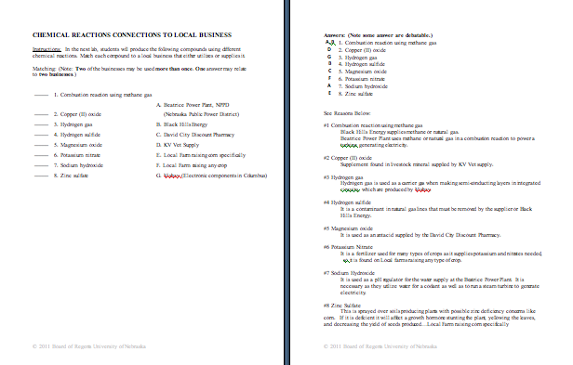
Instructing Concepts: (Powerful Reactions)

Chemical Reactions: A chemical reaction is a process by which one or more substances are changed into new substances by breaking or rearranging chemical bonds between elements. There are three key factors that help identify if a chemical reaction occurred:
1) Form a new substance (indicated by writing a new chemical formula)
Ex. H₂O goes through electrolysis to produce H_{2 &} O₂
2) The change cannot be reversed by physical means
Ex. burnt toast (burnt carbon remains cannot be reversed without more chemical reactions
back into the wheat flour) vs. bent penny (can easily be reversed by physical means)
3) New physical properties such as: different color, different odor, release of gas (fizzing or
foaming), production of sound heat, light, and solid (precipitate).

Chemical Equation: A chemical equation is a set of symbols and formulas written to identify the amounts of reactants to products in a chemical reaction. There are three types used:
1) Word Equation:-the reactants and products in a chemical equation are represented by words
Ex. water + carbon dioxide → glucose + oxygen
2) Formula Equation:-the reactants and products in a chemical equation are represented by
their symbols or formulas (unbalanced)
Ex. H₂O + CO₂ → C₆H₁₂O₆ + O₂
3) Balanced Chemical Equation: - the reactants and products are represented as a formula
equation with coefficients added to indicate an equal amount of elements on the reactants and
products side
Ex.6H₂O + 6CO₂ → C₆H₁₂O₆ + 6O₂ (Total of 12 H on each side etc.)

Types of Chemical Reactions:
1) Synthesis Reaction (Composition Reaction) : - 2 or more substances combine to form a
new compound
Formula: A + X → AX
2) Decomposition Reactions: -single compound undergoes a reaction that produces 2 or more
simpler substances (only occur when heat or electricity “electrolysis” are added)
Formula: AX → A + X
3) Combustion Reaction:-substance combines with oxygen, releasing a large amount of
energy in the form of light and heat
Formula often, but not always: carbon compound + oxygen→ water + carbon dioxide
4) Single-Displacement Reactions (Replacement Reaction) : -one element replaces a similar
element in a compound (usually happens in an aqueous solution)
Formula: A + BX → AX + B (cation replacement) & Y + BX→ BY + X (anion replacement)
5) Double-Displacement Reaction: -ions of 2 compounds exchange places in an aqueous
solution to form 2 new compounds
Formula: AX + BY → AY + BX
6) Acid-Base Reaction: -special kind of double displacement reaction between an acid and
a base. Often, the H⁺ ion in the acid reacts with the OH⁻ ion in the base, causing the
formation of water and some ionic salt.
Formula: HA + BOH → H₂O + BA (ionic salt)
Organizing Learning: (Powerful Reactions)

Summary: Students will view chemical reactions, write balanced chemical equations, and identify the type of chemical reaction that occurred.

Outline:
- View several chemical reactions
- Write the correct balanced equation for each reaction
- Identify the type of chemical reaction

Activity: Students will view a prezi (link below) providing examples of chemical reactions that occur at different types of power plants. They will also perform several chemical reactions in a lab. Using leading questions for both the prezi and lab, students will write a balanced chemical equation for each reaction that occurred. Once the correct chemical equation is written, students will identify the type of chemical reaction viewed.

Resources:
- Prezi developed of NPPD: http://prezi.com/g4ys5ivdkbot/chemical-reactions/

Attachments:
- Answer Sheet to Prezi: S117_SHINE_Powerful_Reactions_O_Prezi_answers.doc
- Types of Chemical Reactions Lab Part #1: S117_SHINE_Powerful_Reactions_O_Lab_Part1.doc
- Types of Chemical Reactions Lab Part #2: S117_SHINE_Powerful_Reactions_O_Lab_Part2.doc
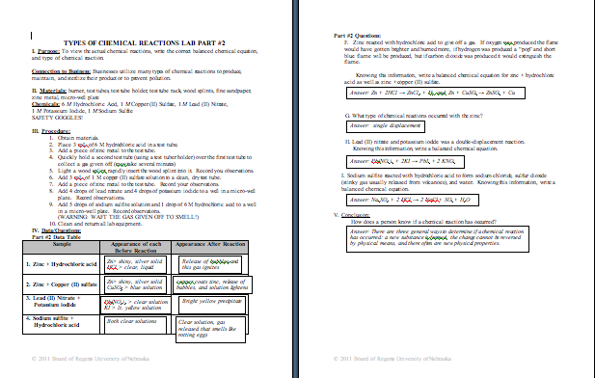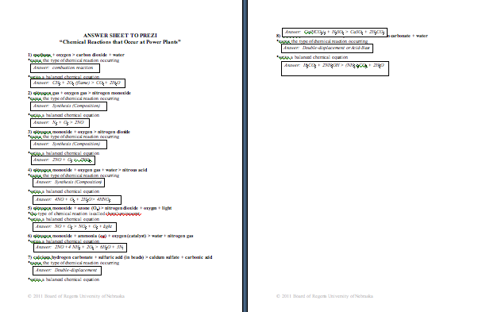
Understanding Learning: (Powerful Reactions)

Summary: Students will write correct chemical equations as well as identify the type of chemical reaction based on the word equation given. Students will distinguish between the types of chemical reactions.

Outline:
- Formative Assessment of Chemical Reactions
- Summative Assessment of Chemical Reactions

Activity: Students will complete written and quiz assessments of chemical reactions.

Formative Assessment: As students are engaged in the lesson ask these or similar questions:
- Can the students write a correct chemical formula for a compound?
- Once the chemical formulas are correct, are students able to balance the chemical equation using coefficients?
- Are students able to identify the chemical reaction?

Summative Assessment: Students can complete the following writing prompt:
How can a person determine what type of chemical reaction is occurring by reading the equation? Provide an explanation for each type of chemical reaction.

Students will complete the following short answer quiz questions about chemical reactions:

1) Balance the following equations and to the left write down the type of reaction occurring.

A. iron + copper (I) nitrate > iron (II) nitrate + copper

B. propane (C₃H₈) + oxygen > carbon dioxide + water

C. magnesium hydroxide + sulfuric acid > magnesium sulfate + water

D. lead (II) nitrate (heated) > lead (II) oxide + nitrogen dioxide + oxygen

