Project SHINE Lesson:
Turb-Up the Velocity!
==========================Lesson Header ==========================
Lesson Title: Turb-Up the Velocity!
Draft Date: 6/23/2011
1st Author (Writer): Elissa Gilger
Associated Business: Nebraska Public Power District (NPPD)
Instructional Component Used: Circular Motion
Grade Level: 11th-12th physics

Content (what is taught):
- Rotational (Angular) Velocity
This Teacher was mentored by:


www.nppd.com

In partnership with Project SHINE grant funded through the

National Science Foundation

- Tangential (Linear) Velocity

Context (how it is taught):
- View examples of rotational versus tangential velocity
- Calculate rotational and tangential velocity in story problems
- Build turbine blades, measuring rotational velocity and calculate tangential velocity for each
Activity Description:
In this lesson, students will distinguish between rotation and tangential velocity through viewing a video of a merry-go-round, performing measurements on a funnel, and building turbine blades.

Standards:

Math: MD2, ME1, ME3 Science: SB1, SB3, SE1, SE2

Technology: TA3, TD3 Engineering: EA3, EB1

Materials List:
- Several YouTube video clips
- Exploring Activity: funnel, erasable marker, measuring tape, stop watch, calculator
- Organizing Lab: 2 mini-CD’s, differing material to make blades like 16 oz plastic cups, plastic plates, cardboard, cardstock, rulers, protractors, markers, scissors, super glue, safety goggles
- One set-up for all groups: ring stand, thermometer clamp (test tube clamp), motor assembly harvested from a CD player, multimeter, alligator clips, fan with hi-low settings, second ring stand with photogate meter connected to an interface
Asking Questions: (Turb-Up the Velocity!)

Summary: Students are asked to make observations of two people riding on a merry-go-round in a video clip and reinforce the concepts learned in the video by twirling a washer on a string.

Outline:
- View the video clip
- Discuss the differences in the two people’s experiences riding on the merry-go-round
- Determine the person farther away from the center is traveling faster
- Demonstrate by twirling a string with a washer at the end
- Determine velocity (tangential/linear) increases as the radius of the circular motion increases

Activity: Students will view a video clip of two people riding on a merry-go-round. After the video-clip, ask these questions and demonstrate a washer rotating on a string:

Questions | Answers
There were two people riding on the merry-go-round. Did both have the same experience? | No, one appeared to be scared and having difficulty walking after the ride and the other appeared to be fine.
What could account for the difference between their experiences? | The location or position of the men. One man looked as though he almost flew off the merry-go-round as he was on the edge, while the other stayed closer to the center and seemed safe.
Why is it safer for a person to sit closer to the center rather than out on the edge? | The center is actually not traveling as fast (shorter circumference distance in the same amount of time). So, the man on the edge was traveling faster (longer circumference distance in the same amount of time) than the man nearer to the edge, which is why he felt dizzier and almost flew off.
If a person twirled a string with a washer tied at the end at the same pace, would the washer travel faster with a short or long string? | Long string…longer circumference distance to travel in the same amount of time.
What happens during circular motion when the radius of the circle increases? | Along the outer part of the circle the object travels faster as the radius increases.

Resources:
- Russian Merry-go-round/Roundabout of Death
http://www.youtube.com/watch?v=5JNH3KmYHck&feature=related
NOTE: Teachers may want to caution students not to try this as the merry-go-round is spun by a rope attached to a car.)
Exploring Concepts: (Turb-Up the Velocity!)

Summary: Students will investigate the differences between rotational (angular) and tangential (linear) velocity.

Outline:
- Measure rotational velocity for two different points on funnel as it is rotated
- Measure and then calculate the total distance for each point traveled during a rotation
- Determine that rotational velocity is the same for each point, but tangential velocity differs due to the distance differences

Activity: Students will mark a funnel at two different points. They will then, rotate the funnel 360˚continually timing for one minute to record the rotational velocity. Next, students will measure the circumference or distance each point travels during one rotation. Using the rotational velocity, they will calculate the total distance traveled at that location of the funnel. Leading questions will help students recognize that each point rotates at the same speed (rotational velocity), but one point travels further in the same amount of time meaning its tangential velocity is faster.

Attachment:
- Funnel Circular Motion Activity: M096_SHINE_Turb_Up_the_Velocity_E_Funnel_Lab.doc
One dot on outer edge

One dot 2/3 from outer edge
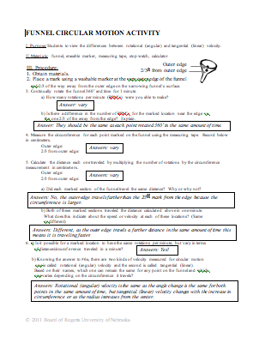
Instructing Concepts: (Turb-Up the Velocity!)
r
v
v
a_{c}
a_{c}
Circular Motion

Putting “Circular Motion” in Recognizable Terms: Circular motion occurs when an object follows a circular path about a center point. When the speed of the object stays constant, the motion is called uniform circular motion.
Putting “Circular Motion” in Conceptual Terms: With uniform circular motion, the speed (v) remains constant, but since the object is following the curved path of a circle, the direction of the velocity is changing. This changing velocity requires acceleration toward the center of the circle, called the centripetal acceleration (a_{c}). Since the object has mass, there will also be a centripetal force (F_{c}) acting on the object toward the center of the circle. The time for the object to go once around the circle is called the period (T).
Putting “Circular Motion” in $ω=\frac{Δθ}{Δt}$Mathematical Terms: In circular motion there are two kinds of velocity: rotational (angular) and tangential (linear). Rotational velocity is found using the formula: where ∆θ can be measured in radians or rotations divide by
the change in time ∆t
The tangential or linear velocity is found using the formula:
v = rώ where r is the radius and ώ is the rotational velocity
Rotational and tangential velocities are often confused. Notice a key difference is that tangential velocity increases as the radius increases, but the rotational velocity will be the same no matter the radius change. The centripetal acceleration is found using the formula:
$a_{c}=\frac{v^{2}}{r}$ where v is the tangential velocity and r is the radius
Using Newton's Second Law of motion, the centripetal force can be found:
$F_{c}=m⋅a_{c}$
$F_{c}=\frac{m⋅v^{2}}{r}$ where m is the mass of the object
During one period, the object goes once around the circle and travels along the circumference of the circle. The speed can be found using the circumference and period:
$v=\frac{d}{t}$
$v=\frac{2⋅π⋅r}{T}$ where r is the radius and T is the period
Putting “Circular Motion” in Process Terms: Centripetal acceleration describes the amount of acceleration an object will experience when following the circular path with uniform speed. Centripetal force is the amount of force needed to cause the uniform circular motion. The centripetal force is applied perpendicular to the direction of motion.
Putting “Circular Motion” in Applicable Terms: When an object is twirled around on a string, the centripetal force is provided by the tension in the string. For the Moon in orbit around the Earth, gravity supplies the centripetal force. When a roller coaster goes over the crest of a hill, if the speed and radius are such that the centripetal acceleration is equal to the acceleration of gravity, the roller coaster riders will feel weightless.
Organizing Learning: (Turb-Up the Velocity!)

Summary: Students will perform a lab designing different turbine blades, measuring the rotational (angular) velocity, and calculating the tangential (linear) velocity.

Outline:
- Construct two different sizes of turbine blades
- Measure the rotational velocity
- Calculate the tangential velocity
- Compare and contrast the performance of the different turbine blades

Activity: Students will construct two different sizes of turbine blades and super glue them to a mini-CD. The mini-CD will be attached to a harvested CD player motor with a photogate timing device and multimeter. Each turbine blade will be tested in front of a fan on high and low settings. Students will then record the rotational speed and millivolts produced by each blade device for each setting. Using this information, students will calculate the tangential velocity and compare/contrast the performance of each turbine blade.

Image taken from Wikimedia Commons: http://commons.wikimedia.org/wiki/Steam_turbine

Resources:
- “Sulzer Turbo Services - Steam Turbine” (shows how the blades become larger to capture the energy of the steam.) http://www.youtube.com/watch?v=ZOkbw5uVQww
- “Steam Turbine” (shows how a steam turbine works to produce electricity) http://www.youtube.com/watch?v=1bl1Q3V_79I
- “Steam Turbine Demonstration” (similar to the lab except we are not going to use steam as it may bother the photogate) http://www.youtube.com/watch?v=ynOnaTrHS7Q&feature=related
- Set up of CD device to measure blade rotation: http://soinc.org/sites/default/files/uploaded_files/PhysicalScienceLabSetup.pdf

Attachment:
Turbine Velocity Lab: M096_SHINE_Turb_Up_the_Velocity_O_Turbine_Lab.doc
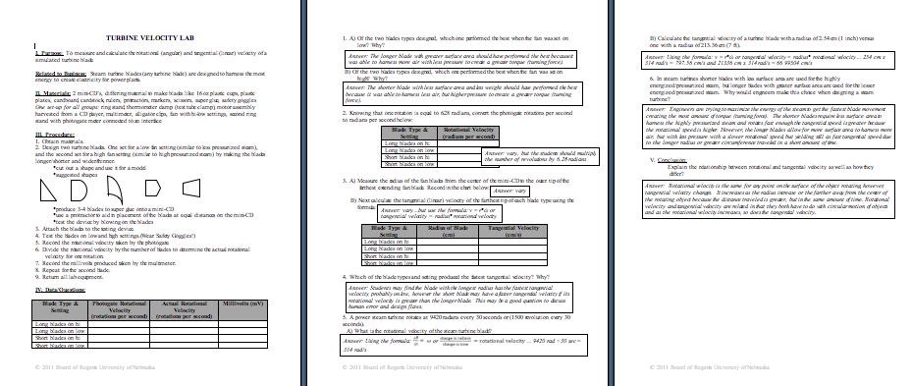
Understanding Learning: (Turb-Up the Velocity!)

Summary: Students will calculate the rotational and tangential velocity as well as explain the differences between the two.

Outline:
- Formative Assessment of Circular Motion
- Summative Assessment of Circular Motion

Activity: Students can perform written and quiz assessments related to circular motion.

Formative Assessment: As students are engaged in the lesson ask these or similar questions:
- Can students calculate rotational and tangential velocity?
- Are students able to distinguish between rotational and tangential velocity?

Summative Assessment: Students can complete the following writing prompt:
Explain the difference between rotational and tangential velocity and give an example of each.

Students can complete the following quiz questions:
1) Keith builds a simple steam turbine, which rotates at 200 radians every 40 seconds or (31.85 revolution every 40 seconds).
- What is the rotational velocity of the steam turbine blade?
- Calculate the tangential velocity of a turbine blade with a radius of 0.2 m (7 14/16 inches).

2) If a steam turbine contains blades that are 1 inch long and some that are 4 foot long with each one attached to the same rotating shaft (meaning they rotate together), compare and contrast the rotational and tangential velocity for each blade.

