Project SHINE Lesson:
This Teacher was mentored by:



http://www.abengoabioenergy.com

In partnership with Project SHINE grant funded through the

National Science Foundation

A Bushel A Day
==========================Lesson Header ==========================
Lesson Title: A Bushel A Day…..
Draft Date: 7/8/2011
1st Author (Writer): Bob Talbitzer
Associated Business: Abengoa Bioenergy
Instructional Component Used: Fermentation
Grade Level: Life Science 11 & 12th Grade

Content (what is taught):
- Alcohol Fermentation

Context (how it is taught):
- Producing Ethanol from Corn Mash
Activity Description:
Students will use an enzyme to extract sugars from corn mash. These sugars will then undergo fermentation producing ethanol. The ethanol will be distilled and its presence validated.

Standards:

Science: SC1

Materials List:
- Corn Mash (20 mesh or finer) 200 g | - 1000mL+ Beaker | - Stoppers
- Distilled Water--700mL | - Autoclave | - Rubber Hose
- Calcium Carbonate Powder | - Pipettes | - Ring Stands
- Celsius and Fahrenheit Thermometers | - Cooling Bath | - pH Paper
- *Alpha Amylase | - Cheesecloth | - pH Meter
- *Glucoamylase | - Stirring Rods | - HCl
- Activated Dry Yeast | - Fractional Distiller | - Balance
- Beaker 50mL | - Plastic Milk Jug (gal.) | - Hot Plate
- Ring Clamps | - Safety Goggles | - Heat Mits
Asking Questions: (A Bushel A Day)

Summary: Students will view a video on the production of ethanol in the biofuel industry.

Outline:
- Show the video “Ethanol on Modern Marvels”
- Have students generate a list of as many steps in the process of creating ethanol as they can identify

Activity: Students will be shown the video “Ethanol on Modern Marvels” (see link below). This video depicts the production of ethanol from the field to the gas pump. During the video students will be asked to list as many steps as they can identify in the process of ethanol production.

Questions | Answers
Where does the production of ethanol start? | In the corn field
How much ethanol is produced each year in the US? | 13.2 Billion gallons in 2010
How is ethanol created? | Fermentation of the grain
What organisms are used in the process of fermentation? | Bacteria and Yeast
What is done with the distiller’s grain after the process of fermentation? | It is usually sold as feed for livestock
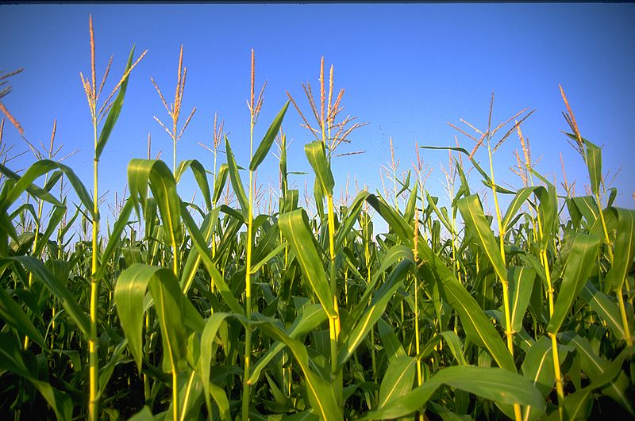
Image SourceWikimedia Commons:
http://commons.wikimedia.org/wiki/File:FEMA_-_2086_-_Photograph_by_Andrea_Booher_taken_on_07-09-1993_in_Missouri.jpg

Resources:
- Production of Ethanol Video: http://www.youtube.com/watch?v=poTGr8ONgl0
Exploring Concepts: (A Bushel A Day)

Summary: Students will analyze ethanol usage data from the state of Nebraska.*

Outline:
- Provide students with handout that illustrates the ethanol usage date from the state of Nebraska
- Break into groups of three or four
- Assign questions from the worksheet to each group
- Once completed, each group will present their answers to the rest of the class

Activity: Students will be broken in groups. Once in their groups, a data sheet will be handed out that detail the ethanol usage from the state of Nebraska. Questions from an accompanying worksheet will be divided amongst the groups, with each group getting a different series of questions. Once the groups have answered the questions, each group will then present their findings to the rest of the class.
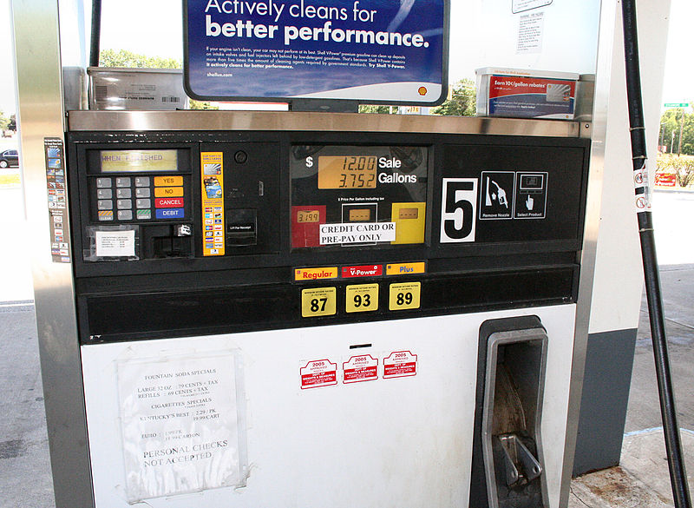
Image Source: Wikimedia Commons
http://commons.wikimedia.org/wiki/File:Gas-pump-Indiana-USA.jpg

Resources:
- Data from other states can be substituted. This information is readily available on the Internet

Attachments:
Ethanol Usage Data: S119_SHINE_A_Bushel_A_Day_E_Usage_Data.doc
Ethanol Usage Data Worksheet: S119_SHINE_A_Bushel_A_Day_E_Data_Wrksht.doc
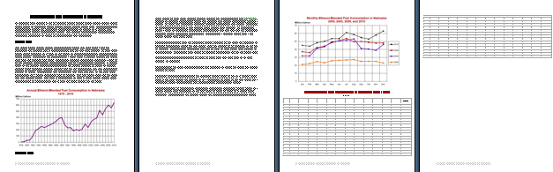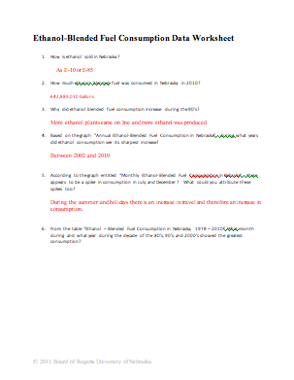
Instructing Concepts: (A Bushel A Day)

Cell Respiration

Types of Energy Organisms: In general, there are two kinds of energy organisms: autotrophic (producers) and heterotrophic (consumers). Autotrophic organisms create their own energy or food supply from a non-living source either using photosynthesis or chemosynthesis.
In contrast, heterotrophic organisms obtain their energy or food supply from other organisms. Both types use the process of cell respiration to convert their food sources into useable cell energy known as ATP (adenosine triphosphate).

Cell Respiration: Cell respiration converts the molecule glucose (C₆H₁₂O₆) into ATP. Glucose is a simple sugar (monosaccharide). Often glucose is not found simply as glucose within an organism, but must be refined from larger organic molecules such as carbohydrates (sucrose, fructose, cellulose, starch etc.), fats, and proteins. Once refined, the process begins in the cytoplasm and continues in the mitochondrion (cell organelle) in eukaryotic organisms. Chemical bonds hold energy. During cell respiration, the bonds between the carbon, hydrogen, and oxygen within glucose are broken or rearranged releasing energy given to ATP. ATP is an unstable carrier molecule that easily releases its third phosphate group discharging energy wherever it is needed within the cell. Once this happens, the ATP molecule changes into stable ADP (adenosine diphosphate) and begins the process all over again.

Types of Cell Respiration: There are two kinds of cell respiration: aerobic and anaerobic. The most significant difference is aerobic utilizes oxygen to aid in transfer of energy from glucose to ATP. This allows the hydrogen (H) atoms within the glucose molecule to bond with the oxygen (O₂) forming a safe waste known as water (H₂O). It, also, permits the glucose molecule to go through three phases of cell respiration (glycolysis, Krebs citric acid cycle, and electron transport) producing lots of ATP. Anaerobic cell respiration is deprived of oxygen generating wastes other than water varying in type depending on the organism. Also, fewer ATP are produced as only one phase (glycolysis) of cell respiration is utilized.

Aerobic Cell Respiration in Humans | Anaerobic Cell Respiration in Humans
Oxygen + glucose → 36 ATP + carbon dioxide + water | glucose → 2 ATP + lactic acid  (lactic acid make cramps in skeletal muscles)
6 O₂ + C₆H₁₂O₆ → 36 ATP + 6 CO₂ + 6 H₂O | C₆H₁₂O₆ → 2 ATP + 2 C₃H₆O₃

Fermentation: Fermentation is another term for anaerobic cell respiration. Often, it is used in reference to production of chemicals by microorganisms such as yeast or bacteria applied to a variety of products such as foods, flavorings, beverages, and pharmaceuticals. Both yeast and bacteria are able to convert sugars into ethyl alcohol (ethanol or C₂H₅OH) and carbon dioxide (CO₂). Humans have captured this ability by using yeast (most commonly Saccharomyces Cerevisae) to raise bread (their release of CO₂ allows the dough to rise) and to produce wine, beer, or ethanol to power combustion engines. Yeasts are often chosen over bacteria as they generate multiple end products in addition to ethyl alcohol. These include other alcohols (butanol, isopropylalcohol, 2,3-butanediol), organic acid (acetic acid, formic acid, and lactic acids), polyols (arabitol, glycerol and xylitol), ketones (acetone) or various gases (methane, carbon dioxide, and hydrogen).
Organizing Learning: (A Bushel A Day)

Summary: Students will produce ethanol from corn mash.

Outline:
- Students will produce ethanol from corn mash
- Students will separate the corn mash from the alcohol solution
- Students will distill the ethanol
- Students will use the splint test to positively identify the presence of ethanol

Activity: Students will complete a laboratory exercise that will convert corn mash to ethanol. The procedures for this lab are attached in a file (see below). As part of the lab, students will separate alcohol from the corn mash and then distill it to make it purer. Finally, a splint test will be utilized to identify the present of ethanol. In this lab procedure, students will use ordinary corn and simple enzymes to produce real ethanol.

Attachment:
Fuel Grade Ethanol From Corn Mash Lab: S119_SHINE_A_Bushel_A_Day_O_Ethanol_Lab.doc
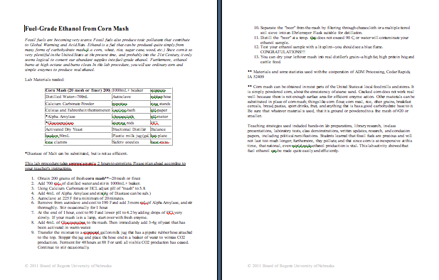
Understanding Learning: (A Bushel A Day)

Summary: Students will create a flow chart detailing the steps of alcohol fermentation in the production of the biofuel ethanol.

Outline:
- Formative Assessment of Cell Respiration
- Summative Assessment of Cell Respiration

Activity: Students will complete written assessments related to cell respiration.

Formative Assessment: As students are engaged in the lesson ask these or similar questions:
- Can students define alcohol fermentation?
- Can students identify the microbes utilized in the alcohol fermentation process?
- Can students determine the presence of ethanol in the distilled grain?

Summative Assessment: Students can complete the following writing prompts:
- Explain how cell respiration relates to the production of ethanol from corn mash.
- Students will create a flow chart detailing the steps and materials involved in the distilling of corn for the production of ethanol.
- Complete a formal lab write-up for the production of ethanol from corn mash.

