Project SHINE Lesson:
Watts Going Down?
==========================Lesson Header ==========================
Lesson Title: Watts Going Down?
Draft Date: 7/8/2011
1st Author (Writer): Bernie Fleischacker
Associated Business: NPPD
Instructional Component Used: Electrical Power Consumption
Grade Level: Middle School

Content (what is taught):
- The concepts of watt, kilowatt, and kilowatt hours
This Teacher was mentored by:


www.nppd.com

In partnership with Project SHINE grant funded through the

National Science Foundation

- The comparative price, energy usage, and life of incandescent lights vs. CFLs
- How much energy is typically used by an American home overall and for lighting purposes
- The amount of money that can be saved by switching from incandescent to CFL lighting

Context (how it is taught):
- Direct teacher instruction of terminology and data related to electrical consumption
- Students work individually, in pairs, or in small groups using the data and formulas given to calculate energy costs and savings
Activity Description:
Students will be introduced to the concepts of watts, kilowatts, and kilowatt hours. They will be given data related to the price, and life of incandescent and CFL lights and will calculate which is cheaper over a ten year period. They will also be given data related to home electrical consumption and comparative wattage of incandescent and CFL to calculate how much electricity and money can be saved by using CFL bulbs as opposed to incandescent bulbs. Finally, they will determine total savings of using CFL bulbs by adding the savings on both the costs of bulbs and electricity.

Standards:

Math: MD1, MD2, ME2, ME3 Science: SE1, SF5

Technology: TA4, TC4, TF4 Engineering: EB1, EC4

Materials List:
- Calculator
- Pencil and Paper
- Eraser
Asking Questions: (Watts Going Down?)

Summary: Students will be questioned about the differences between incandescent and CFL light bulbs in terms of how they work and how much energy they use.

Outline:
- Ask students if they know how incandescent and CFL lighting works
- Ask students which type of lighting they think uses the most energy
- Question students about how much less they think the electricity bill for their home would be if they were to use all CFL rather than incandescent lights
- Given that incandescent lights are cheaper than CFL at this time, ask them if they think CFL lights save money when considering the purchase price

Activity: Hold a large group teacher led discussion to determine if students understand the differences between incandescent and CFL lighting and to have them predict which is the most cost efficient considering both energy usage and purchase price. **To increase motivation, students may write down their guesses for the last two questions and offer some type of reward for those who come the closest to the correct answer for the fourth one and answer yes to the fifth.

Questions | Answers
How do the incandescent light bulbs that most of us have used in our homes work? | They have a filament that heats up and gives off light.
How do compact fluorescent lights(CFLs) work? | They have a gas inside which gives off light when its electrons are excited by electricity.
Which type of light is more energy efficient? In other words, which uses the least electricity? | Since 90% of the energy is used to heat the filament in an incandescent bulb, CFLs are more efficient in producing roughly the same amount of light.
**How much less do you think the electric bill for a typical house would be if only CFL bulbs were used compared to only incandescent bulbs? | Will vary widely, as most students probably don’t have a realistic idea of the cost of electricity and how much energy is used in lighting. Tell them that in this lesson we will compare the two to determine the answer.
**CFL light bulbs currently sell for at least five times what incandescent bulbs do. Do you think the electricity savings using CFL bulbs will make up for the higher cost of the bulbs? | Various responses. Tell them that there is a third factor involved, the life of the bulb, and we will determine the answer considering electricity usage, retail cost, and average life.
Energy Used
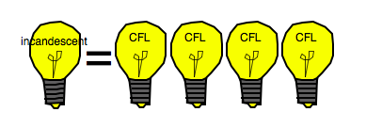
Exploring Concepts: (Watts Going Down?)

Summary: Students will research lighting in the typical American home. The types, cost and energy consumption of light bulbs need to be determined. The concepts of watt, kilowatt, and kilowatt-hours will be explained.

Outline:
- Students will research types, cost, and energy consumption of light bulbs
- Students will learn about watts, kilowatts, and kilowatt-hours

Activity: Students will research light bulbs in America. They will need to find the type, cost, bulb life and energy consumption of typical bulbs. After research is conducted, the concept of watt, kilowatt, and kilowatt-hours needs to be explained. The purpose is to learn about different lighting choices and get students thinking about how much each bulb costs.

Teacher Information:
 | Incandescent | CFL
Cost | approx. $.40/bulb | approx. $2/bulb
Projected life | approx.1000 hours | approx 8000 hours
Energy consumption | 40w, 60w, 75w, 100w | 75% less
Instructing Concepts: (Watts Going Down?)

Electrical Power Consumption

Key Ideas:
- Electricity is the flow of electrons and is a force that can “do work”.
- You must have a complete circuit for electricity to do work.
- Energy is used by all electronic devices when running.
- Modern electrical devices are being engineered to reduce the amount of electricity used while both actively being used and while turned off.
- Some devices don’t need to be switched on to still use electricity, these standby losses are often called electrical “vampires”.
  - The amount of standby power wasted varies among electronic equipment, but overall, the cost to consumers and businesses for all the electricity lost to vampire power in the US is estimated to be $4 billion annually. Approximately 5%-10% of all household use is this type of loss.

Vocabulary:
- Electricity: a fundamental form of energy observable in positive and negative forms that occurs naturally (as in lightning) or is produced (as in a generator) and that is expressed in terms of the movement and interaction of electrons
- Vampire Power: Wasted Standby Power in Home Electronics and Appliances.
- Watt: a standard unit of measurement for electricity. The wattage of devices provides a means of determining relative electrical consumption.
- The rate at which power is consumed by a device or unit (such as a building) is often expressed in kilowatt-hour (kWh).
- Kilowatt Hour (kWh): the basic unit of electric energy equal to 1 kilowatt or 1,000 watts of power used for one hour. The amount of power the customer uses is measured in kilowatt hours (kWh). A 100-Watt light bulb operated for 10 hours uses 1 kWh.
Organizing Learning: (Watts Going Down?)

Summary: Students will calculate which bulb (incandescent or CFL) is more cost effective to use in your home. As part of the calculation, students will decide which bulb they will use.

Outline:
- Students will compare incandescent and CFL bulbs
- Students will decide which bulb is best to use in their home

Activity: Students will compare incandescent and CFL light bulbs to determine which is better to use in their homes. They will need to find or be provided data related to each bulb including: energy consumption, cost, and bulb life. The attached worksheet will help guide the necessary calculations. Note: Solutions are attached as well.

Attachments:
Calculation worksheet: S122_SHINE_Watts_Going_Down_O_Calculations.doc
Calculation worksheet answers: S122_SHINE_Watts_Going_Down_O_Answers.doc
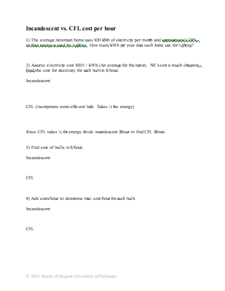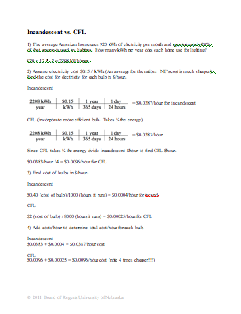
Understanding Learning: (Watts Going Down?)

Summary: Students will determine how much money can be saved over a ten year period by using CFLs instead of incandescent lights considering the cost of the bulbs, the life of the bulbs, and the energy cost.

Outline:
- Formative Assessment of Electrical Power Consumption
- Summative Assessment of Electrical Power Consumption

Activity: Student will complete writing and performance assessments related to electrical power consumption.

Formative Assessment: As students are engaged in the lesson ask these or similar questions:
- Did the students accurately calculate the number of kilowatt hours used by the average American home for lighting in a year?
- Did students correctly figure the ratio of energy consumption of incandescent lights vs. CFLs?
- Did student correctly calculate the costs of incandescent and CFL bulbs and the price ratio between them?

Summative Assessment: Students can complete the following writing prompt:
Explain why a $0.40 incandescent light bulb is more expensive than a $2 CFL light bulb. Which bulb do you want to use in your house? Why?

Student can complete the following performance assessment:
Students will calculate the savings of a CFL bulb vs. incandescent bulb over a ten year period. See attached worksheet for calculations. Note: Solutions are attached as well.

Attachments:
S122_SHINE_Watts_Going_Down_U_Assessment.doc
S122_SHINE_Watts_Going_Down_U_Assessment_Solution.doc
