Project SHINE Lesson:
Refine Your Pallet
==========================Lesson Header ==========================
Lesson Title: Refine Your Pallet
Draft Date: July 28, 2011
1st Author (Writer): Jeremy Scheffler
Associated Business: Kawasaki
This Teacher was mentored by:

www.kawasakilincoln.com

In partnership with Project SHINE grant funded through the

National Science Foundation

Instructional Component Used: Friction
Grade Level: Physics – 11th/12th Grade

Content (what is taught):
- Frictional Forces
- Static and Kinetic Friction
- Coefficient of Friction

Context (how it is taught):
- Students will observe and measure frictional forces between surfaces and use data to determine coefficients of friction
- Students will simulate air pallets used at Kawasaki to reduce frictional forces

Activity Description:
Students will investigate friction by observing and measuring forces exerted when objects slide across surfaces and by constructing devices to reduce frictional forces exerted on sliding objects.

Standards:

Math: ME1, ME2 Science: SA2, SB1

Technology: TA3, TC4 Engineering: EA2

Materials List:
- Textbooks
- Desks
- Smooth and Rough Surfaces
- Wooden Blocks
- Spring Scales
- Weights
- Graph Paper
- Air Compressor
- Air Hoses
- Boxes
- Utility Knives
Asking Questions: (Refine Your Pallet)

Summary: Students rub their hands together and slide their textbooks across their desks to observe frictional forces.

Outline:
- Students will rub their hands together to feel a frictional force.
- Students will slide their textbooks across their desks to observe the force required to overcome friction.

Activity: Have students rub their hands together and observe how pushing their hands together with more or less force makes it harder or easier to slide them across each other. Have students slide their textbooks across their desks and observe the amount of force required to start motion and to continue motion. Have students stack multiple books and observe how the amount of force to slide the book changes. Have students slide the books on a smoother or rougher surface and observe how the amount of force changes.

Questions | Answers
What is a frictional force? | Frictional forces oppose relative motion between to surfaces in contact.
What determines the amount of frictional force between two surfaces? | The properties of the surfaces in contact (smoothness or roughness) and the normal force the surfaces exert on each other.
How does the frictional force opposing the start of motion differ from the frictional force opposing the continuation of motion? | The frictional force opposing the start of motion, static friction, balances any applied force until a threshold value is exceeded. Once sliding occurs, the frictional force opposing the continuation of motion, kinetic friction, can be unbalanced and cause an object to slow down. Static friction is typically greater than kinetic friction if other variables are kept constant.
How could you reduce the force required to slide a very heavy object across a surface? | Make the surfaces smoother, use wheels or rollers, provide a cushion of air underneath it, etc.
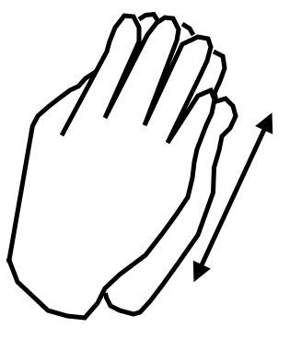
Exploring Concepts: (Refine Your Pallet)

Summary: Students use data for objects sliding across different surfaces to explore the relationship between kinetic friction and the normal force.

Outline:
- Students will measure and record the normal force and kinetic friction for objects sliding across different surfaces
- Students will graph their data to determine the relationship between kinetic friction and the normal force

Activity: Students will complete the following lab activity and record all measurements in a table (shown below).
- Hang a wooden block from a spring scale so that it is not moving and record its weight as the normal force.
- Use a spring scale to pull the block with a horizontal force across a level surface so that it moves with a constant speed and record the force from the spring scale as the kinetic friction.
- Repeat steps 1-2, adding weight to the block each time to change its weight.
- Graph the kinetic friction (y-axis) vs. the normal force (x-axis) and determine the equation of the best-fit line.
- Repeat steps 1-4 using a different surface.
- Explain why different surfaces yield different slopes.
- Present results to the class.

Surface 1 |  | Surface 2
F_{N} (N) | f_{k} (N) | F_{N} (N) | f_{k} (N)
… | … | … | …

After allowing students to compare their results, the teacher can facilitate a discussion that introduces the term coefficient of friction and leads to the general equation $f_{k}=μ_{k}F_{N}$, where the slope of the line produced by the lab data represents the coefficient of kinetic friction for the surfaces used.
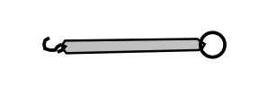
Materials:
- Spring Scales
- Wooden Blocks
- Different Surfaces
Instructing Concepts: (Refine Your Pallet)

Friction

Putting “Friction” in Recognizable Terms: Friction is a force between two objects that tends to “damp out” or oppose motion. It always acts in opposition to the motion of the object. The cause of friction is simple; rough or uneven surfaces attempting to move past each other. As the high points of one surface come in contact with the high points of another surface an electromagnetic force bonds them together making it difficult for the objects to slide past each other.
Putting “Friction” in Conceptual Terms: Friction is dependent on the surface types and the amount of force between them. It can then be decreased or increased by modifying the surface such as: creating a smoother or rougher surface, lubricating or desiccating the surface, or by reducing or increasing the force pressing the surfaces together. Surprisingly the area of contact does not affect frictional force when relative smooth surfaces are in contact since a larger area creates a lower pressure between the surfaces lowering frictional force spread over the larger area. The frictional force per unit area is lower/higher in proportion to the increase/decrease in area.
There are two main types of friction: static and kinetic friction. Static friction is the initial frictional force combating setting an object at rest into motion. Kinetic friction is the on-going frictional force which tends to slow an object in motion. Usually static friction is higher than kinetic friction meaning it takes a greater force to put an object into motion than it does to maintain its motion.
Putting “Friction” in Mathematical Terms: The coefficient of friction measures the difficulty or ease of moving an object across different types of surfaces. It is symbolized by the Greek letter mu, “µ”, and can be calculated by taking the force of friction, F_{f}, divided by the normal force, F_{n}, written as: µ = F_{f} / F_{n}. The normal force is the force pressing the two surfaces together and is perpendicular to the force of friction. Once the coefficient for a type of surface is calculated it can be multiplied times the normal force (F_{f} = μF_{n}) to determine the amount of friction an object will incur moving across that type of surface. There are also two kinds of coefficients: a “static” coefficient and a “kinetic” coefficient measuring the frictional ratio for starting and/or continuing the motion (respectively) of an object.
Note: If an object is on a horizontal surface, the normal force will be equal and opposite to the force of gravity, which is the force of weight of the object. If an object is on a surface at an angle, the force of weight must be resolved into vector components to calculate the normal force or friction on the object. (see attached diagram)
Putting “Friction” in Process Terms: Friction when present hinders an object’s movement or holds it in place. If friction is absent an object would continue to move unimpeded. Thus friction fulfills Newton’s 1st and 3rd Laws of Motion. The 1st Law meaning that an object at rest or held in place by friction will remain at rest unless acted upon by a greater applied force. Although, an object moving will continue to move unless an outside force such as friction changes its motion. The 3rd Law is fulfilled as friction is an equal but opposite force against an applied force to create uniform motion.
Putting “Friction” in Applicable Terms: Friction is both desirable and undesirable depending on if you want an object to move or stay at rest. It is the force that allows us to walk, rest, climb, cling, drive, stop, throw, or catch.
Attachments: I_Sci_002_Friction_I_Diagrams.doc
Organizing Learning: (Refine Your Pallet)

Summary: Students simulate the air pallets used to move 78-Ton rail cars at Kawasaki by using compressed air to reduce the frictional force opposing a “pallet” sliding across the floor.

Outline:
- Students will measure the force required to overcome kinetic friction while sliding a pallet across the floor without air and calculate the coefficient of kinetic friction
- Students will design and construct an air pallet to reduce the force required to slide it and calculate the effective coefficient of friction

Activity: Students will perform the following activity and record all measurements and calculations in the table below.
- Construct a pallet by coiling an air hose underneath a box.
- Measure the weight of the pallet and the horizontal force required to pull it across the floor with a constant speed without air.
- Calculate the coefficient of kinetic friction between the pallet and the floor.
- Design and construct an air pallet prototype by cutting openings in the air hose.
- Test the prototype design using compressed air.
- Use testing results to make any necessary modifications and prepare a final product.
- Measure the weight of the final product and the horizontal force required to pull it across the floor with a constant speed with air.
- Calculate the effective coefficient of friction between the final product and the floor.
- Compare the coefficients of friction calculated in steps 3 and 8 and analyze the performance of the final product.

 | Weight | Horizontal Force | Coefficient of Friction
Without Air
With Air
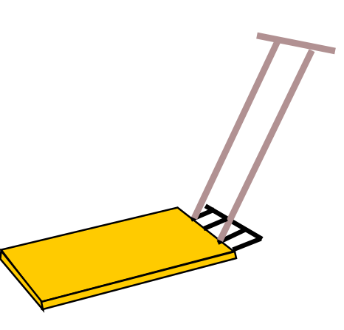
Understanding Learning: (Refine Your Pallet)

Summary: Students will describe frictional forces, identify different types of friction, and use the coefficient of friction to solve problems.

Outline:
- Formative assessment of friction
- Summative assessment of friction

Activity: Students will complete short answer and problems relating to friction.

Formative Assessment: As students are engaged in the lesson ask these or similar questions:
- Are students able to define friction?
- Are students able to distinguish between static friction and kinetic friction?
- Can students calculate frictional forces and solve problems using the coefficient of friction?

Summative Assessment: Students will answer the following short-answer questions:
- What is friction?
- What is the difference between static friction and kinetic friction?
- What determines the coefficient of friction?

Students will solve the following problems:
- A block weighing 300 N is pulled across a horizontal table at constant speed by a horizontal tension force of 50 N.
- Draw a force diagram for the block.
- Calculate the coefficient of kinetic friction.
- A 50. kg crate is initially at rest on a horizontal floor. The coefficient of static friction is 0.25, and the coefficient of kinetic friction is 0.15.
- Calculate the minimum horizontal force that must be applied for the crate to start moving.
- Calculate the horizontal force that must be applied for the crate to move with a constant speed.

