Project SHINE Lesson:
Structure of Ethanol
==========================Lesson Header ==========================
Lesson Title: Structure of Ethanol
This Teacher was mentored by:



http://www.abengoabioenergy.com

In partnership with Project SHINE grant funded through the

National Science Foundation

Draft Date: July 8, 2011
1st Author (Writer): Teresa Walters
Associated Business: Abengoa Bioenergy
Instructional Component Used: Organic Chemistry Nomenclature/Structure (Basic and alcohols)
Grade Level: 9-12

Content (what is taught):
- Nomenclature of Organic Molecules
- Structural Formulas

Context (how it is taught):
- The students will define organic chemistry
- The students will think of ways organic chemistry is used in business
- The students will view a video on ethanol production and discuss the process
- The students will build organic compounds (including ethanol) with molecular models
Activity Description:
The students will describe what organic chemistry is and think of ways organic chemistry is used in business. The students will watch a video on ethanol production and discuss the process. Following the video, the students will use molecular models to build the ethanol molecule, as well as other organic molecules.

Standards:

Math: MC1 Science: SB1

Technology: TA3 Engineering: EB3

Materials List:
- Molecular Model Sets
- Video on Ethanol Production: http://www.youtube.com/watch?v=poTGr8ONgl0
Asking Questions: (Structure of Ethanol)

Summary: The students will be asked to define organic chemistry and think of ways it is used in business.

Outline:
- Students will be asked to define organic chemistry.
- Students will be asked to list ways organic chemistry might be used in business.

Activity: The students will be asked for ideas on what they think organic chemistry is and ways it might be used in business.

Questions | Answers
What is organic chemistry? | Study of carbon compounds.
How is organic chemistry used in business? | Ethanol, food processing, biomass, etc.
Can you think of some organic compounds? | Ethanol, sugar, etc.
What are some local businesses that use organic chemistry? | Ethanol plant, food processing, etc.
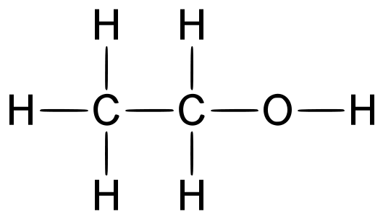
Exploring Concepts: (Structure of Ethanol)

Summary: Students will watch a video on the production of ethanol. After viewing the video, we will discuss how ethanol is made and we will discuss the molecular structure of ethanol.

Outline:
- Students will view a video on ethanol production
- Students will discuss how ethanol is made
- Students will be asked to think about the composition of ethanol, and how it might appear structurally

Activity: The students will view a video on ethanol production (link below). After viewing the video, students will discuss how ethanol is made. Students will start to speculate about how ethanol would look structurally.

Resource:
- Video on ethanol production: http://www.youtube.com/watch?v=poTGr8ONgl0
Instructing Concepts: (Structure of Ethanol)

Organic Chemistry Nomenclature: Organic chemistry is the study of covalently bonded compounds containing carbon (excluding carbonates and oxides). Nomenclature is the naming system developed for these different organic or carbon containing compounds.

Types of Organic Compounds:
1) Hydrocarbons: simplest as they contain only two elements hydrogen and carbon
a) Alkanes (suffix –ane) only have single bonds between hydrogen and carbon
b) Cycloalkanes(prefix cylco-) the carbon atoms are arranged in a cyclic structure
c) Alkenes (suffix –ene) contain double covalent bonds
d) Alkynes (suffix –yne) contain triple covalent bonds
f) Aromatic (suffix benzene) contain six-membered carbon rings and delocalized electrons
Note: if two double bonds the ending changes to –adiene; triple bonds –adiyne; if three double bonds the ending changes to –atriene; triple bonds -atriyne
2) Alcohols: (suffix –ol) contain one or more hydroxyl group (OH¹⁻)
3) Alkyl halides: (halogen prefix) contain one or more halogen atoms in place of a hydrogen
4) Ethers: (the shorter hydrocarbon suffix –oxy and the longer suffix –ane) contain two
hydrocarbon groups are bonded to the same atom of oxygen
5) Aldehydes: (suffix –al) contain carbonyl group (C═O) attached to the final carbon in chain
C H
6) Ketone: (suffix –one) contain carbonyl group (C═O) attached to a carbon within the chain
C
7) Amine/Amides: (suffix –amine, amide, carboxamide or prefix amino-, O
amido-, carbamoyl-) contain derivatives of ammonia (NH₃) ║
8) Carboxylic acids: (suffix –oic acid) contain carbonyl functional group (C─OH)
9) Esters: (suffix –oate) contain carboxylic acid groups in which the hydrogen of the hydroxyl
group has been replaced by an alkyl group

Nomenclature:
The systematic approach to naming organic compounds was formalized by IUPAC (International Union of Pure and Applied Chemistry). There are a number of rules for each type of organic compound only simple hydrocarbon chains and alcohols will be instructed below. When naming straight chains of hydrocarbons a prefix is added indicating the number of carbons to the suffix matching the type (e.g. ethyne H─C≡C─H or C₂H₂). The following prefixes are used to indicate the number of carbons in the chain: meth-1, eth-2, prop-3, but-4, pent-5, hex-6, hept-7, oct-8, non-9, and dec-10.
Branched chains are much more complicated. First, determine the longest continuous carbon chain (parent hydrocarbon) including the maximum number of multiple bonds to determine its correct prefix and suffix. Next, add the names of the alkyl groups (carbon groups branched off the parent group) add the ending –yl and list alphabetically in front of the parent hydrocarbon’s name (if more than one of the same alkyl group add the prefixes di=2, tri=3, tetra=4). Number the parent hydrocarbon’s carbon atoms to create the lowest locant combination for the alkyl groups and/or multiple bonds. Insert these numbers in front of the alkyl groups to indicate which carbon each branches off the parent hydrocarbon. Finally, punctuate the name by placing commas between more than one number for an alkyl group and hyphens between alkyl groups (e.g. 3-ethyl-2,4,5-trimethyloctane). Alcohol names are written with a suffix –ol and a numerical infix indicating the bonding position of the hydroxyl group. If there are multiple hydroxyl groups then di-, tri-, etc prefixes are added (e.g. CH₂OHCH₂OH or ethane-1,2-diol).
Organizing Learning: (Structure of Ethanol)

Summary: Students will be given molecular model sets. They will be asked to build several organic compounds (including ethanol).

Outline:
- Students will be given a molecular model set
- Students will learn how organic compounds are named
- Students will be asked to build several organic compounds, including ethanol

Activity: The students will use molecular model sets to build several organic compounds. To start the activity students will view a PowerPoint related to the naming of organic compounds (see attachment). After students learn how compounds are named, they will build compounds such as ethanol, ethane, methanol and methane. See attachment for possible compounds. After building the compounds, they will be asked to compare and contrast the models.

Materials:
- Molecular Model Sets

Attachments:
S125_SHINE_Structure_of_Ethanol_O_Compounds.doc
S125_SHINE_Structure_of_Ethanol_O_Naming.ppt
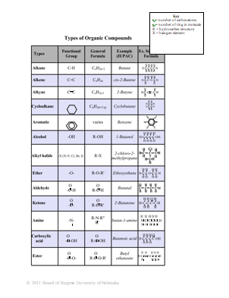
Understanding Learning: (Structure of Ethanol)

Summary: The students will be asked what all of the compounds they built have in common. They will also be asked to explain how compounds such as ethane and ethanol are different.

Outline:
- Formative Assessment of Organic Chemistry Nomenclature/Structure
- Summative Assessment of Organic Chemistry Nomenclature/Structure

Activity: Students will complete written assessments on organic chemistry nomenclature.

Formative Assessment: As students are engaged in the lesson ask these or similar questions:
- Did the students use the correct “atoms” to build their models?
- Did the students make each model correctly?
- Did the students notice the similarities and differences in the models?

Summative Assessment: Students can complete the following writing prompts:
- Explain how an ethanol is structurally different from ethane.
- What did all of the compounds you built have in common?

