Project SHINE Lesson:

Recycle or Not?
==========================Lesson Header ==========================
Lesson Title: Recycle or Not?
Draft Date: July 25, 2011
This Teacher was mentored by:


http://www.nucorbar.com/

In partnership with Project SHINE grant funded through the

National Science Foundation

1st Author (Writer): Suzy Goedeken
Associated Business: Nucor Steel
Instructional Component Used: Renewable/ Nonrenewable Resources
Grade Level: 7-8

Content (what is taught):
- Understand what a resource is
- Identify the difference between renewable and nonrenewable resources
- Recognize what materials can be recycled

Context (how it is taught):
- Learn the difference between renewable and nonrenewable resources
- Students will examine schools current waste management plan and recommend changes
- Tour your local recycling facility
Activity Description:
In this lesson, students will learn what nonrenewable and renewable resources are. They will also learn what materials are recyclable. Then, students will look at their schools current waste management and research ways to improve it. The proposed improvements will be put into a PowerPoint presentation and a persuasive speech.

Standards:

Science: SE2 Technology: TA1, TD2

Materials List:
- Computer
- Recyclable Materials
- Renewable Materials
- Nonrenewable Materials
Asking Questions: (Recycle or Not?)

Summary: Nucor is a leader in the steel industry on recycling unused product. Issues concerning the environment, including the greenhouse gas emissions are a major concern for their production. The company is a strong supporter of the governments VISION program in which the company voluntarily lowers its greenhouse gas emissions. If a big company can do this and still stay profitable, why can’t we as everyday citizens do something to help the environment as well? Students are asked to define the word “resources.”

Outline:
- Read the passage by the poet Carmen Agra Deedy
- Discuss where the paper the school uses comes from
- Students place objects in renewable and nonrenewable groups
- Class will discuss the objects and whether they are in the correct group

Activity: Read the passage by the poet Carmen Agra Deedy:

Everything comes from something,
Nothing comes from nothing.
Just like paper comes from trees,
And glass comes from sand.

Prior to class, the teacher needs to research where the paper the school uses comes from. Discuss with students that paper comes from trees and the particular paper we use comes from _________. Next, have 6 – 10 items on a table. Ask students to place the renewable products in one group and nonrenewable resources on another group. Ideas for the items could be – plastic pop bottle (N), coal (N), # 2 Pencil (R), glass of water (R), Fan (representing Wind) (R). After the sorting, ask the class if there is any product they would like to move. Discuss each object.

Questions | Answers
What is resource? | An aspect of the physical environment that people value and use.
What is Nonrenewable? | Resource
What is renewable? | Resource that can be regenerated if used carefully.
What does Recycle mean? | To save and take reusable material to places where they can be remade into the same product or new products.
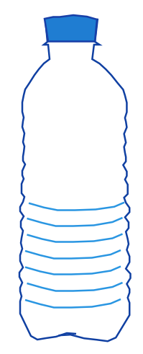
Exploring Concepts: (Recycle or Not?)

Summary: Each group of students will be given a product. They will research where the product originates from and whether it is renewable. In addition, students will state whether the product can be recycled. A recycling worksheet will also be completed.

Outline:
- Each group of students will be given a product to research
- The groups will research where the product originates from, whether it is renewable, and if it is recyclable
- Students will complete a recycling vocabulary worksheet

Activity: Divide students into groups of two. Give each a product and a computer. The group needs to research where to product is from (its origin), whether it is a renewable resource, and whether the product can be recycled. Students will also complete a worksheet on recycling vocabulary.

Attachment:
Recycling Vocabulary Decoder Worksheet: S126_SHINE_Recycle_or_Not_E_Worksheet.doc
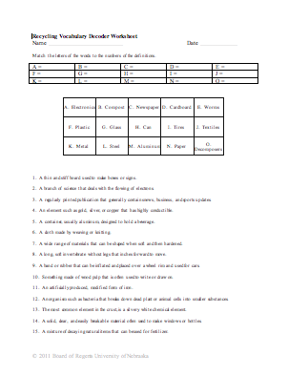
Instructing Concepts: (Recycle or Not?)

Natural Resources

Natural resources occur naturally within and are derived from the environment and exist relatively undisturbed by man. Natural resources are both essential for our survival and used for satisfying our wants.

Classifications
There are many different classifications for natural resources depending on what aspect is being discussed. Common classifications include:
- Based on origin: Biotic (from living things) and Abiotic (from nonliving things)
- Based on stage of development: Potential (exist and may be used in future), Actual (being used at present time), Reserve (part of actual resource that can be developed for use) and Stock (cannot be used at this time due to lack of technology.
- Based on renewability: Renewable (can be replenished or reproduced easily) and nonrenewable (formed over long geological periods so cannot be replenished)
- Based on availability: Inexhaustible (unlimited in quantity…air, sunlight, etc.) and Exhaustible (limited in quantity and can be used up...fossil fuels, etc.)

Management/Conservation
It is critical for natural resources to be managed and conserved, especially if the resource is exhaustible or nonrenewable. These resources cannot be easily replaced. Recently, there has been a global push to use natural resources more responsibly. The conservation movement to reduce, reuse and recycle is directly applicable to natural resources. If society can reduce the use of a natural resource, or reuse it for another application or recycle it for another use the impact on our environment will be reduced. For instance, fewer trees will have to be cut down and less mining will have to occur. This movement is directly connected to the management of natural resources so that future generations will still have access to them.

Consumption
When natural resources are consumed there are consequences to the environment. It can be that plant foliage has been removed so that soil erodes more easily. It can be that the natural environment is disturbed through mining or pollution is generated through use of natural resources. The pollution can be toxic metals put into the environment by the smelting process or greenhouse gas emissions released by the burning of fossil fuels.

Greenhouse Effect
The process whereby thermal radiation is absorbed by atmospheric greenhouse gases is released in all directions is called the greenhouse effect. The release of the thermal energy greenhouse gases creates temperatures that are higher than if only direct solar radiation was occurring. One of the results from consuming some natural resources (fossil fuels) is the release of pollution including carbon dioxide, methane and nitrous oxide. These pollutants are greenhouse gases that can serve to increase the greenhouse effect. The greenhouse effect is necessary for life to exist on the Earth. However, the use of fossil fuels has increased levels of CO₂ in our atmosphere. Scientists speculate that this could be causing global warming and adversely effecting the environment.
Organizing Learning: (Recycle or Not?)

Summary: The class will learn ways to improve the school’s current waste management plan. Students will interview staff to help collect information along with doing electronic research. Once enough research has been collected, a PowerPoint presentation of the student’s recommendations will be created. Finally, students will write a persuasive speech of the proposed changes. After the presentations, students will take a field trip to the local recycling facility.

Outline:
- Students will learn ways to improve the school’s current waste management plan
- Students will do research through interviews and Internet
- A PowerPoint of the student’s recommendations will be created
- Students will write a persuasive speech of the proposed changes
- After the presentations, students will take a field trip to the local recycling facility

Activity: Students should complete the following steps:
- The class will discuss different ways students can learn more about alternative methods that might improve the current waste management plan in the school. This may involve the study of electronic and print resources, interviews with other schools, school cafeteria staff, or school custodial workers, and manufacturers who use recycled materials. Students need to support their recommendations so the class should review how to cite resources.
- Students will have two days in class to interview school staff, correspond with outside sources through e-mail, and use electronic and print resources.
- Once information is collected, students should develop a proposal that outlines current practices and provides justifications for new recommendations. The recommendations can go in several directions:
- REDUCE: A campaign to educate students and staff so less waste is produced (choosing products that come in less packaging, for example)
- REUSE: A plan to reuse more material before it enters the waste stream (printing on the blank sides of used paper, for example)
- RECYCLE: A plan to increase recycling by making it more user friendly and convenient
- Students will then develop a slideshow presentation to be used in conjunction with their proposal (see attached rubric).
- Finally, students will write a persuasive speech to propose their plans to the principal for review and consideration.
- When the presentations are complete, organize a field trip to your local recycling facility.

Attachment:
Slideshow rubric: S126_SHINE_To_Recycle_Or_Not_O_Rubric.doc
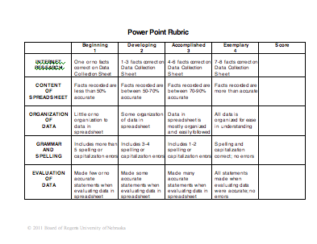
Understanding Learning: (Recycle or Not?)

Summary: Students will present their waste management recommendations for the school.

Outline:
- Formative Assessment of Natural Resources
- Summative Assessment of Natural Resources

Activity: Students will complete written and performance assessments related to natural resources (renewable and nonrenewable).

Formative Assessment: As students are engaged in the lesson ask these or similar questions:
- Were the students able to understand the concept of renewable and nonrenewable resources?
- Can students explain what recycling is any why it is important?

Summative Assessment: Students can complete the following writing prompt:
- Explain the difference between a renewable and nonrenewable resource.
- What are the three R’s of resource conservation and how do they affect the consumption of resources?

Students can complete the following performance assessment: Select a natural resource that can be recycled and conduct research into that process. Present you findings to the class.

