Project SPIRIT 2.0 Lesson:
Tonic Water
==========================Lesson Header ==========================
Lesson Title: Tonic Water
This Teacher was mentored by:


www.bd.com

In partnership with Project SHINE grant funded through the

National Science Foundation

Draft Date: July 22, 2011
1st Author (Writer): Ken Swanson
Associated Business: BD Medical Surgical
Instructional Component Used: Tonicity
Grade Level: 10

Content (what is taught):
- Passive Transport: Diffusion and Osmosis
- Solute and Solvent
- Isotonic, Hypertonic and Hypertonic Solutions

Context (how it is taught):
- View demonstrations and short video clips of passive transport
- View a slide presentation about passive transport and tonicity
- Perform a lab viewing the affects of tonicity on simulated cells

Activity Description:
In this lesson, students will view demonstrations of diffusion, and diffusion through a semi-permeable membrane to discuss the cause of diffusion and its affects on cells. After viewing a slide presentation, students will perform a lab using simulated cells in different solution types contrasting the affects of isotonic, hypertonic, and hypotonic solutions on a cell.

Standards:

Science: SC3, SF1

Materials List:

- One 50 ml Beaker
- Three 250 ml Beaker
- Two 500 ml Beaker
- Food Coloring
- Thistle Tubes (Optional)
- Balance/Scientific Scale
- Dialysis Tubing, Cellulose or Cellophane
- Water
- Starch Packing "Peanuts"
- Glucose
- String
- Internet Connection to View You Tube Videos

Asking Questions: (Tonic Water)

Summary: Students are asked to make observations about how a couple of drops of food coloring become distributed through a small beaker of water.

Outline:
- Demonstrate diffusion
- Observe the coloring becoming more evenly distributed throughout the beaker
- Use leading questions to explain the cause and introduce lesson vocabulary
- Watch a You Tube video(s) about diffusion and/or osmosis

Activity: Teacher will demonstrate diffusion by placing 100 ml of water in a 100 ml beaker. Add a couple of drops of food coloring. Observe that slowly the food coloring distributes itself evenly throughout the beaker. As the students become engaged, ask the following questions.

Questions | Answers
What is happening to the original drops of coloring? | Spreading out
What causes the coloring to change its distribution? | The molecules contain kinetic energy as they move collisions occur pushing the dye molecules a part.
How could rate of color redistribution be increased or make it faster? | Add heat, maybe stir it
What will the end result look like? | Color will be evenly distributed as the molecules will keep spreading a part until they are evenly spaced.

Materials:
- Water
- Food Coloring

Resources:
- Diffusion: http://www.youtube.com/watch?v=STLAJH7_zkY&feature=related
http://www.youtube.com/watch?v=DFhlqgMy1Dk&feature=related
- Diffusion and Osmosis:
http://www.youtube.com/watch?v=qucTUoHAeuY&feature=related

Exploring Concepts: (Tonic Water)

Summary: Students will watch a demonstration displaying the movement of molecules through a semi-permeable barrier.

Outline:
- Students view the teacher’s demonstration and discuss the results
- Students learn about passive transport, diffusion, osmosis, isotonic, hypotonic and hypertonic solutions via video clips or by a slide presentation

Activity: Students will view the movement of iodine molecules through a partly porous barrier to cause starch gains to change color (whitish-yellow to blackish-purple) (see demonstration instructions below). Later, the students will watch a video on diffusion, another on osmosis, and third one on isotonic, hypotonic, and hypertonic solutions.

Resources:
- Starch Demonstration
Dissolve a dozen starch packing "peanuts" in a 250 ml of water in a 500 ml beaker.

Place 100 ml of water in a double seal sandwich bag; add enough 3% iodine solution to give the water a deep brownish color. Seal the bag. Carefully place it in the beaker with the starch solution.

Observe that the iodine solution moves through the pores in the bag and cause the starch molecules to turn a purplish-black.
- Passive Transport: http://www.youtube.com/watch?v=s0p1ztrbXPY
- Osmosis: http://www.youtube.com/watch?v=sdiJtDRJQEc&NR=1
- Red Blood Cells in Isotonic, Hypotonic, and Hypertonic Solutions:
http://www.youtube.com/watch?v=7rX1jNDUsXU

Attachment:
Lesson Slide Presentation: S128_SHINE_Tonic_Water_E_Tonicity.ppt
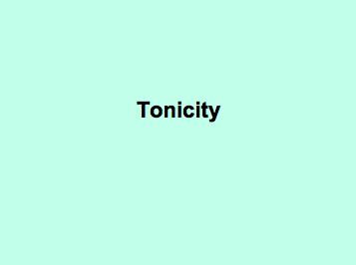

Instructing Concepts: (Tonic Water)

Osmosis and Tonicity
Plasma membrane: All cells have a protective covering known as the plasma membrane or cell membrane. The plasma membrane has more than one role, but an important role is that it controls what enters or exits the cell.
Semi-permeable or Selectively permeable: Semi-permeable or selectively permeable is a term used to describe the plasma membrane’s control to allow some substances into or out of the cell, but not others.
Cell transport: Cell transport is the process through which molecules move in or out of the cell.
Types of Cell Transport: There are two main types of cell transport; passive transport and active transport each with different forms. For this lesson, we will only focus on passive transport of water.
Passive Transport:
- Molecules move from an area of high concentration to an area of low concentration until equal
- This is caused by particles containing kinetic energy forcing them to collide resulting in the particles pushing apart until they have dispersed equally
Forms of Passive Transport
- Osmosis: movement of water from high to low concentration until equal.
- Diffusion: movement of particles (solutes) dissolved in water from high to low concentration until equal.

Solution Types affecting Osmosis in Cells: Solutions are homogeneous mixtures or one throughout which two or more substances are uniformly dispersed. As the cell contains water with dissolved particles inside and outside its plasma membrane, then it is surrounded by solutions. A difficult role of the plasma membrane is to balance the amount of water inside and outside the cell. It is difficult because water movement occurs automatically following the rules of passive transport or osmosis, so a change in the solution outside the cell can greatly affect the balance of water inside the cell known as tonicity.
Tonicity: Tonicity measures osmotic pressure differences or the potential for water to move across the plasma membrane. Pressure differences trigger water movement and occur when concentration of solutes (unable to pass through the plasma membrane) change drawing the water either in or out of the cell to sustain solute to water ratio equality. An example would be if the inside of cell contained a 6 % glucose solution, but the outside had a 2% glucose solution the cell would adjust by sending water outside until attaining a balanced 4% glucose solution throughout. Consequently, the movement of water due to the tonicity changes can affect the shape or size of the cell forcing it to expand or shrink.
- Isotonic Solution (isos means “equal”)
  - A type of solution in which the dissolved solutes in the solution are the same or equal.
  - There is equal movement of water in or out of the cell allowing the cell to keep its shape.
- Hypotonic Solution (hypo means “under”)
  - A type of solution in which the dissolved solutes is lower outside the cell than inside the cell (meaning there is more water on the outside of the cell).
  - Therefore there is movement of water from outside to inside the cell resulting in increased pressure forcing the cell’s membrane to expand and potentially burst.
- Hypertonic Solution (hyper means “over”)
  - A type of solution in which the dissolved solutes is higher outside the cell than inside the cell (meaning there is more water on the inside of the cell).
b. Therefore there is movement of water from inside to outside the cell resulting in less pressure
forcing the cell’s membrane to contract or shrivel.

For extra diagrams see file: I-Sci-35-Osmosis_and_Tonicity_I_Diagrams.doc
Organizing Learning: (Tonic Water)

Summary: Students will work in small groups conducting a lab exercise to explore osmosis and tonicity.

Outline:
- Laboratory equipment is gathered
- Soak dialysis tubing
- Mix glucose isotonic, hypertonic, and hypotonic solutions
- Create three simulated cells using dialysis tubing filled with glucose solution
- Determine the mass of the simulated cells before and after being placed in the different solutions

Activity: In this lab activity, students will have an opportunity to create hypotonic, isotonic, and hypertonic solutions. They will "create" cells out of dialysis tubing filled with glucose solution and place them into one of the three different solutions. They will record the mass of each cell before entering a solution and then after being in a solution. Students will calculate mass changes and discuss the cause(s) of the mass changes. Mass determination may be made by scientific a scale or by inference using volume change in a graduate cylinder; ten ml approximately equal to one gram. (Note: Volume changes could be substituted for mass changes.)

Resources:
- Dialysis Tubing (3, five-inch sections)
- Nylon or Polyester String (6, three-inch pieces)
- Four 250 or 500 ml beakers
- Glucose
- Balance and/or Graduate Cylinders

Attachment:
Osmosis Lab Exercise: S128_SHINE_Tonic_Water_O_Lab.doc
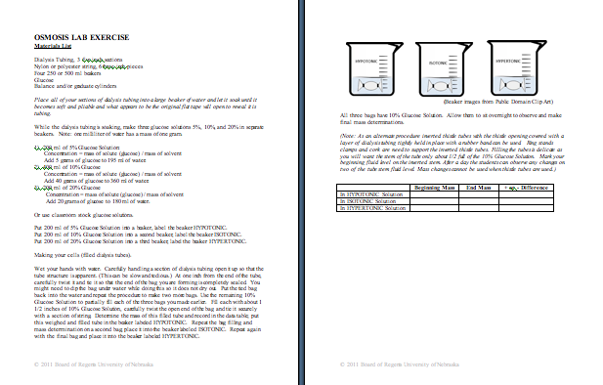
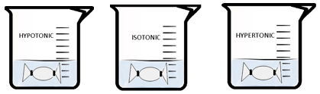
Understanding Learning: (Tonic Water)

Summary: Students will define key terms and apply the principles of tonicity to a real-life medical application.

Outline:
- Formative Assessment of Tonicity
- Summative Assessment of Tonicity

Activity: Students will complete written assessment related to tonicity.

Formative Assessment: As students are engaged in the lesson ask these or similar questions:
- Can students distinguish between key terms: osmosis, diffusion, solute, solution etc.?
- Are students able to explain the driving force for molecular movement?
- Are the students able to correctly identify isotonic, hypertonic, and hypotonic solutions?

Summative Assessment: Students will provide definitions for the following terms:
a. Diffusion
b. Osmosis
c. Hypertonic
d. Hypotonic

Students answer the following essay question: IV catheters (a vascular access device) must be flushed to free them of material such as thrombic occulsions (activated blood clotting factors) or drug precipitates as well as between medications. Some medications may be incompatible upon contact with each other. Ultimately, vascular access device flushing prevents "further complications". Based upon the content of this lesson, what type of solution (liquid) should be used to flush an IV catheter and why is it chosen? Use lesson vocabulary and content to fully explain and support your answer.

