OSMOSIS LAB EXERCISE
Materials List

Dialysis Tubing, 3 five inch sections
Nylon or polyester string, 6 three inch pieces
Four 250 or 500 ml beakers
Glucose
Balance and/or graduate cylinders

Place all of your sections of dialysis tubing into a large beaker of water and let it soak until it becomes soft and pliable and what appears to be the original flat tape will open to reveal it is tubing.

While the dialysis tubing is soaking, make three glucose solutions 5%, 10%, and 20% in separate beakers. Note: one milliliter of water has a mass of one gram.

1) 200 ml of 5% Glucose Solution:
Concentration = mass of solute (glucose) / mass of solvent
Add 5 grams of glucose to 195 ml of water.
2) 400 ml of 10% Glucose
Concentration = mass of solute (glucose) / mass of solvent
Add 40 grams of glucose to 360 ml of water.
3) 200 ml of 20% Glucose
Concentration = mass of solute (glucose) / mass of solvent
Add 20 grams of glucose to 180 ml of water.

Or use classroom stock glucose solutions.

Put 200 ml of 5% Glucose Solution into a beaker, label the beaker HYPOTONIC.
Put 200 ml of 10% Glucose Solution into a second beaker, label the beaker ISOTONIC.
Put 200 ml of 20% Glucose Solution into a third beaker, label the beaker HYPERTONIC.

Making your cells (filled dialysis tubes).

Wet your hands with water. Carefully handling a section of dialysis tubing open it up so that the tube structure is apparent. (This can be slow and tedious.) At one inch from the end of the tube, carefully twist it and tie it so that the end of the bag you are forming is completely sealed. You might need to dip the bag under water while doing this so it does not dry out. Put the tied bag back into the water and repeat the procedure to make two more bags. Use the remaining 10% Glucose Solution to partially fill each of the three bags you made earlier. Fill each with about 1 1/2 inches of 10% Glucose Solution, carefully twist the open end of the bag and tie it securely with a section of string. Determine the mass of this filled tube and record in the data table; put this weighed and filled tube in the beaker labeled HYPOTONIC. Repeat the bag filling and mass determination on a second bag; place it into the beaker labeled ISOTONIC. Repeat again with the final bag and place it into the beaker labeled HYPERTONIC.

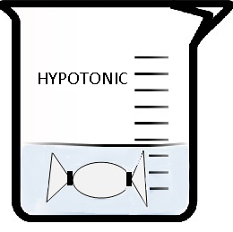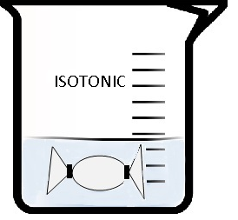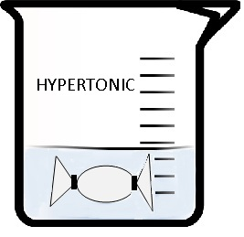
(Beaker images from Public Domain Clip Art)

All three bags have 10% Glucose Solution. Allow them to sit overnight to observe and make final mass determinations.

(Note: As an alternate procedure inverted thistle tubes with the thistle opening covered with a layer of dialysis tubing tightly held in place with a rubber band can be used. Ring stands clamps and cork are need to support the inverted thistle tubes. Filling the tubes is delicate as you will want the stem of the tube only about 1/2 full of the 10% Glucose Solution. Mark your beginning fluid level on the inverted stem. After a day the students can observe any changes on two of the tube stem fluid level. Mass changes cannot be used when thistle tubes are used.)

 | Beginning Mass | End Mass | + or - Difference
In HYPOTONIC Solution
In ISOTONIC Solution
In HYPERTONIC Solution

