Project SHINE Lesson:
Fuel for the Future
==========================Lesson Header ==========================
Lesson Title: Fuel for the Future
Draft Date: 7/21/11
1st Author (Writer): Bob Talbitzer
This Teacher was mentored by:



http://www.abengoabioenergy.com

In partnership with Project SHINE grant funded through the

National Science Foundation

Associated Business:
Instructional Component Used: Enzymes
Grade Level: 9th 10th

Content (what is taught):
- Enzyme Function
Plant Material Ethanol Plant Enzyme Yeast Ethanol

Context (how it is taught):
- Extracting an enzyme from a potato and then demonstrating enzymatic action by measuring the oxygen produced when the enzyme is added to hydrogen peroxide (H₂O₂)
Activity Description:
In this lesson, students will extract Catalase, an enzyme found in most cellular life, from a potato. The catalase will then be used to demonstrate enzymatic reactions, by adding the enzyme to hydrogen peroxide producing O₂ as a product. Correlations will be drawn between enzyme function and how they might be used in the production of cellulosic ethanol.

Standards:

Science: SC1, SC3

Materials List:
- LabQuest
- Vernier O₂ Gas Sensor
- 3.0% H₂O₂
- Electronic Balance
- Distilled Water
- Blender
- Cheese Cloth
- Graduated Cylinder
- Eye Dropper
- 250 mL Nalgene Bottle
- 400 mL Beaker
Asking Questions: (Fuel for the Future)

Summary: Students will watch a video on the development of enzymes that function in breaking down cellulose into ethanol.

Outline:

Show the video “Novozyme Ethanol Enzyme” promo video (link below)

In groups, students will develop a list of discussion questions that will be shared and discussed in class

Activity: Students will be shown the video “Novozyme Ethanol Enzyme” promo video (see YouTube link below). This video details why alternative forms of fuel are crucial for the long term stability of our infrastructure and how cellulosic ethanol could be a remedy to the eventual shortages in fossil fuel based products. Finally, students will discover how the use of enzymes derived from microbes is crucial in the production of cellulosic ethanol.

Questions | Answers
Why do alternative forms of fuel need to be researched and discovered? | Petroleum based fuels are a non renewable resource that will eventually be depleted.
What are some sources for cellulosic ethanol? | Corn Cobs
What is a crucial component in the production ethanol from cellulosic material? | The isolation and manufacturing of enzymes that efficiently break down cellulose in plant mater into sugars that can be converted to ethanol.

Resource:
Novozyme Ethanol Enzyme Promo Video: http://www.youtube.com/watch?v=6EL12vltYng
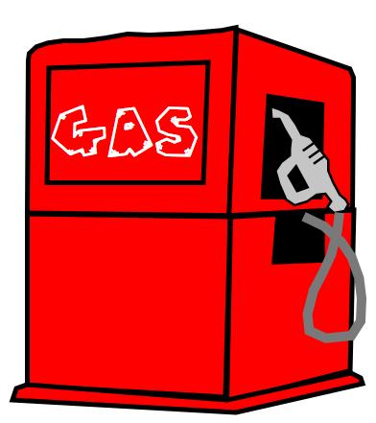
Exploring Concepts: (Fuel for the Future)

Summary: Students will view an animation on enzyme function.

Outline:
- Students will view an animation on enzyme function
- Students will answer questions taken from the animation
- In groups students will brainstorm and then share with the class how enzymes might be important in the production of ethanol as a biofuel

Activity: Students will independently view an animation on enzyme function. During the viewing students will answer questions on worksheet. (see attached document) Students will then take part in a classroom discussion on enzymatic function based upon the animation and their answers to the questions.
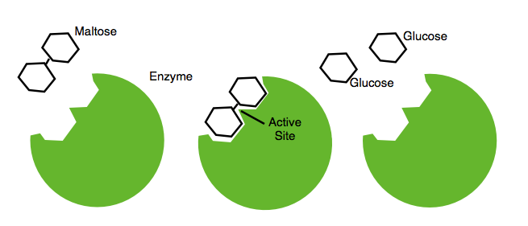

Resources:
How Enzymes Work Video: http://highered.mcgraw-hill.com/sites/0072495855/student_view0/chapter2/animation__how_enzymes_work.html

Attachments:
Worksheet: S129_SHINE_Fuel_For_the_Future_E_Worksheet.doc
Worksheet Answers: S129_SHINE_Fuel_For_the_Future_E_Worksheet_Ans.doc
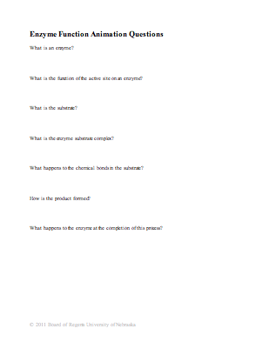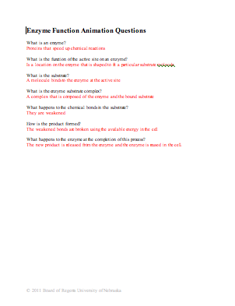
Instructing Concepts: (Fuel for the Future)

Enzymes

Enzymes: Enzymes are specialized proteins acting as “biological catalysts”. Proteins are organic compounds made of subunits known as amino acids. A protein is really a polymer containing 50 or more amino acids held together by peptide bonds. The sequence of amino acids and length of the polymer give each protein a uniquely ordered arrangement and three-dimensional shape designed for a specific function. Enzymes, therefore as proteins, each have a specific shape and function.
Biological meaning they are substances derived from living organisms, while catalyst means a compound that speeds up chemical reactions. Catalysts increase the rate of a chemical reaction (breaking and forming of chemical bonds) without themselves being altered in the reaction or altering the product of the reaction. (e.g. 2 H₂O₂ ^{MnO}₂ 2 H₂O + O₂ in this reaction manganese dioxide is used to more rapidly release oxygen from hydrogen peroxide producing water, but notice none of the MnO₂ itself is broken down to form the oxygen ). Enzymes as catalysts are capable of increasing the reaction rate by as much as 10²⁰. They are able to do this in many ways: reduce the activation energy, reduce energy of transition state, temporarily react with the chemical creating a compound form more likely to react, reduce entropy by changing orientation, and finally increase temperatures speeding up reactions. So, enzymes are compounds that help chemical reactions like digestion occur faster within a living organism.
Enzyme Activation: Enzymes often catalyze only a single reaction. A simple example is peroxidase. It decomposes hydrogen peroxide (H₂O₂) into hydrogen (H₂) and oxygen (O₂) gases. Humans view this reaction when they use hydrogen peroxide on a small wound. The hydrogen peroxide does not react (appears as a clear liquid) until placed on the cut then the enzyme peroxidase in the blood speeds up the break down releasing bubbles or the gases. The oxygen gas kills anaerobic bacteria and viruses within the cut preventing infection. Enzyme activation occurs when the enzyme comes in contact with the substrate. Substrate is the beginning molecule before the reaction. In the example above, the hydrogen peroxide is the substrate. The enzymes shape is designed specifically for the substrate. The exact location on the enzyme where the substrate fits is known as the active site. Once the substrate is placed in the active site like a puzzle piece, the resulting molecule is called the enzyme-substrate complex. After the substrate is locked into place, the chemical reaction occurs such as hydrogen peroxide decomposing into hydrogen and oxygen gases. These are the products or new compounds after the reaction of the substrate. The enzyme, unaffected by the reaction, will release them and wait to repeat the process all over again. Subsequently, the activation of enzymes is deemed as a lock and key model. The enzyme is the specific “key” that fits the substrate “lock”. Once in place the enzyme is able to “unlock” the complex compound or begin a chemical reaction.
Nomenclature of Enzymes: The naming system for enzymes usually abides by the following principles. First, each enzyme ends with the suffix –ase (few exceptions include pepsin, rennin, and trypsin). The suffix follows the name of the substrate involved in the reaction (e.g. lactase is the enzyme breaking down the sugar, lactose). However, the enzyme can also be named after the type of reaction it catalyzes (e.g. DNA polymerase is the enzyme that forms DNA polymers, which is the process of making DNA).
Attachment:
I_Sci_061_Enzymes_I_Diagrams.doc
Organizing Learning: (Fuel for the Future)

Summary: Students will extract the enzyme catalase from a potato and use the enzyme to quantify enzyme activity by measuring the production of oxygen as a result of the enzyme reaction.

Outline:
- Extract catalase from a raw potato
- Add catalase to the substrate hydrogen peroxide (H₂O₂)
- Measure the oxygen production using the LabQuest and Oxygen O₂ probe to substantiate enzymatic reaction*
- Brainstorm experimental designs that might be used to determine if cellulosic enzymes are functioning in the breakdown of cellulose in plant matter

Activity: Students will complete a lab exercise to extract the enzyme catalase from a potato. To complete the lab, students must have some method of measuring O₂ production. LabQuest is a standalone and computer interface that works with Vernier sensors but any O₂ sensor would work. Vernier software and technology is a company founded by a high school teacher to provide technology designed with teachers in mind. After the extraction is completed, they will answer questions about the lab (see attachment for activity).

Resource:
- LabQuest O₂ or other O₂ sensor

Attachment:
Catalase Extraction Lab With Questions: S129_SHINE_Fuel_For_the_Future_O_Lab.doc
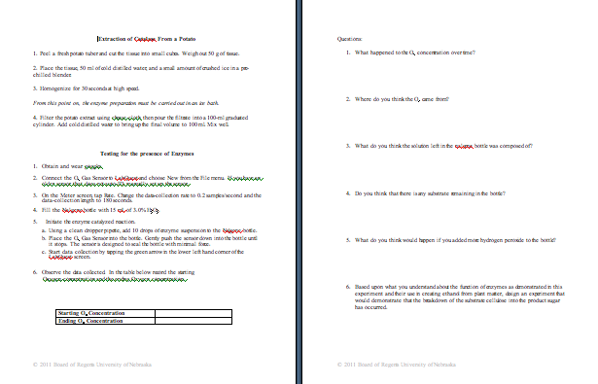
Understanding Learning: (Fuel for the Future)

Summary: Students will demonstrate their understanding of enzymatic function by designing a flow chart that outlines the process of enzyme action.

Outline:
- Formative Assessment of Enzyme
- Summative Assessment of Enzyme

Activity: Students will complete written, performance and quiz assessments related to enzymes.

Formative Assessment: As students are engaged in the lesson ask these or similar questions:
- Do students understand the key vocabulary (Enzyme, Substrate, Active Site, Enzyme/Substrate Complex)?
- Do students understand the function of an enzyme?
- Were students able to find the presence of O₂ in the lab?

Summative Assessment: Students can complete the following writing prompt: Create a list of potential sources of enzyme and cellulosic material that could be used to create the biofuel ethanol and why.

Students can complete the following performance assessment: Students will create a flow chart using creative characters/symbols to represent the stages in enzyme action.

Students can complete the following quiz questions: See attached file for quiz.

Attachments:
Enzyme Quiz: S129_SHINE_Fuel_For_the_Future_U_Quiz.doc
Enzyme Quiz Answers: S129_SHINE_Fuel_For_the_Future_U_QuizAns.doc
