Project SHINE Lesson:
You Lite Up My Life!
==========================Lesson Header ==========================
Lesson Title: You Lite Up My Life!
This Teacher was mentored by:

www.nebraskamachinery.com

and



http://www.lincolnelectric.com

In partnership with Project SHINE grant funded through the

National Science Foundation
Draft Date: 9-5-2011
1st Author (Writer): Larry St.Hilaire
Associated Business: NMC and Lincoln Electric
Instructional Component Used: Welding
Grade Level: 11-12

Content (what is taught):
- Measuring
- Welding SMAW Arc Welding
- Proper Clothing and equipment

Context (how it is taught):
- The Use of Rulers
- PowerPoint on Welding
- Lincoln Welding Website

Activity Description:
Students will discuss different types of welding and material that can be used. Then they will create a project on their own by trial and error. Instruction will be provided on welding and then students will try to build the same project again noting the differences after instruction.

Standards:

Math: MD2 Science: SB1

Technology: TA1 Engineering: EB2

Materials List:
- Assortment of Metal to be Used With the Welder
- Internet Connection
- Welding Equipment

Asking Questions: (You Lite Up My Life!)

Summary: Students will discuss different types of welders and how different rods and temperature work on each project.

Outline:
- Students will be given different type of metal materials
- Students will discuss different welding settings options for current project.
- Students will fill out KWL chart

Activity: Students will be given different type of metal materials board. The teacher will facilitate the class filling out a KWL chart where students will list what they know about shielded metal arc welding (SMAW) and what they want to learn about SMAW arc welding.

Questions | Answers
How important is it to understand the process system before one comes to a well thought out decision? | I want to be able to decide if this is the best process for the situation.
What problems have you had when you tried to use SMAW power source? | These will vary with students.
What do we need to know to identify a problem with the SMAW process, equipment, or its operation? | Know where to find out information about solving SMAW problems.
How does the thickness of the material affect the required amps? | More thickness requires either higher amps or longer exposure to achieve weld.
Do different materials require different amp settings? | Yes.

Resources: KWL Chart
K | W | L
What I Know | What I Want To Learn | What did I Learn
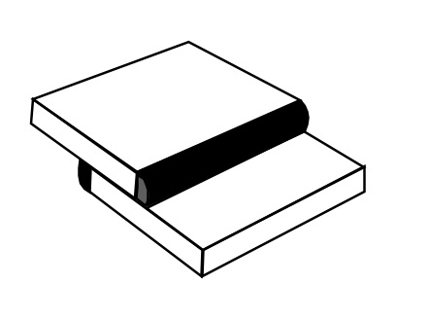
Exploring Concepts: (You Lite Up My Life!)

Summary: Students will create a project out of different type of materiel using a SMAW arc welder.

Outline:
- Students will understand how to set up and prepare to perform shielded metal arc welding operations on plain carbon steel
- Students will perform shielded metal arc welding operations

Activity: Students will build a project out of variety of material in design and thickness using a choice of settings based on material type. Students will use the material of their choice and settings of their choice and construct a project. No formal instruction will be given. It is an exploration of the possibilities available to students.

Resources:
- Lincoln Electric Welding Projects:
http://www.lincolnelectric.com/en-us/support/welding-projects/Pages/welding-projects.aspx
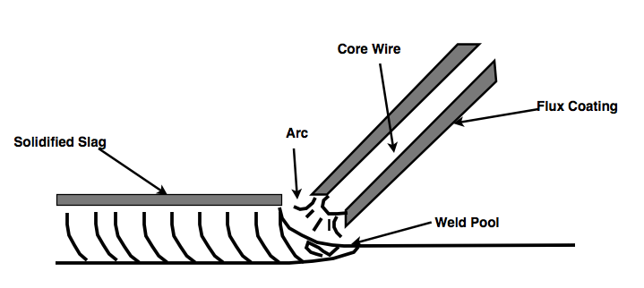
Instructing Concepts: (You Lite Up My Life!)

Welding

Welding is the process of joining pieces of metal by heating them to their melting point. When suitable temperature is reached the metals melt and fuse (stick) together into one piece. Welding is done with or without the use of filler metal pressure. Filler metal, when used, has just about the same material and melting point as the base metals to be joined. There are almost 100 welding and allied processes classified by the American Welding Society (AWS). With the constant development of new alloys, applications, and requirements by industry, additional welding processes are added on a regular basis.

Gas Welding includes a group of welding processes that make use of burning gases to produce the heat required to melt and refuse the metal. Acetylene or hydrogen mixed with oxygen are the most commonly used gases, welding techniques that are fusion as part of the process are called fusion welding. Filler material may or may not be used when gas welding. The filler material comes in the form of a welding rod. The welding rod must be made of a similar composition and melting temperature as the metal being welded. When acetylene and oxygen are used for gas welding, the process is called oxyacetylene welding. This is the welding technique most commonly used in schools. The gases burn with an extremely hot flame (6300F or 3482C); more than ample for doing an adequate job of joining most weld able metals. The acetylene and oxygen must be mixed in correct proportions to properly and safely weld. The term “oxygen-fuel gas equipment” is often used in welding. It refers to the use of oxygen with gases such as acetylene, hydrogen, natural gas, butane and propane, to provide the source of heat.

Brazing includes a group of welding processes in which metal pieces to be joined are heated below their melting point. Temperature of the metal must be above 800 deg. F (425 deg. C). Nonferrous filler metal is used which has a melting point above 800 deg. F (425 deg. C) and below the melting point of the base metals.

Soldering is a joining process using an alloy filler metal. This metal has a melting point below 800 deg. F (425 deg. C) and below the melting point of the base metal. Molten solder is usually a lead-tin alloy. It adheres (sticks) to the metal surfaces filling the space between the parts being joined.

Flame utting is a process which uses high temperature oxidation (combining metal with oxygen) to cut metal. Heat produced by the oxyacetylene flame, followed by a stream of oxygen from the torch, burns away the oxides to form cut.
Organizing Learning: (You Lite Up My Life!)

Summary: Students will modify their welding project by changing settings on welder or type of material used.

Outline:
- Students will modify their design project based on what they have learned
- Students will compare/contrast their experiences

Activity: Students will cut metal to size for the project they will be making. They will adjust the welding equipment they use to affect the speed and depth of the weld to understand what setting is best fit for the project that is being worked on. Students will journal what material will work best with the type of project they decide to make. Students will chart showing different settings used on different thickness of material they are using.

Resources: Data Chart

Metal | Setting Used
½ inch thick
¼ inch thick
1/8 inch thick
Understanding Learning: (You Lite Up My Life!)

Summary: Students will write about the affect of changing something related to SMAW Arc Welding and how this will change the quality of a weld and the finish product.

Outline:
- Formative Assessment of Welding Technology
- Summative Assessment of Welding Technology

Activity: Student will answer written assessment regarding welding technology.

Formative Assessment: As students are engaged in the lesson ask these or similar questions:
- Did the students adjust the amps by increasing or decreasing it?
- Did the speed (too fast or too slow arc movement) affect the final product?
- If the students use material that is too thick or too thin did that affect the project outcome?

Summative Assessment: Students can answer the following writing prompts:
- Use your data; write a paper describing the effectiveness of one material over another and what material worked best.
- List 5 variables that could affect the quality of your project.
- Pick one of your variables and test it. Then write a paper comparing data to describe the benefits of using one type of material over another.

Attachment:
- Rubric: S130_SHINE_You_Lite_Up_My_Life_U_Rubric.doc
