Project SHINE Lesson:
Breaking the Mold
==========================Lesson Header ==========================
Lesson Title: Making & Breaking the Mold
Draft Date: 7-2-2010
1st Author (Writer): Elissa Gilger
2nd Author (Editor/Resource Finder): Kawasaki
Instructional Component Used: Thermodynamics, Injection Molding
Grade Level: High School
This Teacher was mentored by:

www.kawasakilincoln.com

In partnership with Project SHINE grant funded through the

National Science Foundation

Content (what is taught):
- Use of thermodynamics in injection molding
- Application of the heat gain formula Q=mC∆T
- Application of temperature scales conversion formulas ºC = 5/9 (ºF-32) & K = ºC + 273

Context (how it is taught):
- View products made using injection molding
- Discuss the injection molding process and thermodynamics
- Perform a lab creating a Jell-O jiggler using a simulated injection molding process

Activity Description:
In this lesson, students investigate how thermodynamics are used in the industrial process of injection molding. Students will view products made using injection molding and discuss the process. Student pairs will perform a lab using Jell-O and a pre-made plastic mold simulating the injection molding process. The student pair will also calculate the heat gain and loss using the formula Q=mC∆T needed for injection molding to occur.

Standards:

Science: SB1, SB3, SE2 Technology: TA3

Engineering: EB1, EB2 Math: MD2

Materials List:
Exploring Activity
- Toy made from plastic mold
- Pictures of products made using injection molding
- Diagram of injection molding
Lab Activity
- Hot plate
- Thermometer
- 250 mL beaker
- Tap water
- Glass stirring rod
- 3 oz or 85 g box of Jell-O
- 60 mL syringe
- Premade plastic mold
Asking Questions: (Breaking the Mold)

Summary: Students will discuss the term “mold” and its use in industry.

Outline:
- Discuss the use of molds

Activity: The teacher will use a common phrase, “They broke the mold when you were made?” to ask leading questions to discuss the use of molds.

Questions | Answers
What does the phrase “They broke the mold when you were made?” | Answer: Generally it means the person is unique or special. The planet earth could be searched and not find another like that person.
What is a mold? | Answer: Cast with the features, form, and shape of an object. Material can be put into the mold and will take on the shape carved out.
Are molds used today? | Answer: Yes, they are used by those with personal hobbies to make jewelry or decorative house hold items, but primarily by industry to make products.
More in Depth:  Why does industry like to use molds? Why not create a unique item every time? | Answer: Industry often needs consistent or uniform products. Molds ensure the products come out the same as well as save on cost since products can be made rapidly rather than individual by hand.
Exploring Concepts: (Breaking the Mold)

Summary: Students investigate the relationship between injection molding and thermodynamics.

Outline:
- Teacher will show students items made using injection molding
- Discuss the process of injection molding
- Discuss the impact of thermodynamics on the process

Activity: In this lesson, the teacher will show students products made by injection molding. Teacher will ask leading questions to help students discover the process of injection molding and the importance of thermodynamics to the process. The teacher will discuss the brief overview of injection molding below and students will complete the exploratory activity in the attached file: S132_SHINE_Breaking_the_Mold_E_Activity.doc.

Brief overview of Injection Molding: Injection molding is a common manufacturing process. It involves a mold made of steel or aluminum with the features of the product carved out. Next, a thermoplastic or thermosetting plastic material is heated and forced through a barrel into the mold cavity. The plastic cools into the shape of the product and is removed. The process is used to produce body panels for vehicles, bottle caps, pocket combs, barrels for syringes, and toys to state only a few examples.
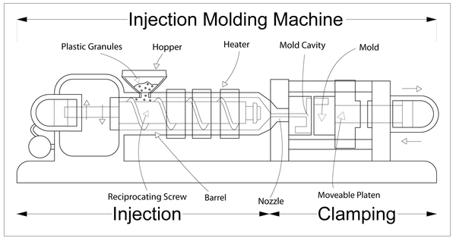
Image Taken From Wikipedia
http://en.wikipedia.org/wiki/Injection_molding
Attachment:
S132_SHINE_Breaking_the_Mold_E_Activity.doc
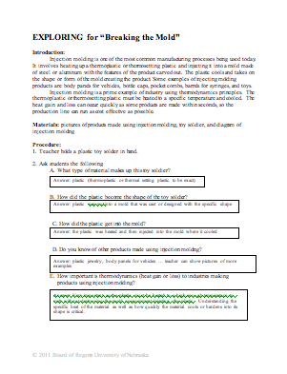
Instructing Concepts: (Breaking the Mold)

Thermodynamics

Thermodynamics: Thermodynamics is the study of the processes in which energy is transferred as heat or work and is based upon the Kinetic-Molecular Theory. A theory that matter is made of tiny particles that are always in motion. When these particles increase in motion or increase in kinetic energy (KE) the object becomes hotter and if the motion is decreased than the object becomes cooler. Temperature measures the average motion or KE of those particles, while thermal energy (internal energy) measures the total or sum of the potential energy (PE) and KE of all the particles within the substance. Often, the terms temperature and thermal energy become confused with the term “heat”. Heat in thermodynamics is a measurement of the amount of kinetic energy that flows from one object to another due to temperature differences. This transfer of heat will continue until both objects reach the same temperature known as thermal equilibrium.

Laws of Thermodynamics:
1) First Law of Thermodynamics: The first law is really a restatement of the Law of Conservation of Energy meaning that the amount of energy at the beginning will equal the amount of energy at the end (energy is neither created nor destroyed it only changes form). Often, heat can be transformed into work. An example is a car engine (heat engine): original heat produced by igniting the gas = amount of work done by the cylinder + amount of waste heat expelled or ΔU = Q + W, where ΔU is change in internal energy, Q is heat transferred to the system, and W is work done on the system.
2) Second Law of Thermodynamics: Heat will never of itself flow from a cold to hot object. The reason heat flows spontaneously from hot to cold and not the reverse is because it follows that principle of entropy. Entropy measures the amount of disorder (messiness) in a system. Natural systems tend to proceed toward a state of greater disorder. As KE increases, so does the disorder of the particles within the substance unless forced by an outside source to be orderly.
3) Third or Zeroth Law of Thermodynamics: Simply stated that no system can reach absolute zero. Absolute zero is the temperature at which all KE ceases (0 K,-459˚F, or-273˚C). Investigators have discovered it difficult to attain because in order to transfer the heat out of an object there must be a temperature difference. So, a second object must be colder than absolute zero to draw heat or KE away from the first object making it unlikely to attain.
4) Zeroth Law of Thermodynamics: If two systems are at the same time in thermal equilibrium with a third system, they must then also be in thermal equilibrium with each other.

Measuring Thermodynamics:
1)Heat: As stated earlier, measures the amount of KE transferred from a hot object to a colder object until reaching thermal equilibrium and is calculated using the formula below:
Q = mC∆T, where Q is heat, m is mass, C is specific heat, and ΔT is change in temperature
2) Specific Heat: Specific heat measures the capacity of a substance to store heat based on its chemical composition and is calculated using the formula below:
, where C is specific heat, Q is heat, m is mass, and ΔT is change in temperature
3) Latent Heat: Latent heat measures the amount of heat per unit mass required to change the phase of a substance and is calculated in the formula below:
, where L is latent heat, Q is heat, and m is mass (or Q = mL)
Organizing Learning: (Breaking the Mold)

Summary: Students investigate the relationships between thermodynamics and injection molding by applying the formula: Q=mC∆T.

Outline:
- Student pairs will perform a lab using injection molding of Jell-O
- Data collected during the lab includes mass of Jell-O, specific heat of Jello-O, and temperature changes
- Convert temperature scales to perform calculations
- Student pairs will then calculate heat gains and losses relating them to injection molding

Activity: In this lesson, students will learn about molds, thermoplastics, injection molding, and thermodynamics. Students will discuss the use of molds and thermoplastics in the process of injection molding. Student pairs will perform a lab relating the principles of thermodynamics to injection molding. Each pair will heat and dissolve Jell-O recording its mass and temperature changes. Next, the students will draw the Jell-O into a 60 mL syringe to inject into a plastic pre-made mold. Finally, students pairs will use the data to calculate the heat gained by the Jell-O using the formula: Q=mC∆T and relate Jell-O “jigglers” to thermoplastics.

Attachment:
S132_SHINE_Breaking_the_Mold_O_lab.doc
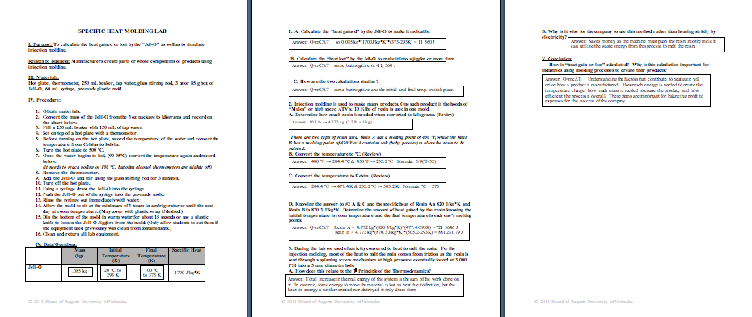
Understanding Learning: (Breaking the Mold)

Summary: Students will perform a lab applying the formula Q=mC∆T and the principles of thermodynamics to injection molding.

Outline:
- Formative Assessment on Thermodynamics
- Summative Assessment on Thermodynamics

Activity: Students will complete written and quiz assessments relating to thermodynamics.

Formative Assessment: As students are engaged in the lesson ask these or similar questions:
- Can students relate thermodynamics to injection molding?
- Were students able to apply the formula Q=mC∆T for calculating heat gained or lost?

Summative Assessment: Students can complete the following writing prompt:
Explain how thermodynamics applies in the process of injection molding for a plastic component.

Students can complete the following quiz questions:

- Convert temperature scales.
- Convert 34° C into °F.
- Convert 34° C into K.
- Convert 410 K into °F.

- Calculate heat gain and loss.
Knowing that olive oil has a specific heat of 1970 J/kg*K, if a mass of 3 grams is placed in a metal 9 x 13 baking pan at a temperature of 350°F. What is the heat gained by the olive oil? What is the heat lost by the pan to the olive oil?

