SPIRIT 2.0 Lesson:
A Robot’s Work is Never Done
==============================Lesson Header===========================
Lesson Title: A Robot’s Work is Never Done
Draft Date: 5/12/12
1st Author (Writer): David Porter
Instructional Component Used: Force and Work
Grade Level: 4th-12th

Content (what is taught):
- Work equals force multiplied by distance

Context (how it is taught):
- Discussion
- Hands-on inquiry-based activities
- Computations

Activity Description: Students will both observe and experiment with force being applied to objects as well as the distance an object is moved in order to understand the concept of work as a relationship between those two factors.

Standards:
Math: MA2, MD2 Science: SA1, SB2

Technology: TA3, TD2, TD3 Engineering: EA1, EA4

Materials List:
- A variety of weights (ex. plastic bottles filled with water, backpacks with books, or small hand-held weights (1-5 pounds), small bags of sand, etc.)

Wheeled robots such as CEENBoTs

Small cardboard boxes (approximately six inches square

Various items which could be placed under the box to reduce friction (rollers such as cylindrical pencils or dowels, smooth plastic, casters, etc.)

Force sensing device such as a spring scale or force sensor

Objects to be pulled

Scales to measure the objects’ mass

Meter sticks

Asking Questions: (A Robot’s Work is Never Done)

Summary: Students will be introduced to the scientific concept of work as a force which has moved something by performing a variety of tasks, which vary in the level of force needed and work being done.

Outline:
- Students will complete tasks, many of which require considerable force but which involve no work (since the objects do not move)
- Students will rank their activities according to the amount of work they believe was done
- The teacher will define work and help students to understand that objects must be displaced in order for work to have been done
- Students will re-order the original tasks according to the amount of work actually done

Activity: Students will be assigned tasks with different levels of force. They will be asked who did the most work, after which the formula for work will be provided. A class discussion will be conducted about the formula. Students will then re-order the amount of work that was actually done in the performance of the tasks. For a complete activity description see attached file: S144_Robots_work_never_done_A_Activity.doc

Resources:
- A variety of weights (ex. plastic bottles filled with water, backpacks with books, small hand-held weights (1-5 pounds), etc.)

Attachment:
- S144_Robots_work_never_done_A_Activity.doc
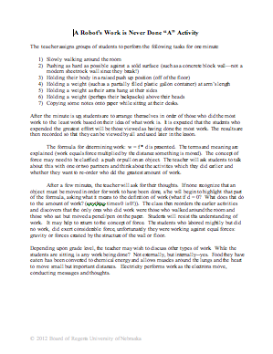

Exploring Concepts: (A Robot’s Work is Never Done)

Summary: The teacher will open the lesson with a challenge: students will use a wheeled robot to create more or less efficient ways of moving objects/accomplishing work. A concluding discussion will consolidate lessons gained regarding the relationships between work, force and displacement

Outline:

Students will use wheeled robots to create more or less efficient ways of moving objects/accomplishing work

Discussion about the relationships between work, distance an object must be moved and force

Activity: Students will be given two scenarios where one person does more work than the other because of efficiency improvements or different work methods. These scenarios will be brainstorming points that allow students to solve the problem presented in the activity which is, “Use a wheeled robot (such as a CEENBoT) to demonstrate two ways in which the robot could do more or less work.” After the activity is completed, a class discussion concludes as a summary. For a complete activity description see attached file: S144_Robots_work_never_done_E_Activity.doc

Possible Extension: Students could be asked to consider the drive for efficiency and how important efficiency to reduce energy use. For instance, vehicles are being built with lower rolling resistance, lower air resistance, and better lubrication in order to conserve force and require less work. Likewise, car manufacturers are using lighter weight materials and some car engines now shut off when their force is not needed (such as when stopped at idle). This is a way of resting, reducing the amount of force needed--which lessens the amount of work done. Students could research one of these topics and report how each reduces the amount of work that is required.

Resources:

Wheeled robots such as CEENBoTs

Small cardboard boxes (approximately six inches square)

A variety of weights (one to two pounds each) such as small bags of sand, water bottles, or rocks

Various items which could be placed under the box to reduce friction (rollers such as cylindrical pencils or dowels, smooth plastic, casters…)

Attachment:
- S144_Robots_work_never_done_E_Activity.doc
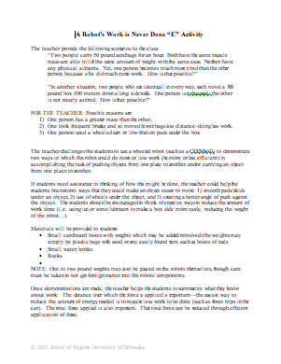
Instructing Concepts: (A Robot’s Work is Never Done)

Putting “Work” in Recognizable Terms: If one person lifts a 3 Newton object 4 meters and another lifts a 2 Newton object 6 meters, did they perform the same amount of work? The answer is yes, because work involves both the force applied to move or displace an object and the distance of the movement. (Note: W = F x d = 3 x 4 = 2 x 6 =12)

Putting “Work” in Conceptual Terms: Work is viewed in two types of situations when an object’s speed is changed or most commonly when an object’s position changes. If a child is swinging, work is performed when an adult pushes the child forward along with the swing. This increases the child/swing’s speed forward. Work is also performed when someone pulls against the bow on an arrow; an applied force goes against the elastic force of the bow string, lifts a bowling ball up from the ground; an applied force goes against the force of weight of the bowling ball, or slides a couch across the floor; an applied force goes against the force of friction of the floor to couch. In all these instances, a force was applied to move an object some distance against an opposing force.

Putting “Work” in Mathematical Terms: Work can be mathematically computed by the formula W = F * d where “W” is the work done, “d” is the displacement of the object, and “F” is the force applied to the object. Note that to use this formula the force and displacement have to be in the same direction. Work is measured in joules (J) or the number of Newton’s multiplied by meters. Force can be calculated as well using Newton's 2nd Law formula, F = mass*acceleration, provided the acceleration is constant.
If an object has a force acting at angle to the displacement, like a little girl pulling a wagon at an upward angle, then the formula W = F * d * cos q is used where the angle between the force and displacement is q. Since the wagon moves horizontally, only the horizontal component of the force does work.

Putting “Work” in Process Terms: Thus, work is a measurement of the amount of energy that is transferred to an object by a force in the direction of the displacement. It is possible to exert a force and that does not do work. There are two key instances: 1) If a force is applied but no displacement occurs, then no work is performed. If a person pushes and pushes on a stuck car and it does not move then no work was performed.
2) When the force is applied at a 90 angle to the displacement, then no work is performed. For instance in circular motion the centripetal force does no work because it is perpendicular to the velocity of the object, or if a person carries a book horizontally across the room while applying a vertical force against the book, no work is performed. However, if the force is applied in opposition to the displacement this is considered negative work because the cosine of an angle is negative for angles from 90to 180.

Putting “Work” in Applicable Terms: Work applies anywhere that a force in the direction of the displacement moves an object or when speed changes. It happens when stairs are climbed, objects are picked up, or merry-go-rounds are slowed down/sped up.

Organizing Learning: (A Robot’s Work is Never Done)

Summary: Students will use a wheeled robot (such as a CEENBoT) to measure the amount of force used by a robot and will then use this data to determine the amount of work being done using the formula for work. This will be repeated so that three concepts will be shown: the amount of work done is dependent upon the amount of force used as well as the distance the object is moved, and that if there is no movement—no work has been done.

Outline:
- A force sensing device will be attached to the back of a wheeled robot
- Objects of varying mass and composition will be pulled over a measured distance; the amount of force required will be noted. One object will be too heavy for the robot to pull (in order to demonstrate that if no movement occurs, no movement has been done)
- The amount of work done in each trial will be calculated using the formula for work

Activity: Students will attach a device to measure force to the back of a wheeled robot. This device may be as simple as a spring scale (it should have a scale which measures in the unit of Newtons). A higher tech/more accurate device would be a dual-range force sensor coupled with a hand-held digital read-out for the sensor (such as a Vernier LabQuest). The hand-held unit could be placed on the robot with the force sensor pulled behind just as the spring scale would be. An object is then attached to the back of the spring scale/force sensor so that the amount of force being used to pull the object will be visible. Students will use the force readings and multiply them by the distance over which the object was pulled. This simple calculation is the formula for work: w = f * d. A class discussion will be conducted to summarize the activity. For a complete activity description see attached file: S144_Robots_work_never_done_O_Activity.doc

Object | Mass | Distance Moved | Work Done | Surface Conditions

Resources:

Wheeled robot

Force sensing device such as a spring scale or force sensor

Objects to be pulled

Scales to measure the objects’ mass

Meter sticks

Attachment:

S144_Robots_work_never_done_O_Activity.doc
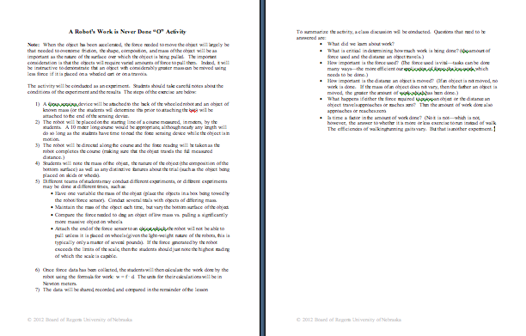

Understanding Learning: (A Robot’s Work is Never Done)

Summary: Students will be assessed on their conceptual knowledge of work.

Outline:
- Formative Assessment of Work
- Summative Assessment of Work

Activity: Students will complete written/conceptual assessments related to work.

Formative Assessment: As students are engaged in the lesson ask these or similar questions:

Do students understand how could to reduce the amount of work which needs to be done to move an object? (move it a shorter distance, reduce the amount of force needed to move it)

Can students articulate what will happen to the amount of work being done if a smooth plastic surface were placed on the bottom of the object—or if it was being pulled on ice? (the amount of work done will be reduced)

Can students explain how the amount of work being done is affected if the object was being pulled over a rough surface or through sand or if the mass of the object was increased? (the amount of work done would be expected to increase)

Do students understand the amount of work being done if an object can’t be moved—even if a great deal of force is being applied against it? (no work is done).

Summative Assessment: Student can answer the following writing prompt:

Explain the formula W = f * d by defining what each variable represents using correct vocabulary. How does changing the surface or method of object movement affect the work done? Why?

Students can answer the following quiz questions:
- The first student raises a 100 pound weight 6 inches. A second student raises the 100 pound weight 12 inches. A third student, who is strong enough to lift a 150 pound weight 18 inches, tries mightily—but fails to move a 200 pound weight. Which student does the most work? (the second student) Which student does the least work? (the third student)
- Two people are moving sandbags, one using a wheeled cart and the other carries them. Both move the same number of identical bags the same distance. Why does the second person end up doing more work? (more force is required to carry the bags than to use a wheeled cart)
- A person has been hired to move 100 boxes and will be paid $50. List at least two very important questions (related to the amount of work she will have to do) that she should ask before taking the job. What do those questions have to do with the amount of work she will have to do?

