Vanishing or Transforming Act of Energy
==========================Lesson Header ==========================
Lesson Title: Vanishing or Transforming Act of Energy
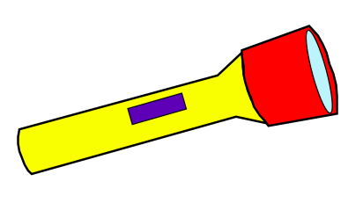
Draft Date: 3-24-2012
1st Author (Writer): Elissa Gilger
Instructional Component Used: Energy and Energy Transfer
Grade Level: Middle School or High School

Content (what is taught):
- Distinguish between matter and energy (realize they are interchangeable)
- Identify different types of energy
- Explain energy transfer or the Law of Conservation of Energy

Context (how it is taught):
- Demonstrate the differences between matter and energy using a flashlight
- View different types of energy and energy transfer by building simple circuits
- Identify different types of energy and energy transfer by either viewing or programming a CEENBoT to perform specific actions
Activity Description:
Students will distinguish between matter and energy after viewing a simple demonstration using a flashlight. Next, students will build simple circuits identify types of energy and energy transfer in each. Finally, students will either view a preprogrammed or program a CEENBoT for a specific function in which different energy types are transformed. Students will explain how the CEENBoT operations relate to the Law of Conservation of Energy.

Standards:

Math: MB1 Science: SB3, SE1, SE2

Technology: TF1, TF3 Engineering: EA2

Materials List:
- Flash light
- Electronic Snap Circuit Kit
- 4 AA batteries or similar devices
- CEENBoT
- CEENBoT Commander program
- AVRISP In-System Programmer
- 3 jumpers, mini photocell light sensor
- 1 kΩ resistor, darkened location, ZX-thermometer
- Cold pack or cup of ice
- Parallax Sound Impact Sensor (may need different style of jumpers for the sound sensor)
Asking Questions: (Vanishing or Transforming Act of Energy)

Summary: Students will view a flashlight turned off and then on using this simple demonstration to explain the differences between matter, energy, and energy transfer

Outline:
- Demonstrate flashlight with light off
- Demonstrate flashlight with light on
- Ask students to distinguish between matter, energy, and energy transfer

Activity: A flashlight will be turned off and on and students will view the differences between matter, energy, and energy transfer.

Questions | Answers
All items on Earth and the universe can be classified into two categories, which are? | Matter and energy  (Note: Einstein’s law of physics E=mc² explains how matter can be changed into energy or in essence they are interchangeable. This can be added or not depending on the age level of students.)
What is matter? | Anything that has mass and takes up space.
What is energy? | Anything that does not have mass or takes up space and provides the ability to perform work or cause change.
What are some examples of energy besides light? | Heat, electricity, sound etc.
What happens to the energy once the flashlight is turned off? Does it vanish? | No, it does not vanish. It is being held as potential energy (chemical energy) in the battery inside the flashlight. Once the flashlight is turned on it is transformed from chemical energy to electric energy to light (electromagnetic energy).
Exploring Concepts: (Vanishing or Transforming Act of Energy)

Summary: Students will identify different types of energy and energy transfer.

Outline:
- Connect simple circuits
- Identify different types of energy viewed
- Explain the sequence of energy transfer in each circuit.

Activity:
Students will complete an activity where they will connect simple circuits converting different types of energy. After connecting the circuits, students will identify the different types of energy viewed as well as explain the sequence of energy transfer. For a complete activity description see attached file: S135_Vanishing_Transforming_Acts_Energy_E_Activity.doc

Resources:
- Electronic Snap Circuit Kit
- 4 AA Batteries

Attachment:
- S135_Vanishing_Transforming_Acts_Energy_E_Activity.doc
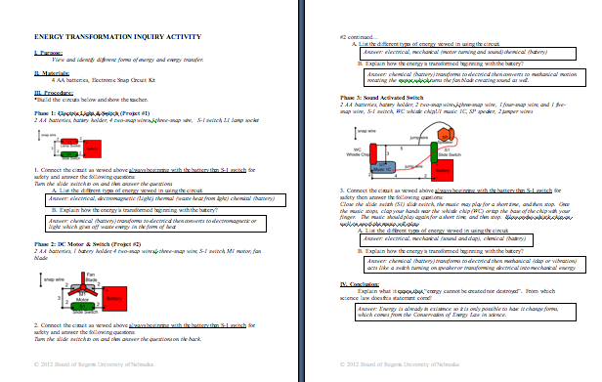
Instructing Concepts: (Vanishing or Transforming Act of Energy)

Energy and Energy Transfer

Definition of Energy
Energy is defined as the capacity to do work that causes physical change within a closed system. In a closed system, energy cannot be created or destroyed only transformed into a different type.
Energy Types
Some scientists state that there are only two types of energy potential and kinetic. Potential energy is stored energy. Kinetic energy is energy resulting from motion. Many forms of energy exist within these two types: mechanical, electrical, thermal, nuclear, wind, chemical, water, geothermal, wave, light, and sound.
Energy Transfer/conversion
Energy can be converted or transferred from one form to another. The Law of Conservation of Energy from physics says that the total energy in a closed system is constant over time. Most forms of energy can be converted from one form to another with a high degree of efficiency. The exception to the rule is thermal energy: all of the energy in the universe may one day be converted to thermal energy which slowly cools until a very cold equilibrium is reached. Conversion of thermal energy is limited by the second law of thermodynamics. A result of this law is that energy cannot be created or destroyed. It can only be changed from one state to another. Examples where this change in state occurs are:
- Hydroelectric dams: Dammed water (potential), moves through turbines and turns them (kinetic) which causes a generator to create electricity (electrical).
- Electric lamp: Electricity (electrical) makes a light bulb light up (heat and light)
- Microphone: Sound energy converted into electricity.
- Fossil Fuel power plant: Fossil fuels (potential) are burned (thermal) to heat water which in turn moves turbines (kinetic) to create electricity (electrical).
- Friction: Kinetic energy is turned into thermal energy.
- Solar cells: Light energy is turned into electricity (electrical)
This list is far from exhaustive but should point out the many different ways that energy can be transformed.
Energy Costs
The cost of energy is more than the price that you pay for the electricity, gasoline, natural gas, etc. that you use. The financial costs of these items are paid everyday and vary depending on the location where the energy was purchased and the time of year. The use of energy has hidden costs associated with it such as climate and environmental impact.
Energy Efficiency
Energy efficiency is defined as the process of using less energy to provide the same level of service. Creating more efficient products such as higher mileage cars, florescent light bulbs, high efficiency furnace and AC units, or appliances can do this. It can be caused by better insulation or building design.
Energy Conservation
Energy conservation is the effort to reduce the consumption of energy. The goal of conservation is to preserve finite resources and reduce pollution. It can be accomplished by creating more efficient related energy products or simply by creating habits that utilize less energy such as turning off the lights or carpooling.
Organizing Learning: (Vanishing or Transforming Act of Energy)

Summary: Students will view and identify different types of energy and energy transformation through the operation of a CEENBoT.

Outline: Middle School and High School level
Middle School Level
- Sent to stations with preprogrammed and wired CEENBoTs
- View an action performed by the CEENBoT and determine the types of energy transformed to perform the action
- Explain how the lab relates to the Law of Conservation of Energy

High School Level
- Taught how to program and wire a CEENBoT for different sensors
- Given a prompt to direct the CEENBoT to convert different types of energy to make the CEENBoT perform a specific action
- Explain how the lab relates to the Law of Conservation of Energy

Activity: Middle School and High School level
Middle School Level
Student pairs will be sent to stations with preprogrammed and wired CEENBoTs. After viewing, the action performed by the CEENBoT students will determine the types of energy transformed while the CEENBoT was operating. Finally, students will explain how the lab relates to the Law of Conservation of Energy.

High School Level
Student pairs will be shown how to wire and program a CEENBoT. Next, they will be provided with supplies and given a prompt such as: convert electromagnetic (light) energy into electrical energy, which is converted into mechanical energy or motion of the robot. Once the program is developed they will show the teacher. Finally, students will explain how the lab relates to the Law of Conservation of Energy.

Lab Setup:
Create the programs in CEENBoT Commander and download them in the robots to be used. High school students could create their own programs.

Attachments:
- S135_Vanishing_Transforming_Acts_Energy_O_Programs.doc
- S135_Vanishing_Transforming_Acts_Energy_O_Lab.doc (1 document, 4 pages)
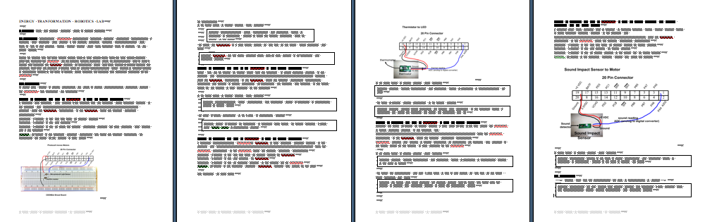
Understanding Learning: (Vanishing or Transforming Act of Energy)

Summary: Students will distinguish between matter and energy, identify different types of energy, and explain energy transfer.

Outline:
- Formative Assessment of Energy and Energy Transfer
- Summative Assessment of Energy and Energy Transfer

Activity: Students will complete written and quiz assessments about energy and energy transfer.
Formative Assessment: As students are engaged in the lesson ask these or similar questions:
- Can students distinguish between matter and energy?
- Are students able to identify the types of energy forms?
- Can students explain energy transfer in real life items or scenarios?

Summative Assessment: Students can complete one of the following writing prompt.
1) Explain how does energy differ from matter?
2) Explain the energy transfer including the forms of energy in the following scenario. To get her hair ready for school, Jennifer turned on her blow dryer to hot, drying her hair. Begin with coal and end with the heat as well as any waste energy given off from the blow dryer.

Student can complete the following quiz question.

1) Label the type of energy next to each one (be specific more than kinetic and potential energy).
A. water turning turbines at a hydrological power plant
B. heat being released from an oven
C. light coming from a firefly
D. spaghetti on a plate

