ENERGY TRANSFORMATION INQUIRY ACTIVITY

I. Purpose:
View and identify different forms of energy and energy transfer.

II. Materials:
4 AA batteries, Electronic Snap Circuit Kit

III. Procedure:
*Build the circuits below and show the teacher.

Phase 1: Electric Light & Switch (Project #1)
2 AA batteries, battery holder, 4 two-snap wires,1 three-snap wire, S-1 switch, L1 lamp socket
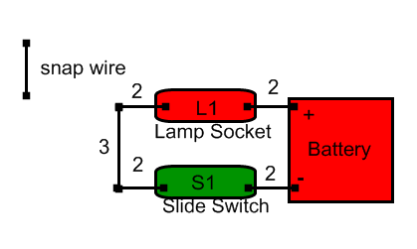
1. Connect the circuit as viewed above always beginning with the battery then S-1 switch for safety and answer the following questions:
Turn the slide switch to on and then answer the questions.
A. List the different types of energy viewed in using the circuit.
Answer: electrical, electromagnetic (Light), thermal (waste heat from light) chemical (battery)

B. Explain how the energy is transformed beginning with the battery?
Answer: chemical (battery) transforms to electrical then converts to electromagnetic or light which gives off waste energy in the form of heat

Phase 2: DC Motor & Switch (Project #2)
2 AA batteries, 1 battery holder, 4 two-snap wires,1 three-snap wire, S-1 switch, M1 motor, fan blade
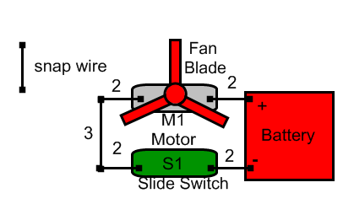
2. Connect the circuit as viewed above always beginning with the battery then S-1 switch for safety and answer the following questions:
Turn the slide switch to on and then answer the questions on the back.

#2 continued…
A. List the different types of energy viewed in using the circuit.
Answer: electrical, mechanical (motor turning and sound) chemical (battery)

B. Explain how the energy is transformed beginning with the battery?
Answer: chemical (battery) transforms to electrical then converts to mechanical motion rotating the motor which turns the fan blade creating sound as well.

Phase 3: Sound Activated Switch
2 AA batteries, battery holder, 2 two-snap wire,1 three-snap wire, 1 four-snap wire, and 1 five-snap wire, S-1 switch, WC whistle chip,U1 music 1C, SP speaker, 2 jumper wires
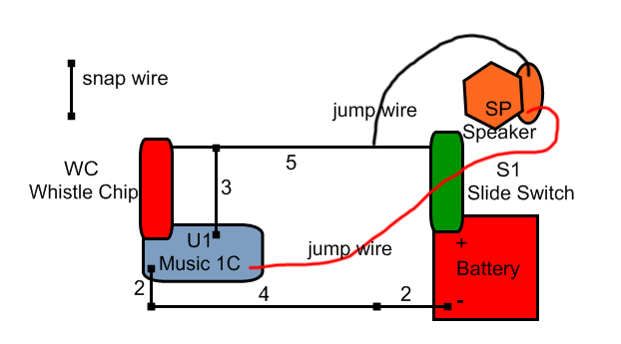
3. Connect the circuit as viewed above always beginning with the battery then S-1 switch for safety then answer the following questions:
Close the slide switch (S1) slide switch, the music may play for a short time, and then stop. Once the music stops, clap your hands near the whistle chip (WC) or tap the base of the chip with your finger. The music should play again for a short time, and then stop. Blow on the whistle chip as well to see if the music will play.
A. List the different types of energy viewed in using the circuit.
Answer: electrical, mechanical (sound and clap), chemical (battery)

B. Explain how the energy is transformed beginning with the battery?
Answer: chemical (battery) transforms to electrical then mechanical (clap or vibration) acts like a switch turning on speaker or transforming electrical into mechanical energy (sound).

IV. Conclusion:
Explain what it means that “energy cannot be created nor destroyed”. From which science law does this statement come?
Answer: Energy is already in existence so it is only possible to have it change forms, which comes from the Conservation of Energy Law in science.

