ENERGY TRANFORMATION ROBOTICS LAB

I. Purpose: View and identify different types of energy transfer.

II. Materials: CEENBOT, CEENBoT Commander program, AVRISP In-System Programmer, 3 jumpers, mini photocell light sensor, 1 kΩ resistor, darkened location, ZX-thermometer, cold pack or cup of ice, Parallax Sound Impact Sensor (may need different style of jumpers for the sound sensor)

(Note: To change this lab from middle school level to high school level, have the high school students wire and program the CEENBoT for the desired energy changes. Begin by demonstrating how to wire a circuit and program the CEENBoT (include an explanation about how each sensor is wired), provide the supplies, then give the students a prompt such as change electromagnetic (light) energy to electric energy to mechanical energy in the form of motion. Then, evaluate the program and operation produced by the CEENBoT.)

III. Procedure:
1. Move from station to station identifying the types of energy transformation occurring through the CEENBoT and answering the questions:

Station #1 (students will turn on CEENBoT to view the energy transfers)
3 jumpers, mini photocell light sensor, 1 kΩ resistor and the photocell drive program (located in the attached file: S135_Vanishing_Transforming_Acts_Energy_O_Photocelltodrive.zip) installed from the CEENBoT commander to the CEENBoT using the AVRISP In-System programmer
*Connect a jumper to pin #19 (+5 VDC or voltage source)
*Connect a jumper to pin #20 (ground)
*Connect a jumper to pin #1 (read the voltage difference between the mini photocell light sensor and 1 kΩ resistor)
-connect as shown in the following diagram (photocell will drive the motors, increasing or decreasing the speed by the amount of light given)
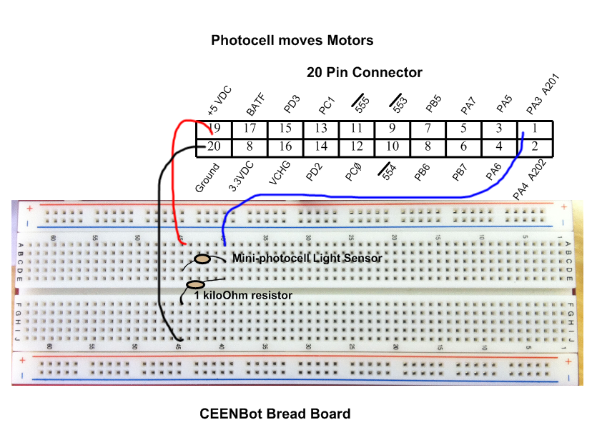
#1 continued…
1. A. What types of energy transfer were viewed?
Answer: electromagnetic (light) transformed into electrical, which is converted to mechanical energy to move the motors eventually view as motion of the robot.

B. Place the CEENBoT in a dark place, switch off and turn on the robot. What happened and why?
Answer: CEENBot did not move because there was no light energy to be converted into electrical energy.

Station #2 (students will turn on the CEENBoT to view energy transfers)
SAME SET UP as station #1 except down load the photocell to sound program (located in the attached file: S135_Vanishing_Transforming_Acts_Energy_O_Photocelltosound.zip) installed from the CEENBoT commander to the CEENBoT using the AVRISP In-System programmer (photocell will change to sound, increasing or decreasing the duration and intensity of the sound based on the amount of light received by the photocell)

2. A. What types of energy transfer were viewed?
Answer: electromagnetic (light) transformed into electrical, which is converted to mechanical energy to create sound.

B. Why is sound considered to be a form of mechanical energy?
Answer: sound is created by vibrations of particles (gas, liquid, or solids) meaning it gives them motion which is mechanical energy

Station #3 (students will turn on CEENBoT to view the energy transfers)
3 jumpers, ZX-Thermometer (thermistor), thermistor to LED program installed (located in the attached file: S135_Vanishing_Transforming_Acts_Energy_O_ThermistortoLED.zip from the CEENBoT commander to the CEENBoT using the AVRISP In-System programmer
*Connect a jumper to pin #19 (+5 VDC or voltage source on thermistor)
*Connect a jumper to pin #20 (ground on thermistor)
*Connect a jumper to pin #1 (thermal reading to the central pin on thermistor)
-connect as shown in the following diagram (thermistor reading will switch on the LED)

See Diagram on Next Page!
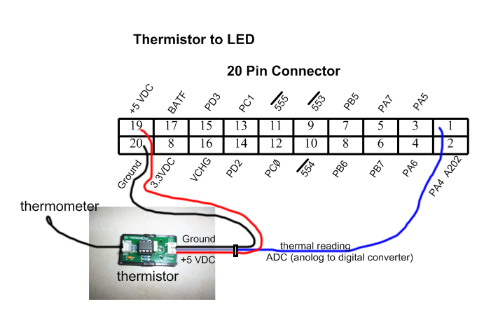
3. A. What types of energy transfer were viewed?
Answer: thermal energy transformed into electrical, which is converted to electromagnetic or light.

B. Why is thermal energy considered to be kinetic energy?
Answer: thermal energy really measures the overall total movement of the particles inside a substance, the faster the particles the hotter the substance will be

Station #4 (students will turn on CEENBoT to view the energy transfers)
Connect the same as station #3 except include a cold pack or cup of ice and install the thermistor to sound program (located in the attached file: S135_Vanishing_Transforming_Acts_Energy_O_Thermistortosound.zip) from the CEENBoT commander to the CEENBoT using the AVRISP In-System programmer
(thermistor reading will change to sound, increasing or decreasing the duration and intensity of the sound based on the amount of heat received by the thermistor)

4. A. What types of energy transfer were viewed?
Answer: thermal energy transformed into electrical, which is converted to mechanical energy in the form of sound.

B. Place the thermometer end into a cold pack or cup of ice, switch off and turn on the robot. What happened and why?
Answer: No sound was made because the thermal energy was so small that there was not enough to convert into electrical energy to make the mechanical sound.

Station #5 (students will turn on CEENBoT to view the energy transfers and SHOUT LOUDLY into the sound sensor)
3 jumpers (may need different type to connect to sensor), Parallax Sound Impact Sensor, sound to drive program installed (located in the attached file: S135_Vanishing_Transforming_Acts_Energy_O_Soundtodrive.zip) from the CEENBoT commander to the CEENBoT using the AVRISP In-System programmer
*Connect a jumper to pin #19 (+5 VDC or voltage source on sound sensor)
*Connect a jumper to pin #20 (ground on sound sensor)
*Connect a jumper to pin #1 (sound reading to the signal pin on sound sensor)
-connect as shown in the following diagram (sound will drive the motors)
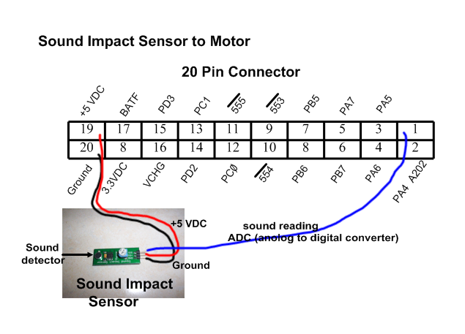

5. What types of energy transfer were viewed?
Answer: mechanical energy in the form of sound transformed into electrical, which is converted to mechanical energy in the form of moving the robot.

IV. Conclusion:
Explain how this lab demonstrated the Law of Conservation of Energy.
Answer: Throughout the lab, energy was neither created nor destroyed it only changed form like electromagnetic (light) energy transformed into electrical energy.

