Vanishing or Transforming Act of Energy Lab
CEENBoT Commander Programs

To setup for the lab create these programs in CEENBoT Commander and download into each lab station robot using the AVRISP In-System programmer.

Note: These programs use special tools in CEENBoT Commander such as the ADC and Sound tools. These tools may not visible in the tool menu. You may need to make the tools visible in the tool menu using File > Options > Tools tab, then select the ADC tool under Available Tools and click the Add button to add the tool to the Active tools.

CEENBoT Commander Project Name: photocelltodrive

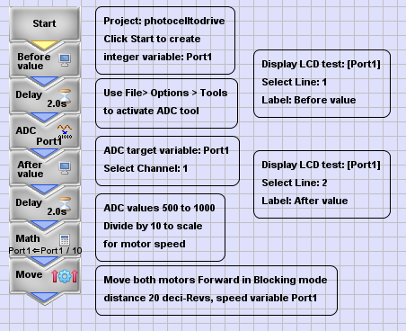
CEENBoT Commander Project Name: photocelltosound

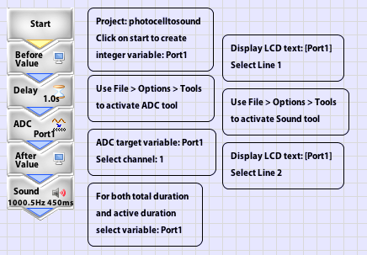

CEENBoT Commander Project Name: thermistortoLED

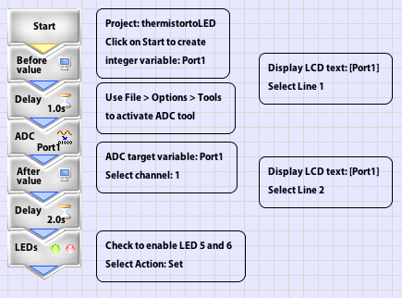
CEENBoT Commander Project Name: thermistortosound

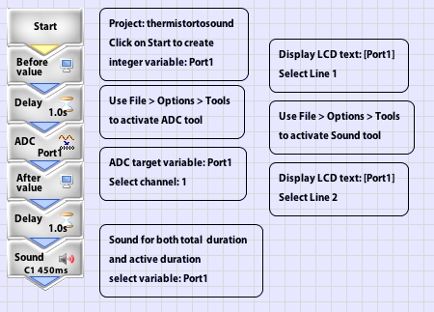

CEENBoT Commander Project Name: soundtodrive

