HIGH SCHOOL LEVEL ROBOT RESISTANCE LAB

I. Purpose: Identify resistors by color code, calculate resistor needed to obtain the correct amount of current flow, and view their effects on the current or motion of the robot.

Explanation: The robot is programmed to read the difference in voltage between the two resistors implanted by the students. This difference in voltage is converted from analog to digital. The robot’s programming translates the digital number to direct the motors, which moves the robot. The motor’s speed changes with the second resistor such that they move faster if the resistance is small or slower if the resistance is great.

II. Materials: CEENBot, CEENBot Commander on lap top, AVRISP In-System programmer, five 0.5 Watt resistors (variety for students to choose from) one 1 kΩ resistor, color code chart for reading resistors, 3 jumpers (connectors), stopwatch

III. Procedure:
1. Obtain materials.
2. Set up the breadboard as shown below. Make the 2nd resistor another 1 kΩ resistor to begin.
3. *Connect one jumper to pin #19 (+5 VDC or voltage source)
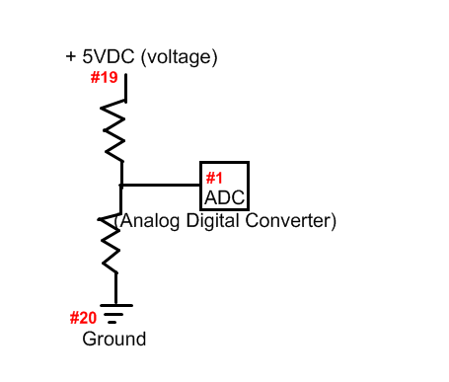
*Connect one jumper to pin #20 (ground)
*Connect one jumper to pin #1 (read the voltage difference)
*Connect resistors in series
-connect to bread board as shown below
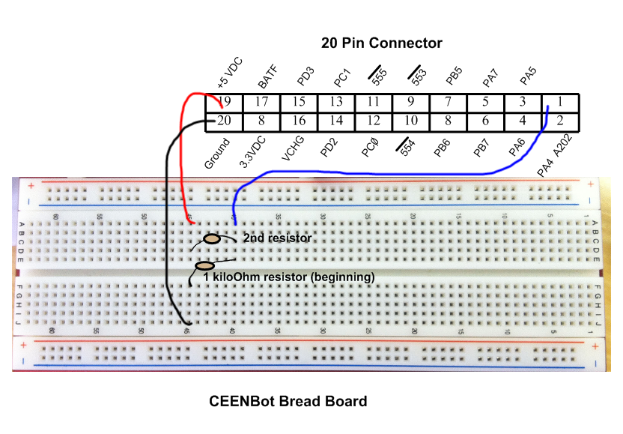
4. Program the CEENBoT using the files in the attachment: S136_Viva_Le_Resistance_O_Lab_Resistorchangemotor.zip
5. Test the CEENBot to make sure everything is connected correctly. (NOTE: anytime a change is made to the breadboard turn off the CEENBot for your safety and the safety of the CEENBot)
6. Record the time it took for the CEENBot to travel 10 revolutions using the two 1 kΩ resistors as well as the color code, Ohm value, and Tolerance value of each following resistor as they change.
7. Calculate the total resistance for the circuit using the two 1 kΩ resistors. Record.
8. Calculate the amount of current flowing through the circuit. Record.
9. Replace the first 1 kΩ resistor with a resistor that will produce half the amount of current as the two 1 kΩ resistors or a quarter of the original current.
(Hint: The first circuit with only one resistor would have been 5 volts/ 1000 Ω or 1 kΩ = 0.005 amps, but another 1000Ω or 1 kΩ was added making the amps 0.0025 amps or ½ .)
10. Place the ohm resistor (least) in the correct position on the bread board as seen below. (NOTE: anytime a change is made to the breadboard turn off the CEENBot for your safety and the safety of the CEENBot)
11. Turn on the CEENBot.
12. Record the time and determine if it is twice as long as the last time to verify you choose the correct resistor as well as the other components on the data table.
13. Repeat steps number #9-12 except choose a resistor or two resistors that does the following: decreases the resistance by half of original (time should be ½ as long), decreases the resistance by 1/5 of original (time should be 1/5 as long), and increase the resistance by 1/3 of original (time should be 1/3 longer).
14. Return all equipment.

IV. Data/ Questions:

Resistors & Time:
Resistors | Time (s) | Color Code | Ohm (Ω) & Tolerance Values | Total Resistance  (Ohms) | Total Current  (Amps)
Example | 21 seconds | black, brown, black, red | 1Ω with 2% tolerance
1st |  |  | 1 kΩ with 2% tolerance
2nd

3rd

4th

5th

Answers: Resistors & Time:
Resistors | Time (s) | Color Code | Ohm (Ω) & Tolerance Values | Total Resistance  (Ohms) | Total Current  (Amps)
Example | 21 seconds | black, brown, black, red | 1Ω with 2% tolerance | 1001 | 0.00499
1st | vary | brown, black, red, gold | 1 kΩ with 5% tolerance | 2000 | 0.0025
2nd | 2x slower | orange, black, red, gold | 3 kΩ with 5% tolerance | 4000 | 0.00125
3rd | 2x faster | green, black, brown, gold | 500 Ω (two) with 5% tolerance | 1000 | 0.005
4th | 5 x faster | brown, black, brown, gold | 100 Ω (two) with 5% tolerance | 200 | 0.025
5th | 1/3 slower | orange, orange, brown, gold | 330 Ω (plus 1000) with 5% tolerance | 1330 | 0.00375

1. What happened to the robot as the resistance increased? Explain the cause of this.
Answer: The robot traveled slower because as the resistance increases this decreases the amount of current received by the motors slowing them down.

2. Write down the correct Ohm and tolerance values for each 4-band resistor:
780 kΩ or 780 000Ω at 2 %
A. violet, gray, green, red
B. yellow, brown, orange, silver
41 kΩ or 41 000Ω at 10 %
C. blue, black, gray, no band
600 MΩ or 600 000 000Ω at 20 %

3. During the lab the resistors always received 5 volts of current from the robot, if the voltage were increased to 10 volts how would this affect the robot to during the experiment? Explain.
Answer: An increase in voltage would have allowed more current or electricity to reach the motors causing the robot to travel faster.
1

4. Beginning with a 500 Ω, determine a resistance for the following scenarios:
A. a resistance 2x greater
Answer: A) 1000 Ω
B) 250 Ω
C) 125 Ω
D) 1750 Ω
E) 83 1/3 Ω
B. a resistance ½ as much
C. a resistance ¼ as much
D. a resistance 3 ½ x greater
E. a resistance 1/6 as much

5. Calculate the current through a circuit that has 9 volts using the resistance totals from question #4.
A.
Answer: A) 0.009 A
B) 0.0045 A
C) 0.00225 A
D) 0.0514 A
E) 0.108 A
B.
C.
D.
E.
V. Conclusion: Explain how the terms resistance, voltage, and current relate to each other when using a circuit.
Answer: Current is the amount of electricity flowing through a circuit, which can be changed by increasing or decreasing the resistance as well as the voltage.

