ROBOT RESISTANCE LAB

I. Purpose: Identify resistors by color code and view their effects on the current or motion of the robot.

Explanation: The robot is programmed to read the difference in voltage between the 1kΩ resistor and the second resistor implanted by the students. This difference in voltage is converted from analog to digital. The robot’s programming translates the digital number to direct the motors, which moves the robot. The motors speed changes with the second resistor such that they move faster if the resistance is small or slower if the resistance is great.

II. Materials: CEENBoT, CEENBoT Commander on lap top, ASVIR programmer interface, five 0.5 Watt resistors (100Ω, 270Ω, 560Ω, 1.8kΩ, and 3.9kΩ chose a variety to help teach students how to read the different colors) one 1 kΩ resistor, color code chart for reading resistors, 3 jumpers (connectors), stopwatch
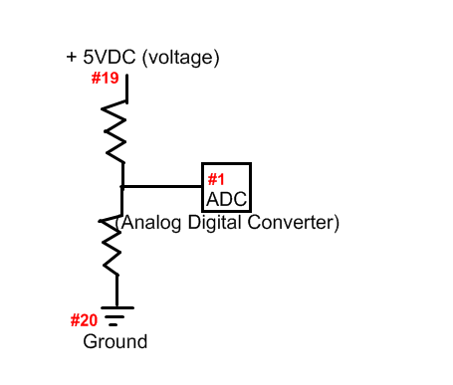

III. Procedure for Teacher:
1. Obtain materials.
2. Teacher must set up the bread board in advance, so that students will only switch resistors. (If working with advance students they may set up the bread board.)
3. *Connect one jumper to pin #19 (+5 VDC or voltage source)
*Connect one jumper to pin #20 (ground)
*Connect one jumper to pin #1 (read the voltage difference)
*Connect resistors in series (always leave the 1kΩ in place)
-connect to bread board as shown below
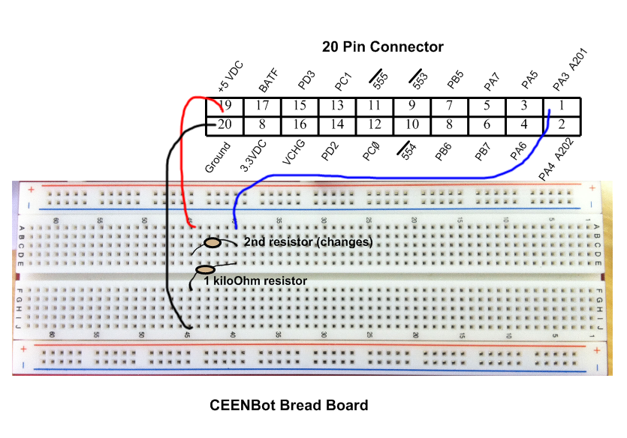
4. Program the CEENBoT using the files in the attachment: S136_Viva_Le_Resistance_O_Lab_Resistorchangemotor.zip
5. Test the CEENBoT using a second resistor to make sure everything is connected correctly. (NOTE: anytime a change is made to the breadboard turn off the CEENBoT for your safety and the safety of the CEENBoT)
Answer: An increase in voltage would have allowed more current or electricity to reach the motors causing the robot to travel faster.

III. Procedure for Students:
1. Obtain materials.
2. Order the five 0.5 Watt resistors from least to greatest resistance.
3. Record color code, Ohm value, and Tolerance value of each resistor in the chart below.
4. Place the smallest ohm resistor (least) in the correct position on the bread board as seen below. (NOTE: anytime a change is made to the breadboard turn off the CEENBoT for your safety and the safety of the CEENBoT)
780 kΩ or 780 000Ω at 2 %
41 kΩ or 41 000Ω at 10 %
Answer: The robot traveled slower because as the resistance increases this decreases the amount of current received by the motors slowing them down.
Answer will vary.
600 MΩ or 600 000 000Ω at 20 %
5. Turn on the CEENBoT.
6. Time how long it takes the CEENBoT to travel the programmed 10 revolutions. Record below.
7. Repeat steps #4-6 except changing the resistor in the order of least to greatest in resistance.
8. Return all equipment.

IV. Data/ Questions:

Resistors & Time:
Resistors | Color Code | Ohm (Ω) & Tolerance Values | Time (s)
Ex. least resistance | black, brown, black, red | 1Ω with 2% tolerance | 21 seconds
Least resistance
More resistance
Great resistance
Greater resistance
Greatest resistance
1. What happened to the robot as the resistance increased? Explain the cause of this.

2. Were you able to place the resistors in the correct order the first time? Explain why this did or did not occur?

3. Write down the correct Ohm and tolerance values for the following resistors:
A. violet, gray, green, red
B. yellow, brown, orange, silver
C. blue, black, gray, no band

4. During the lab the resistors always received 5 volts of current from the robot, if the voltage were increased to 10 volts how would this affect the robot to during the experiment? Explain.
Answer: Current is the amount of electricity flowing through a circuit, which can be changed by increasing or decreasing the resistance as well as the voltage.

V. Conclusion: Explain how the terms resistance, voltage, and current relate to each other when using a circuit.

