Project SHINE Lesson:
Numerical Abbreviations and the 3 Factor
==========================Lesson Header ==========================
Lesson Title: Numerical Abbreviations and the 3 Factor
Draft Date: 6/13/2012
1st Author (Writer): David Madcharo
Associated Business: Nebraska Public Power District
Instructional Component Used: Dimensional Analysis
Grade Level: 9-10
This Teacher was mentored by:


www.nppd.com

In partnership with Project SHINE grant funded through the

National Science Foundation

Content (what is taught):
- Powers of 10
- Numerical Abbreviations
- Mathematics with Abbreviations

Context (how it is taught):
- Real World Examples
- Demonstrations and Example Problems
- Problem Solving
Activity Description:
Students will learn about and be able to convert representative numbers to their abbreviated number notation and perform calculations and conversions using abbreviated number notation.

Standards:

Math: MD1 Science: SA1

Technology: TC4 Engineering: ED4
Asking Questions: (Numerical Abbreviations and the 3 Factor)

Summary: Students will discuss very large and very small numbers, how they are represented, and where they might be seen in daily life.

Outline:
- Representing very large and very small numbers
- Very large and very small numbers in daily life

Activity: A class discussion will be conducted about common very large or very small numbers and how they are typically represented. As students list these extreme numbers, they should be written on the board with their different representations (for instance 1000000, 1 million, 1 x 10⁶). Next a number line should be drawn to show the relationships of powers of 10 on a number line where each major tick is a factor of 1000 (10³) from the next.

Questions | Answers
What is a large number? Give some examples. | 100 million, infinity, 16 Gig
What are some large numbers you typically see in your daily lives? | $15 trillion (National Debt), 500GB (HD capacity), 2GB (Flash drive), 10,000 kW-hours (electric bill)
What is a really small number? Give some examples. | 1/1,000,000; a mil (1/1000); a microsecond
What are some really small numbers you might see in your daily lives? | A mil (property tax rates), 8 milliseconds (hard drive seek time);

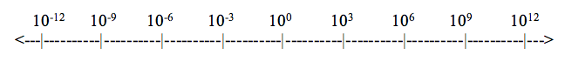
Exploring Concepts: (Numerical Abbreviations and the 3 Factor)

Summary: Students will be able to convert representative numbers to their abbreviated number notation and perform calculations and conversions using abbreviated number notation.

Outline:
- Write out extremely large and extremely small numbers in long hand
- Convert extremely large and extremely small numbers to their abbreviated notation
- Demonstrate sample math problems using long hand and abbreviated number formats

Activity: The activity starts with students writing out in long hand extremely large and extremely small numbers from everyday examples. Possible examples are below:

- Apple iPad 2 can have 16,000,000,000, 32,000,000,000, or 64,000,000,000 bytes of memory. How is this typically referenced in their ads? (Answer: 16GB, 32GB, 64GB)
- The national debt is 16,000,000,000,000 (as of the writing of this lesson). How would you represent this? (Answer: 16 trillion dollars)
- World population 7, 000, 000, 000 (as of the writing of this lesson). How else could this number be represented? (Answer: 7 billion people)

Students should think of other examples of these extreme numbers and how we represent them in other forms without writing them completely out. What if you had to do math with these numbers? Where do these large and small numbers fit on the number line below?

Instructing Concepts: (Numerical Abbreviations and the 3 Factor)

Dimensional Analysis

Putting Dimensional Analysis in Conceptual Terms: Dimensional Analysis (aka Factor-Label Method or Unit Factor Method) is a problem solving technique helpful in converting from one unit of measurement to another. It involves using conversion factors that are multiplied or divided into the original unit’s value to determine the secondary unit’s value.

Putting Dimensional Analysis in Mathematical Terms: Dimensional Analysis begins by determining a conversion factor or setting a unit equal to one in comparison to another unit. Some examples of conversion factors are:
1 foot = 12 inches 1 inch = 2.54 cm 1 mole = 6.022 x 10²³ particles

Note: It would also be correct to write 1 inch = 1/12 (0.83) foot, but often is easier to write the conversion factor making the larger unit equal to one. Then the amount of the other unit is written in a whole number rather than as a fraction or decimal value.

Next the conversion factor is applied to the original unit value either to be multiplied or divided.
Write the conversion factor as a fraction multiplied by the original value. Place the units desired to be eliminated or canceled on the bottom and the secondary unit on top.

Example:
Math component (34 x 1 = 34 … 34 ÷ 12 = 2.83)
Unit component (inches ÷ inches cancel the units
converting them to feet)
Convert 34 inches to feet
1 foot
12 inches
34 inches x = 2.83 ft

If several conversion factors are used to convert the original unit value, they can be written as many fractions multiplied together or in the method shown below. A horizontal line is drawn to represent all the fractions and several conversion factors are written together beginning with the original unit value and ending with the final unit value.
Math component (multiply numbers on top and divide numbers
on bottom)
Top: 5400 x 2.54 x 10 x 1 x 1 = 137160
Bottom: 1317160 ÷ 1 ÷ 1 ÷ 1 ÷ 365 ¼ ÷ 24 ÷ 3600 = 0.00435
Unit component (each one cancels until mm and sec remain)

Example

Convert to
5400 inches 2.54 cm 10 mm 1 year 1 day 1 hour = 0.00435 mm/sec
1 year 1 inch 1 cm 365 ¼ days 24 hours 3600 sec

Putting Dimensional Analysis in Applicable Terms: Dimensional Analysis can be utilized in unit conversion problems found in math and science especially mathematical story problems and chemistry stoichiometry problems as well as numerous other applications not listed here.
Organizing Learning: (Numerical Abbreviations and the 3 Factor)

Summary: Students will build a table and number line identifying numerical abbreviations, their names, and exponential value and solve problems using numerical abbreviations including conversions between abbreviations.

Outline:
- Students will complete a table identifying the numbers 1,000,000,000,000 (1 Tera) to 0.000 000 000 001 (1 pico)
- Students will properly label (name and abbreviation) a number line from 10⁻¹² to 10¹²
- Students will solve problems using dimensional analysis.

Activity: Students (with instructor guidance) will complete a table correctly identifying the name, abbreviation, numerical value and exponential value from 1,000,000,000,000 to 0.000000000001 and fill in a number line showing the relationship between abbreviated values. Students will then solve problems using abbreviated numbers and convert to their simplest expression using dimensional analysis. (Answers are in red)

Number | Prefix Name | Abbreviation | Power of 10
1,000,000,000,000 | Tera | T | 10¹²
1,000,000,000 | Giga | G | 10⁹
1,000,000 | Mega | M | 10⁶
1,000 | kilo | k | 10³
1 | Typically no name | No abbreviation | 10⁰
0.001 | milli | m | 10⁻³
0.000001 | micro | u | 10⁻⁶
0.000000001 | nano | n | 10⁻⁹
0.000000000001 | pico | p | 10⁻¹²
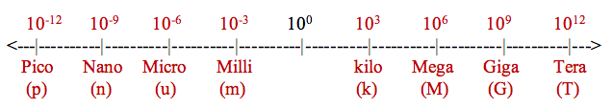
Example Problems:
- Convert 1000000 to prefix notation = 1M
- Convert 0.000000001 to prefix notation = 1n
- 900n + 20u = 20.9u
- 10n – 9.2n = 0.8n
- 200 x 60k = 12,000k = 12M
- 150M / 30k = 5k
To see solutions using dimensional analysis to solve them see attached file.

Attachment:
- S141_SHINE_Numerical_Analysis_3_Factor_O_Answers.doc
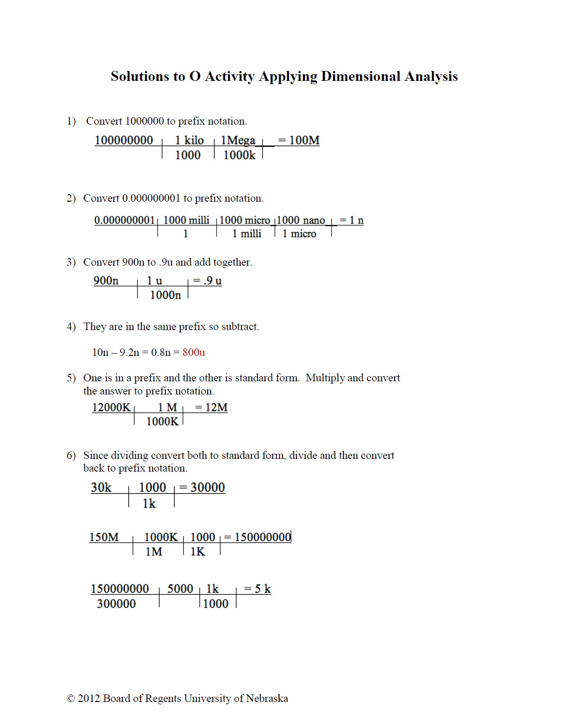
Understanding Learning: (Numerical Abbreviations and the 3 Factor)

Summary: Students will be able to convert representative numbers to their abbreviated number notation and perform calculations using abbreviated number notation using dimensional analysis.

Outline:
- Formative Assessment of Dimensional Analysis
- Summative Assessment of Dimensional Analysis

Activity: Students will complete assessments related to dimensional analysis.

Formative Assessment: As students are engaged in the lesson ask these or similar questions:
- Were students able to correctly identify values by their abbreviation?
- Were students able to convert numbers to their abbreviated formats?
- Were students able to solve problems using abbreviated number formats?

Summative Assessment: Students can complete the following performance assessments.
- Students will correctly identify numerical abbreviations providing their name, numerical value, and exponential value. Examples: Abbreviation (Answers in red)
M – (Mega) (1,000,000) (10⁶)
G – (Giga) (1,000,000,000) (10⁹)
m – (milli) (0.001) (10⁻³)
u – (micro) (0.000001) (10⁻⁶)

2) Students will solve problems containing numerical abbreviations. (Answers in red)
800k + 400k =1200k = 1.2M
25M / 50k = 500 (typically no abbreviation, but technically can be 5 hecto)
10G x 4m = 40M
12,000 x 3000 = 36,000,000 = 36M
36m / 6u = 6000 = 6k
48u / 4k = .012u = 12n

3) The electric company needs to measure the amount of electricity used by a home with 25 light bulbs using 75 watts each that are left on for four hours every day for a month (30 days). How does the electric company track the amount of electricity used?

